UNIT 6 · LESSON 3 STANDARD 6.AT.5

Explore Numerical Expressions with Exponents (Flagship)
Student Notes Packet
Name: ______________________ Date: ____________ Period: ________
Level 2 · Standard

Today's Goals
Content: I can write and evaluate numbers in exponent form using a base and a power.
Language: I can explain my work using the words exponent, base, power, and evaluate.

Key Vocabulary
Look at the picture, read the word, then read what it means.
 | Powers and Exponents Potencias y exponentes  A power uses a base and an exponent to show repeated multiplication.  Example: 2⁴ = 2 × 2 × 2 × 2 = 16
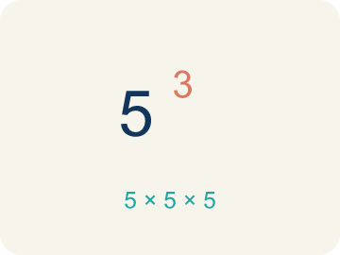 | Exponent Exponente  A small number that tells how many times to multiply a number by itself.  Example: In 2³, the small 3 means multiply 2 by itself 3 times: 2 × 2 × 2 = 8
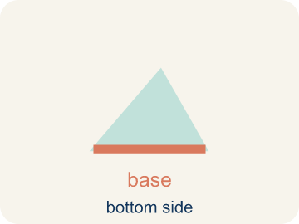 | Base Base  The number that gets multiplied by itself.  Example: In 5², the base is 5 — it is the number being multiplied: 5 × 5 = 25
 | Power Potencia  A number written with a base and an exponent, like 2³.  Example: 10³ = 10 × 10 × 10 = 1,000 — read as '10 to the third power' or '10 cubed'
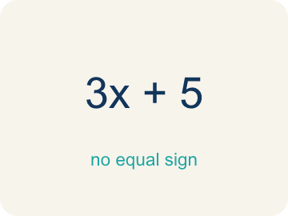 | Evaluate Evaluar  To find the value by putting numbers in for the letters.  Example: Evaluate 3⁴: write 3 × 3 × 3 × 3, then multiply step by step: 9 × 9 = 81

Guided Notes
Fill in each blank as we go. Use the Word Bank to help you.
WORD BANK
Powers and Exponents • Exponent • Base • Power • Evaluate

1. A power writes repeated multiplication with a base and an ________________.
2. The small raised number that shows how many times the base is multiplied is the ________________.
3. The number being multiplied repeatedly in a power, like the 3 in 3⁴, is the ________________.
4. A number written with a base and an exponent, like 3⁴, is a ________________.
5. To find the value of an expression, like 2³ = 8, is to ________________ it.

Write About the Math
Use the support level you need. Every level answers the same math question.

1. Understand the Question explain
How large is the file after 5 layers? Why does the file size grow so quickly?
Your job: Answer the question. Use math evidence. Explain how the evidence proves your answer.
Responde la pregunta. Usa evidencia matemática. Explica cómo la evidencia demuestra tu respuesta.

2. Plan Your Math Words check at least two
☐ Powers and Exponents — A power uses a base and an exponent to show repeated multiplication.
Potencias y exponentes — Una potencia usa una base y un exponente para mostrar multiplicación repetida.
☐ Exponent — A small number that tells how many times to multiply a number by itself.
Exponente — Un número pequeño que dice cuántas veces multiplicar un número por sí mismo.
☐ Base — The number that gets multiplied by itself.
Base — El número que se multiplica por sí mismo.
☐ Power — A number written with a base and an exponent, like 2³.
Potencia — Un número escrito con una base y un exponente, como 2³.
☐ Evaluate — To find the value by putting numbers in for the letters.
Evaluar — Encontrar el valor poniendo números en lugar de las letras.
Say it first: Say your idea to a partner or quietly to yourself before you write.
After 5 layers the file is ___ MB because 4 × 2⁵ = 4 × ___ = ___. The file grows quickly because each layer ___ the size.
Di tu respuesta primero: Mi respuesta es ___ porque ___.

3. Build Your Explanation choose your support
This model shows the parts of an explanation. It does not answer your writing question.
Claim: The exponent counts how many times we multiply, not what we add.
Evidence: Students connect each switch flip to one more factor of 2 and explain that 2³ = 2 × 2 × 2 = 8, distinguishing repeated multiplication from repeated addition (which would give 6).
Reasoning: This evidence connects the definition of exponent to the mathematical claim.

Start Most language support
Complete the frames. Use the word bank.
Completa las oraciones. Usa el banco de palabras.
After 5 layers the file is ___ MB because 4 × 2⁵ = 4 × ___ = ___. The file grows quickly because each layer ___ the size.
My answer is ___.
Mi respuesta es ___.

Build Some language support
Write two connected sentences. Use because, so, or but.
Escribe dos oraciones conectadas. Usa porque, entonces o pero.
My claim is ___.
Mi afirmación es ___.
I know because ___.
Lo sé porque ___.
So ___.
Entonces ___.

Explain Light language support
Write a claim, give math evidence, and explain your reasoning.
Escribe una afirmación, da evidencia matemática y explica tu razonamiento.
My claim is ___.
Mi afirmación es ___.
My math evidence is ___.
Mi evidencia matemática es ___.
This proves ___ because ___.
Esto demuestra ___ porque ___.

4. Check Your Explanation five quick checks
☐ I answered the question.
Respondí la pregunta.
☐ I used math evidence: numbers, an equation, a model, or a comparison.
Usé evidencia matemática: números, una ecuación, un modelo o una comparación.
☐ I explained how the evidence proves my answer.
Expliqué cómo la evidencia demuestra mi respuesta.
☐ I used at least two math words.
Usé por lo menos dos palabras matemáticas.
☐ I reread complete sentences and punctuation.
Volví a leer mis oraciones completas y la puntuación.

Worked Example

Watch & Read I Do — follow along with your teacher
Sound Check
You're a sound engineer at a music studio. Each time you flip a switch, the volume doubles. The starting volume is 1 unit. After flipping the switch 3 times, the volume is 2³ = 2 × 2 × 2 = 8 units — that's 8 times louder! How loud does it get after more flips?

Think about:
• What happens to the volume each time you flip a switch?
• Why is 2³ equal to 8, not 6?
• How is repeated multiplication different from repeated addition?
• What if the volume tripled each time instead of doubled?
• How many flips would it take to reach over 1,000 volume units?

Solved Example I Do — watch each step
Problem: What is the value of 4³?
A) 64
B) 12
C) 43
D) 7
Step 1: 4³ = 4 × 4 × 4 = 64.
Answer: A. 64

Guided Practice

Solve Together We Do — work with your class
Problem: What is the value of 6²?
A) 36
B) 12
C) 62
D) 8
Step 1:

Step 2:

Answer:

A music studio is recording tracks. Each track layer doubles the file size. A single track is 4 MB. The file size after n layers is given by 4 × 2ⁿ.
How large is the file after 5 layers? Why does the file size grow so quickly?

Sentence frame: After 5 layers the file is ___ MB because 4 × 2⁵ = 4 × ___ = ___. The file grows quickly because each layer ___ the size.

Turn & Talk discuss with a partner
1. [Launch] In the sound studio, the volume doubles each time you flip the switch. Why is the volume after 3 flips 2³ = 8 and not 2 × 3 = 6?
Start with: After 3 flips the volume is ___ because we multiply 2 three times.
Después de 3 cambios el volumen es ___ porque multiplicamos 2 tres veces.
Word bank: Exponent, Base, Power, Evaluate
2. [Explore] Look at the table: when the exponent goes up by 1 (like from 2³ to 2⁴), what happens to the value, and why?
Start with: When the exponent increases by 1, the value is multiplied by ___.
Cuando el exponente aumenta en 1, el valor se multiplica por ___.
Word bank: Exponent, Base, Power, Evaluate
3. [Connect] Each recording layer doubles the file size, modeled by 4 × 2ⁿ. Why does the file size grow so fast as you add layers?
Start with: After 5 layers the file is ___ MB because 4 × 2⁵ = ___.
Después de 5 capas el archivo es ___ MB porque 4 × 2⁵ = ___.
Word bank: Power, Base, Exponent, Evaluate
4. [Practice] During practice on Powers and Exponents, what strategy did you use when a problem felt tricky?
Start with: When a problem felt tricky, I ___ to figure it out.
Cuando un problema fue difícil, yo ___ para resolverlo.
Word bank: Exponent, Base, Power, Evaluate

Exit Ticket
Answer on your own. This shows what you learned today.
★ What is the value of 3⁴?
A) 81
B) 12
C) 34
D) 64

