UNIT 6 · LESSON 5 STANDARD 6.AT.6A

Write and Evaluate Algebraic Expressions
Student Notes Packet
Name: ______________________ Date: ____________ Period: ________
Level 3 · Enrichment

Today's Goals
Content: I can write an algebraic expression for a real situation and evaluate it for a given value of the variable.
Language: I can explain my expression using the words variable, term, coefficient, constant, substitute, and evaluate.

Key Vocabulary
Look at the picture, read the word, then read what it means.
 | Write Algebraic Expressions Escribir expresiones algebraicas  Translate words or a situation into numbers, variables, and operation symbols.  Example: Five more than n becomes n + 5.
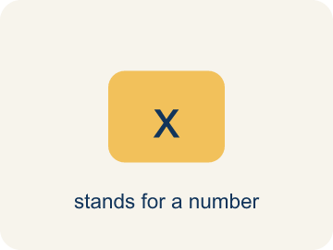 | Variable Variable  A letter that stands for a number that is unknown or can change.  Example: In 5t + 20, t could be hours worked — if t = 3, the expression equals 35; if t = 8, it equals 60
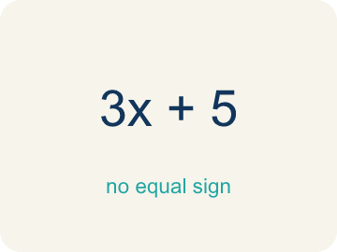 | Algebraic Expression Expresión algebraica  A math phrase that has at least one letter.  Example: 3n + 7 means 'triple a number, then add 7' — it has a variable (n), a coefficient (3), and a constant (7)
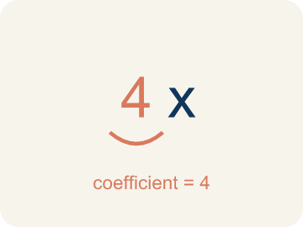 | Coefficient Coeficiente  The number in front of a letter, like the 3 in 3x.  Example: In 8x, the coefficient 8 means '8 groups of x' — if x = 3, then 8x = 8 × 3 = 24
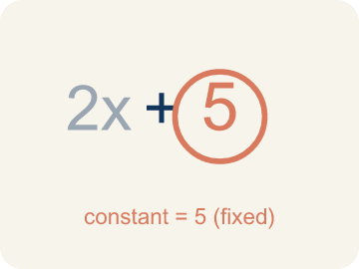 | Constant Constante  A fixed number in an expression or equation that does not change.  Example: In 3n + 7, the 7 never changes no matter what n is — like a flat fee that stays the same
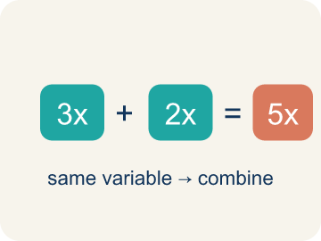 | Like terms Términos semejantes  Terms with the same letter raised to the same power, like 2x and 5x.  Example: 4x + 2x = 6x (like terms, same variable); but 4x + 2y cannot be combined (different variables)
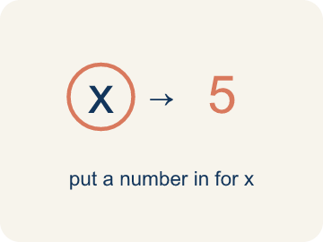 | Substitute Sustituir  To replace a variable with a given number before working out the value.  Example: For s = 30: 4.25s + 23.50 → 4.25 × 30 + 23.50
 | Evaluate Evaluar  To find what an expression is worth once every variable has a number, following the order of operations.  Example: 4.25 × 30 + 23.50 = 151

Guided Notes
Fill in each blank as we go. Use the Word Bank to help you.
WORD BANK
Write Algebraic Expressions • Variable • Algebraic Expression • Coefficient • Constant • Like terms • Substitute • Evaluate

1. Turn the words into numbers, operations and a ________________.
2. A letter that stands for an unknown number is a ________________.
3. A math phrase with variables, numbers, and operations but no equal sign is an ________________.
4. The number multiplied by a variable, like the 7 in 7n, is the ________________.
5. A term that is just a number and never changes, like the 5 in 3x + 5, is a ________________.
6. Terms with the same variable part are ________________.
7. Replace the variable with a given number before you ________________ the expression.
8. To put numbers in for the letters and work out the value is to ________________.

Write About the Math
Use the support level you need. Every level answers the same math question.

1. Understand the Question explain
Write an expression for the total cost. What does each part of the expression represent?
Your job: Answer the question. Use math evidence. Explain how the evidence proves your answer.
Responde la pregunta. Usa evidencia matemática. Explica cómo la evidencia demuestra tu respuesta.

2. Plan Your Math Words check at least two
☐ Write Algebraic Expressions — Translate words or a situation into numbers, variables, and operation symbols.
Escribir expresiones algebraicas — Traducir palabras o una situación a números, variables y símbolos de operaciones.
☐ Variable — A letter that stands for a number that is unknown or can change.
Variable — Una letra que representa un número desconocido o que puede cambiar.
☐ Algebraic Expression — A math phrase that has at least one letter.
Expresión algebraica — Una frase matemática que tiene al menos una letra.
☐ Coefficient — The number in front of a letter, like the 3 in 3x.
Coeficiente — El número frente a una letra, como el 3 en 3x.
☐ Constant — A fixed number in an expression or equation that does not change.
Constante — Un número fijo en una expresión o ecuación que no cambia.
Say it first: Say your idea to a partner or quietly to yourself before you write.
The total cost is ___ + ___h. The ___ represents the ___ and ___h represents the ___.
Di tu respuesta primero: Mi respuesta es ___ porque ___.

3. Build Your Explanation choose your support
This model shows the parts of an explanation. It does not answer your writing question.
Claim: Write 12t + 50: the 12t grows with tickets, the 50 stays fixed.
Evidence: Students write 12t + 50, identify t as the variable number of tickets, 12 as the coefficient (price per ticket), and 50 as the constant venue fee that does not change.
Reasoning: This evidence connects the definition of algebraic expression to the mathematical claim.

Start Most language support
Complete the frames. Use the word bank.
Completa las oraciones. Usa el banco de palabras.
The total cost is ___ + ___h. The ___ represents the ___ and ___h represents the ___.
My answer is ___.
Mi respuesta es ___.

Build Some language support
Write two connected sentences. Use because, so, or but.
Escribe dos oraciones conectadas. Usa porque, entonces o pero.
My claim is ___.
Mi afirmación es ___.
I know because ___.
Lo sé porque ___.
So ___.
Entonces ___.

Explain Light language support
Write a claim, give math evidence, and explain your reasoning.
Escribe una afirmación, da evidencia matemática y explica tu razonamiento.
My claim is ___.
Mi afirmación es ___.
My math evidence is ___.
Mi evidencia matemática es ___.
This proves ___ because ___.
Esto demuestra ___ porque ___.

4. Check Your Explanation five quick checks
☐ I answered the question.
Respondí la pregunta.
☐ I used math evidence: numbers, an equation, a model, or a comparison.
Usé evidencia matemática: números, una ecuación, un modelo o una comparación.
☐ I explained how the evidence proves my answer.
Expliqué cómo la evidencia demuestra mi respuesta.
☐ I used at least two math words.
Usé por lo menos dos palabras matemáticas.
☐ I reread complete sentences and punctuation.
Volví a leer mis oraciones completas y la puntuación.

Worked Example

Watch & Read I Do — follow along with your teacher
Concert Planner
You're planning a concert at the music studio. Tickets cost $12 each, and there's a flat $50 venue fee no matter how many people attend. If t represents the number of tickets sold, how would you write an expression for the total revenue?

Think about:
• What value changes depending on how many people come?
• What stays the same no matter the number of tickets?
• How would you calculate the total if 10 tickets are sold?
• What if there were two different ticket prices — regular and VIP?
• How many tickets would need to be sold to earn $200?

Solved Example I Do — watch each step
Problem: Which expression represents 'the product of 6 and a number n'?
A) 6n
B) 6 + n
C) n − 6
D) n ÷ 6
Step 1: 'Product' means multiplication, so the product of 6 and n is 6n.
Answer: A. 6n

Independent Practice

On Your Own You Do — show your work
Solve each problem. Show your thinking in the work box.

Level 2 Enrichment stretch your thinking
1. Field day needs one $4.25 item per student plus a one-time $23.50 shipping fee. Write the expression, then find the cost for 30 students AND for 60 students. Does doubling the students double the cost? Explain.

Exit Ticket
Answer on your own. This shows what you learned today.
★ A club orders one $4.25 shirt for each student plus a one-time $23.50 shipping fee. Write the expression for s students, then find the cost for 30 students.
A) 4.25s + 23.50; for s = 30 the cost is $151.00
B) 4.25s + 23.50; for s = 30 the cost is $832.50
C) 4.25 + 23.50s; for s = 30 the cost is $709.25
D) 27.75s; for s = 30 the cost is $832.50

Answer Key & Teacher Guide
Teacher reference — remove or fold back before distributing to students.

Guided Notes (Fill-in)
Notes 1: Write Algebraic Expressions
Notes 2: Variable
Notes 3: Algebraic Expression
Notes 4: Coefficient
Notes 5: Constant
Notes 6: Like terms
Notes 7: Substitute
Notes 8: Evaluate

Worked Notes (I Do / We Do)
I Do: A. 6n
We Do: A. y − 9

Independent Practice
Watch for this mistake: A common mistake in Write Algebraic Expressions is treating 'each' or 'per' as if it means add instead of multiply, and attaching the variable to the wrong number. For 'a $25 setup fee plus $8 per hour, h,' students often write 25 + 8 + h (adding all three numbers) or 25h + 8 (multiplying the flat fee by h) instead of the correct 8h + 25. Since $8 applies per hour, it must multiply the variable (8h), and the flat $25 fee is a constant added only once — check that the per-unit rate, not the flat fee, is the number multiplied by the variable.

Level 1 Support
1. A) m + 15 — 'Sum' means addition, so the sum of m and 15 is m + 15.
2. A) $66.00 — Substitute s = 10: 4.25 × 10 + 23.50. Multiply first: 42.50, then add: 42.50 + 23.50 = $66.00.
3. A) Product — 'Product' means multiplication. 'Sum' means addition, 'difference' means subtraction, and 'quotient' means division.

On Level
4. A) $63 — Substitute n = 6: 8 × 6 + 15 = 48 + 15 = $63.

Level 2 Enrichment
5. The expression is 4.25s + 23.50. For s = 30: 4.25 × 30 + 23.50 = 127.50 + 23.50 = $151.00. For s = 60: 4.25 × 60 + 23.50 = 255.00 + 23.50 = $278.50. Doubling the students does NOT double the cost. Twice $151.00 would be $302.00, but the actual cost is $278.50 — a difference of exactly $23.50. The reason is that only the 4.25s term depends on the number of students; the shipping fee is a constant charged once no matter how many students come, so it is not doubled along with everything else.

Exit Ticket
A) 4.25s + 23.50; for s = 30 the cost is $151.00 — “Each student” attaches to the variable: 4.25s. The shipping fee is charged once, so it is a constant: 4.25s + 23.50. Substituting s = 30 gives 4.25 × 30 + 23.50 = 127.50 + 23.50 = $151.00.

Math Writing Criteria
The support level changes the amount of language scaffolding, not the mathematical expectation.
☐ I answered the question.
☐ I used math evidence: numbers, an equation, a model, or a comparison.
☐ I explained how the evidence proves my answer.
☐ I used at least two math words.
☐ I reread complete sentences and punctuation.

