UNIT 6 · LESSON 8 STANDARD 6.AT.7

Generate Equivalent Expressions
Student Notes Packet
Name: ______________________ Date: ____________ Period: ________
Level 3 · Enrichment

Today's Goals
Content: I can use the commutative, associative, and identity properties to rewrite expressions.
Language: I can explain my reasoning using the words commutative property, associative property, and identity property.

Key Vocabulary
Look at the picture, read the word, then read what it means.
 | Properties of Operations Propiedades de las operaciones  Rules that let you reorder or regroup numbers without changing an expression's value.  Example: 3 + 5 = 5 + 3 (commutative property).
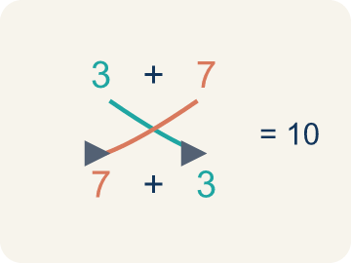 | Commutative Property Propiedad conmutativa  You can change the order and get the same answer.  Example: 3 + 7 = 7 + 3 = 10 both ways; 4 × 5 = 5 × 4 = 20 both ways — order does not matter
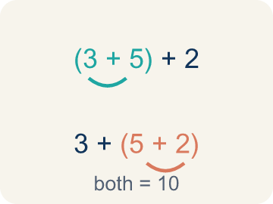 | Associative Property Propiedad asociativa  You can change the grouping and get the same answer.  Example: (2 + 3) + 4 = 5 + 4 = 9 and 2 + (3 + 4) = 2 + 7 = 9 — same answer, different grouping
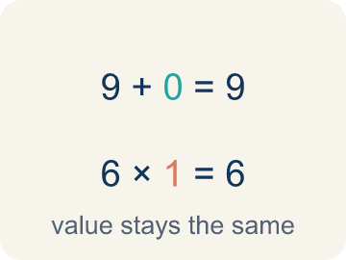 | Identity Property Propiedad de identidad  Adding 0 or multiplying by 1 keeps the same value.  Example: 9 + 0 = 9 (zero is the identity for addition); 6 × 1 = 6 (one is the identity for multiplication)
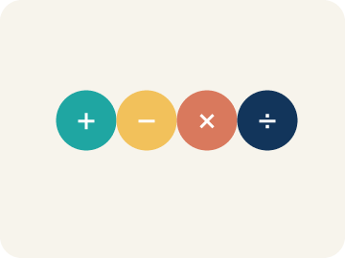 | Property Propiedad  A rule that is always true in math.  Example: Commutative works for + and ×, but NOT for − or ÷ (since 5 − 3 = 2 but 3 − 5 = −2)
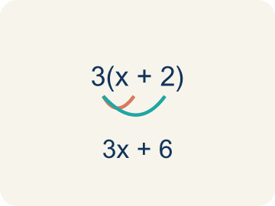 | Distributive Property Propiedad distributiva  Multiplying a number by everything inside the parentheses: a(b + c) = ab + ac.  Example: 5(7 + 2) = 5 × 7 + 5 × 2 = 35 + 10 = 45; and 5 × 9 = 45 — same answer either way

Guided Notes
Fill in each blank as we go. Use the Word Bank to help you.
WORD BANK
Properties of Operations • Commutative Property • Associative Property • Identity Property • Property • Distributive Property

1. Rules that let you reorder or regroup without changing the ________________.
2. The rule that order does not change a sum or product, like a + b = b + a, is the ________________.
3. The rule that grouping does not change a sum or product, like (a + b) + c = a + (b + c), is the ________________.
4. The rule that adding 0 or multiplying by 1 keeps a number the same is the ________________.
5. A rule that is always true in math is a ________________.
6. The rule that lets you multiply a number across a sum, like a(b + c) = a × b + a × c, is the ________________.

Write About the Math
Use the support level you need. Every level answers the same math question.

1. Understand the Question explain
What properties did the engineer use, and why does rearranging make the calculation easier?
Your job: Answer the question. Use math evidence. Explain how the evidence proves your answer.
Responde la pregunta. Usa evidencia matemática. Explica cómo la evidencia demuestra tu respuesta.

2. Plan Your Math Words check at least two
☐ Properties of Operations — Rules that let you reorder or regroup numbers without changing an expression's value.
Propiedades de las operaciones — Reglas que permiten reordenar o reagrupar números sin cambiar el valor de una expresión.
☐ Commutative Property — You can change the order and get the same answer.
Propiedad conmutativa — Puedes cambiar el orden y obtener la misma respuesta.
☐ Associative Property — You can change the grouping and get the same answer.
Propiedad asociativa — Puedes cambiar la agrupación y obtener la misma respuesta.
☐ Identity Property — Adding 0 or multiplying by 1 keeps the same value.
Propiedad de identidad — Sumar 0 o multiplicar por 1 mantiene el mismo valor.
☐ Property — A rule that is always true in math.
Propiedad — Una regla que siempre es verdadera en matemáticas.
Say it first: Say your idea to a partner or quietly to yourself before you write.
The engineer used the ___ property to change the ___ and the ___ property to change the ___. This makes it easier because 4 × 25 = ___, which is a friendly number to multiply by.
Di tu respuesta primero: Mi respuesta es ___ porque ___.

3. Build Your Explanation choose your support
This model shows the parts of an explanation. It does not answer your writing question.
Claim: The commutative property lets you change the order of a sum without changing the total.
Evidence: Students name the commutative property and explain that 3 + 5 + 2 gives 10 in any order because reordering addends does not change the sum.
Reasoning: This evidence connects the definition of properties of operations to the mathematical claim.

Start Most language support
Complete the frames. Use the word bank.
Completa las oraciones. Usa el banco de palabras.
The engineer used the ___ property to change the ___ and the ___ property to change the ___. This makes it easier because 4 × 25 = ___, which is a friendly number to multiply by.
My answer is ___.
Mi respuesta es ___.

Build Some language support
Write two connected sentences. Use because, so, or but.
Escribe dos oraciones conectadas. Usa porque, entonces o pero.
My claim is ___.
Mi afirmación es ___.
I know because ___.
Lo sé porque ___.
So ___.
Entonces ___.

Explain Light language support
Write a claim, give math evidence, and explain your reasoning.
Escribe una afirmación, da evidencia matemática y explica tu razonamiento.
My claim is ___.
Mi afirmación es ___.
My math evidence is ___.
Mi evidencia matemática es ___.
This proves ___ because ___.
Esto demuestra ___ porque ___.

4. Check Your Explanation five quick checks
☐ I answered the question.
Respondí la pregunta.
☐ I used math evidence: numbers, an equation, a model, or a comparison.
Usé evidencia matemática: números, una ecuación, un modelo o una comparación.
☐ I explained how the evidence proves my answer.
Expliqué cómo la evidencia demuestra mi respuesta.
☐ I used at least two math words.
Usé por lo menos dos palabras matemáticas.
☐ I reread complete sentences and punctuation.
Volví a leer mis oraciones completas y la puntuación.

Worked Example

Watch & Read I Do — follow along with your teacher
Band Formation
You're a band director arranging musicians on stage. You have 3 guitarists, 5 drummers, and 2 keyboard players. Whether you seat the guitarists first or the drummers first, you still have 3 + 5 + 2 = 10 musicians. The order you arrange them doesn't change the total!

Think about:
• Does the order you add the musicians change the total?
• What if you group different sections together first — does the total change?
• What happens when you add 0 musicians to a group?
• Do these same rules work for subtraction or division?
• Can rearranging terms help make mental math easier?

Solved Example I Do — watch each step
Problem: Which property is shown? 5 + 13 = 13 + 5
A) Commutative Property
B) Associative Property
C) Identity Property
D) Distributive Property
Step 1: The order of the addends changed, so this is the Commutative Property of Addition.
Answer: A. Commutative Property

Exit Ticket
Answer on your own. This shows what you learned today.
★ Which property is shown? (8 + 5) + 2 = 8 + (5 + 2)
A) Associative Property
B) Commutative Property
C) Identity Property
D) Distributive Property

Answer Key & Teacher Guide
Teacher reference — remove or fold back before distributing to students.

Guided Notes (Fill-in)
Notes 1: Properties of Operations
Notes 2: Commutative Property
Notes 3: Associative Property
Notes 4: Identity Property
Notes 5: Property
Notes 6: Distributive Property

Worked Notes (I Do / We Do)
I Do: A. Commutative Property
We Do: A. Associative Property

Independent Practice
Watch for this mistake: A common mistake in Properties of Operations is applying the commutative property where it does not belong, or confusing it with the associative property. Students often assume 15 − 8 = 8 − 15 (it does not: 7 ≠ −7 — commutative only works for addition and multiplication), or they see parentheses move and call it "associative" even when the numbers inside just swapped places, like (2 + 3) + 4 = (3 + 2) + 4 (that is commutative — the order inside the parentheses changed, not the grouping). Before you label a property, ask: did only the order change (commutative), did only the grouping change (associative), or was a 0 or 1 involved (identity)?

Level 1 Support
1. A) Identity Property — Adding 0 does not change the value, so this is the Identity Property of Addition.
2. A) Commutative Property — Changing the order of factors is the Commutative Property of Multiplication.

Exit Ticket
A) Associative Property — The grouping (parentheses) changed but the numbers stayed in the same order, so this is the Associative Property of Addition.

Math Writing Criteria
The support level changes the amount of language scaffolding, not the mathematical expectation.
☐ I answered the question.
☐ I used math evidence: numbers, an equation, a model, or a comparison.
☐ I explained how the evidence proves my answer.
☐ I used at least two math words.
☐ I reread complete sentences and punctuation.

