UNIT 6 · LESSON 9 STANDARD 6.NOS.1

Divide Whole Numbers by Fractions
Student Notes Packet
Name: ______________________ Date: ____________ Period: ________
Level 1 · Support

Today's Goals
Content: I can divide a whole number by a fraction by multiplying by the reciprocal.
Language: I can explain my steps using the words fraction, reciprocal, quotient, and Keep, Change, Flip.

Key Vocabulary
Look at the picture, read the word, then read what it means.
 | Divide Whole Numbers by Fractions Dividir números enteros entre fracciones  Find how many fractional groups fit in a whole number by multiplying by the reciprocal.  Example: 4 ÷ 1/2 = 4 × 2 = 8
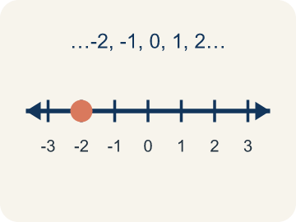 | Whole Number Número entero  A counting number with no fraction or decimal, like 0, 1, 2, 3.  Example: 4 is a whole number; as a fraction it is 4/1
 | Fraction Fracción  A number that shows part of a whole, like 3/4.  Example: 1/2 means 1 out of 2 equal parts — like cutting a sandwich in half and taking one piece
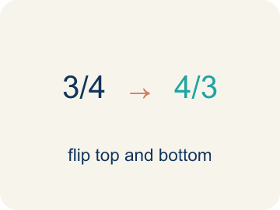 | Reciprocal Recíproco  A fraction turned upside down.  Example: The reciprocal of 2/3 is 3/2. Flip the fraction to divide: 6 ÷ 2/3 = 6 × 3/2
 | Keep, Change, Flip Mantener, cambiar, invertir  A way to divide fractions: keep the first, change ÷ to ×, flip the second.  Example: 6 ÷ 1/3 → Keep 6, Change ÷ to ×, Flip 1/3 to 3/1 → 6 × 3 = 18
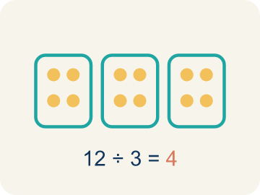 | Quotient Cociente  The answer when you divide.  Example: In 4 ÷ 1/2 = 8, the quotient is 8

Guided Notes
Fill in each blank as we go. Use the Word Bank to help you.
WORD BANK
Divide Whole Numbers by Fractions • Whole Number • Fraction • Reciprocal • Keep, Change, Flip • Quotient

1. Multiply the whole number by the ________________ of the fraction.
2. A counting number like 0, 1, 2, or 3 with no fraction or decimal part is a ________________.
3. A number that shows part of a whole, like 3/4, is a ________________.
4. The fraction you get by flipping a fraction upside down is its ________________.
5. To divide by a fraction, I ________________: keep the first number, change ÷ to ×, and flip the second fraction.
6. The answer to a division problem is the ________________.

Write About the Math
Use the support level you need. Every level answers the same math question.

1. Understand the Question explain
How does dividing a whole number by a fraction help the detective?
Your job: Answer the question. Use math evidence. Explain how the evidence proves your answer.
Responde la pregunta. Usa evidencia matemática. Explica cómo la evidencia demuestra tu respuesta.

2. Plan Your Math Words check at least two
☐ Divide Whole Numbers by Fractions — Find how many fractional groups fit in a whole number by multiplying by the reciprocal.
Dividir números enteros entre fracciones — Hallar cuántos grupos fraccionarios caben en un número entero multiplicando por el recíproco.
☐ Whole Number — A counting number with no fraction or decimal, like 0, 1, 2, 3.
Número entero — Un número de contar sin fracción ni decimal, como 0, 1, 2, 3.
☐ Fraction — A number that shows part of a whole, like 3/4.
Fracción — Un número que muestra una parte de un todo, como 3/4.
☐ Reciprocal — A fraction turned upside down.
Recíproco — Una fracción volteada de arriba abajo.
☐ Keep, Change, Flip — A way to divide fractions: keep the first, change ÷ to ×, flip the second.
Mantener, cambiar, invertir — Una manera de dividir fracciones: deja la primera, cambia ÷ por ×, voltea la segunda.
Say it first: Say your idea to a partner or quietly to yourself before you write.
The detective can set up ___ markers because 10 ÷ 1/4 = ___.
Di tu respuesta primero: Mi respuesta es ___ porque ___.

3. Build Your Explanation choose your support
This model shows the parts of an explanation. It does not answer your writing question.
Claim: Each whole pound makes 2 half-pound bags, so 4 pounds makes 8 bags.
Evidence: Students see that 4 ÷ 1/2 = 8 and explain there are 2 halves in each whole pound.
Reasoning: This evidence connects the definition of divide whole numbers by fractions to the mathematical claim.

Start Most language support
Complete the frames. Use the word bank.
Completa las oraciones. Usa el banco de palabras.
The detective can set up ___ markers because 10 ÷ 1/4 = ___.
My answer is ___.
Mi respuesta es ___.

Build Some language support
Write two connected sentences. Use because, so, or but.
Escribe dos oraciones conectadas. Usa porque, entonces o pero.
My claim is ___.
Mi afirmación es ___.
I know because ___.
Lo sé porque ___.
So ___.
Entonces ___.

Explain Light language support
Write a claim, give math evidence, and explain your reasoning.
Escribe una afirmación, da evidencia matemática y explica tu razonamiento.
My claim is ___.
Mi afirmación es ___.
My math evidence is ___.
Mi evidencia matemática es ___.
This proves ___ because ___.
Esto demuestra ___ porque ___.

4. Check Your Explanation five quick checks
☐ I answered the question.
Respondí la pregunta.
☐ I used math evidence: numbers, an equation, a model, or a comparison.
Usé evidencia matemática: números, una ecuación, un modelo o una comparación.
☐ I explained how the evidence proves my answer.
Expliqué cómo la evidencia demuestra mi respuesta.
☐ I used at least two math words.
Usé por lo menos dos palabras matemáticas.
☐ I reread complete sentences and punctuation.
Volví a leer mis oraciones completas y la puntuación.

Worked Example

Watch & Read I Do — follow along with your teacher
Detective Agency Case File
Agent Park has 4 pounds of evidence powder. Each testing bag holds exactly 1/2 pound. He needs to prepare as many testing bags as possible before the lab deadline. How many bags can he fill?

Think about:
• How much total powder does Agent Park have?
• How much goes into each bag?
• Will the number of bags be more or less than 4?
• Why does dividing by 1/2 give a number larger than 4?
• How is dividing by a fraction related to multiplying?

Solved Example I Do — watch each step
Problem: What is 6 ÷ 1/3?
A) 18
B) 2
C) 6/3
D) 3
Step 1: 6 ÷ 1/3 = 6 × 3/1 = 18.
Step 2: There are 18 thirds in 6 wholes.
Answer: A. 18

Guided Practice

Solve Together We Do — work with your class
Problem: What is 3 ÷ 1/5?
A) 15
B) 3/5
C) 5/3
D) 8
Step 1:

Step 2:

Answer:

A detective has 10 feet of rope to section off a crime scene. Each section needs to be 1/4 of a foot long for detailed evidence markers. How many markers can the detective set up?
How does dividing a whole number by a fraction help the detective?

Sentence frame: The detective can set up ___ markers because 10 ÷ 1/4 = ___.

Turn & Talk discuss with a partner
1. [Launch] Agent Park has 4 pounds of evidence powder and fills bags that hold 1/2 pound each. How many bags can he fill, and how do you know?
Start with: 1/2 pound fits into 4 pounds a total of ___ times.
1/2 libra cabe en 4 libras un total de ___ veces.
Word bank: whole number, fraction, quotient
2. [Explore] How does 'Keep, Change, Flip' turn 6 ÷ 1/3 into a multiplication problem?
Start with: I keep ___, change the sign to ___, and flip ___ to ___.
Mantengo ___, cambio el signo a ___, y volteo ___ a ___.
Word bank: reciprocal, Keep, Change, Flip, quotient
3. [Connect] When would dividing a whole number by a fraction help you in real life?
Start with: Dividing a whole number by a fraction is useful when ___.
Dividir un número entero entre una fracción es útil cuando ___.
Word bank: whole number, fraction, reciprocal
4. [Practice] During practice on Divide Whole Numbers by Fractions, what strategy did you use when a problem felt tricky?
Start with: I keep ___, change the sign to ___, and flip ___ to ___.
Mantengo ___, cambio el signo a ___, y volteo ___ a ___.
Word bank: Whole Number, Fraction, Reciprocal, Keep, Change, Flip

Independent Practice

On Your Own You Do — show your work
Solve each problem. Show your thinking in the work box.

Level 1 Support extra scaffolding
1. What is 10 ÷ 1/4?
A) 40
B) 2.5
C) 14
D) 10/4

2. What is 5 ÷ 1/2?
A) 10
B) 5/2
C) 2.5
D) 7

Exit Ticket
Answer on your own. This shows what you learned today.
★ What is 9 ÷ 1/3?
A) 27
B) 3
C) 9/3
D) 1/27

