UNIT 7 · LESSON 1 STANDARD 6.NOS.6

Explore Integers and Their Opposites
Student Notes Packet
Name: ______________________ Date: ____________ Period: ________
Level 3 · Enrichment

Today's Goals
Content: I can use integers to represent quantities in everyday life, explain what 0 means in each situation, and name the opposite of an integer on the number line.
Language: I can explain my reasoning using the words integer, opposite, negative, positive, and number line.

Key Vocabulary
Look at the picture, read the word, then read what it means.
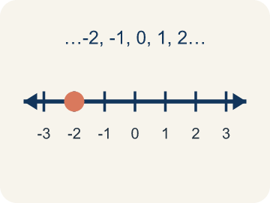 | Integer Número entero  The counting numbers, their opposites, and 0.  Example: ..., -3, -2, -1, 0, 1, 2, 3, ...
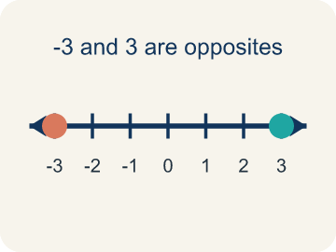 | Opposite Opuesto  A number that is the same distance from 0 as another number, but on the other side of 0.  Example: 86 and -86 are both 86 units from 0, on opposite sides
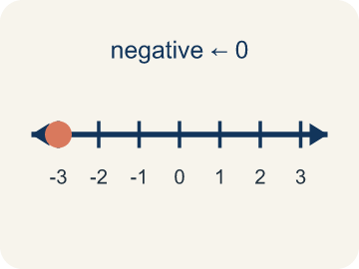 | Negative number Número negativo  A number less than 0, written with a − sign. On a number line it sits to the left of 0.  Example: -86 meters means 86 meters BELOW sea level
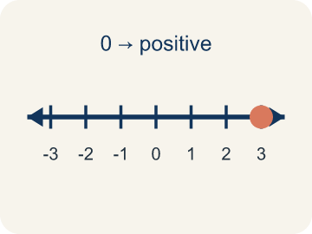 | Positive number Número positivo  A number greater than 0. On a number line it sits to the right of 0.  Example: 9°C is 9 degrees ABOVE zero
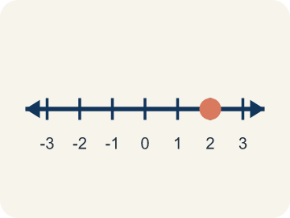 | Number line Recta numérica  A straight line where numbers are placed in order. It extends to the left of 0 to show values less than 0.  Example: -3, -2, -1, 0, 1, 2, 3 marked in order from left to right

Guided Notes
Fill in each blank as we go. Use the Word Bank to help you.
WORD BANK
Integer • Opposite • Negative number • Positive number • Number line

1. A counting number, its opposite, or 0 is an ________________.
2. A number the same distance from 0 but on the other side is the ________________.
3. A number less than 0, written with a − sign, is a ________________.
4. A number greater than 0 is a ________________.
5. A line with numbers placed in order is a ________________.

Write About the Math
Use the support level you need. Every level answers the same math question.

1. Understand the Question explain
Write each play as an integer, then decide: did the team make a first down, and how far are they from the line of scrimmage?
Your job: Answer the question. Use math evidence. Explain how the evidence proves your answer.
Responde la pregunta. Usa evidencia matemática. Explica cómo la evidencia demuestra tu respuesta.

2. Plan Your Math Words check at least two
☐ Integer — The counting numbers, their opposites, and 0.
Número entero — Los números para contar, sus opuestos y el 0.
☐ Opposite — A number that is the same distance from 0 as another number, but on the other side of 0.
Opuesto — Un número que está a la misma distancia de 0 que otro número, pero del otro lado del 0.
☐ Negative number — A number less than 0, written with a − sign. On a number line it sits to the left of 0.
Número negativo — Un número menor que 0, escrito con un signo −. En la recta numérica queda a la izquierda del 0.
☐ Positive number — A number greater than 0. On a number line it sits to the right of 0.
Número positivo — Un número mayor que 0. En la recta numérica queda a la derecha del 0.
☐ Number line — A straight line where numbers are placed in order. It extends to the left of 0 to show values less than 0.
Recta numérica — Una recta donde los números se colocan en orden. Se extiende a la izquierda del 0 para mostrar valores menores que 0.
Say it first: Say your idea to a partner or quietly to yourself before you write.
The 10-yard loss is the integer ___ and the 3-yard loss is the integer ___. Combining all four plays leaves the team ___ yards from where they started, which is ___ the line of scrimmage. Because they needed at least 10 yards, the team ___ make a first down.
Di tu respuesta primero: Mi respuesta es ___ porque ___.

3. Build Your Explanation choose your support
This model shows the parts of an explanation. It does not answer your writing question.
Claim: In this situation 0 means ___ because ___.
Evidence: Student explains 0 is a chosen reference point (sea level), so values above it are positive and values below it are negative.
Reasoning: This evidence connects the definition of integer to the mathematical claim.

Start Most language support
Complete the frames. Use the word bank.
Completa las oraciones. Usa el banco de palabras.
The 10-yard loss is the integer ___ and the 3-yard loss is the integer ___. Combining all four plays leaves the team ___ yards from where they started, which is ___ the line of scrimmage. Because they needed at least 10 yards, the team ___ make a first down.
My answer is ___.
Mi respuesta es ___.

Build Some language support
Write two connected sentences. Use because, so, or but.
Escribe dos oraciones conectadas. Usa porque, entonces o pero.
My claim is ___.
Mi afirmación es ___.
I know because ___.
Lo sé porque ___.
So ___.
Entonces ___.

Explain Light language support
Write a claim, give math evidence, and explain your reasoning.
Escribe una afirmación, da evidencia matemática y explica tu razonamiento.
My claim is ___.
Mi afirmación es ___.
My math evidence is ___.
Mi evidencia matemática es ___.
This proves ___ because ___.
Esto demuestra ___ porque ___.

4. Check Your Explanation five quick checks
☐ I answered the question.
Respondí la pregunta.
☐ I used math evidence: numbers, an equation, a model, or a comparison.
Usé evidencia matemática: números, una ecuación, un modelo o una comparación.
☐ I explained how the evidence proves my answer.
Expliqué cómo la evidencia demuestra mi respuesta.
☐ I used at least two math words.
Usé por lo menos dos palabras matemáticas.
☐ I reread complete sentences and punctuation.
Volví a leer mis oraciones completas y la puntuación.

Worked Example

Watch & Read I Do — follow along with your teacher
Below Sea Level
The lowest elevation in North America is Badwater Basin in Death Valley: 86 meters below sea level. When we measure elevation, sea level is defined as 0. So 86 meters below sea level cannot be written as plain 86 — that would put it ABOVE the water. Numbers less than zero are negative numbers, written with a − sign, so the elevation of Badwater Basin is −86 meters. On a number line, −86 is 86 units to the LEFT of 0, while 86 is 86 units to the RIGHT of 0. Those two numbers are opposites.

Think about:
• Why does 0 represent sea level rather than 'nothing'?
• Will Badwater Basin be above or below 0 on a number line?
• Where have you heard the phrase 'below zero' before?
• What number is exactly as far above sea level as Badwater Basin is below it?
• Is 0 positive, negative, or neither?

Solved Example I Do — watch each step
Problem: Badwater Basin is 86 meters below sea level, and sea level is 0. Which integer represents that elevation?
A) -86
B) 86
C) 0
D) -68
Step 1: Below sea level means less than 0, so the elevation is written with a negative sign: -86 meters.
Answer: A. -86

Independent Practice

On Your Own You Do — show your work
Solve each problem. Show your thinking in the work box.

Level 2 Enrichment stretch your thinking
1. At 6 a.m. in Reykjavik the temperature was -12°C. At 2 p.m. it was the opposite of the 6 a.m. temperature, and at 11 p.m. it was the opposite of the 2 p.m. temperature. What were the temperatures at 2 p.m. and 11 p.m.?
A) 12°C and -12°C
B) -12°C and 12°C
C) 12°C and 24°C
D) 0°C and 12°C

2. A football team starts at the line of scrimmage, which is 0. During one series they had a 10-yard loss, a 4-yard gain, a 3-yard loss, and a 21-yard gain. Where does the series leave them?
A) 12 yards past the line of scrimmage
B) 8 yards past the line of scrimmage
C) 18 yards past the line of scrimmage
D) 38 yards past the line of scrimmage

Exit Ticket
Answer on your own. This shows what you learned today.
★ Which situation is best represented by the integer -15?
A) A diver 15 meters below the surface of the water
B) A hill 15 meters above sea level
C) A deposit of $15 into a bank account
D) A football play with a 15-yard gain

Answer Key & Teacher Guide
Teacher reference — remove or fold back before distributing to students.

Guided Notes (Fill-in)
Notes 1: Integer
Notes 2: Opposite
Notes 3: Negative number
Notes 4: Positive number
Notes 5: Number line

Worked Notes (I Do / We Do)
I Do: A. -86
We Do: A. 9

Independent Practice
Watch for this mistake: The most common mistake in this lesson is thinking that the opposite of a negative integer is still negative — for example, saying the opposite of -7 is -7, or that the opposite of -12 is -24. Opposites are the same DISTANCE from 0 but on OPPOSITE sides of 0, so taking an opposite always changes the direction and never changes the distance: the opposite of -7 is 7 and the opposite of -12 is 12. The one exception is 0, which is 0 units from itself and is therefore its own opposite. Before you submit, count the units from 0 and check that your answer is on the other side.

Level 1 Support
1. A) 0 — Zero is 0 units from itself, so there is no other side to move to. Zero is its own opposite.

On Level
2. A) -8, -3, 0, 5 — Least to greatest reads left to right on the number line: -8, then -3, then 0, then 5.
3. A) -120 meters — Farther below sea level means farther to the left of 0. -120 is 120 units below 0, which is deeper than 86 units below 0.
4. A) 0 is an integer, and it is its own opposite — Integers are the counting numbers, their opposites, and 0. Zero is 0 units from itself, so it is its own opposite.

Level 2 Enrichment
5. A) 12°C and -12°C — The opposite of -12 is 12, so 2 p.m. was 12°C. The opposite of 12 is -12, so 11 p.m. was back to -12°C.
6. A) 12 yards past the line of scrimmage — Write each play as an integer: -10, 4, -3, 21. Combining them gives -10 + 4 - 3 + 21 = 12, so the team ends 12 yards past the line of scrimmage.

Exit Ticket
A) A diver 15 meters below the surface of the water — A negative integer represents a quantity below the chosen 0. With the water surface as 0, a diver 15 meters below it is -15.

Math Writing Criteria
The support level changes the amount of language scaffolding, not the mathematical expectation.
☐ I answered the question.
☐ I used math evidence: numbers, an equation, a model, or a comparison.
☐ I explained how the evidence proves my answer.
☐ I used at least two math words.
☐ I reread complete sentences and punctuation.

