UNIT 7 · LESSON 2 STANDARD 6.NOS.6

Represent Rational Numbers and Their Opposites on the Number Line
Student Notes Packet
Name: ______________________ Date: ____________ Period: ________
Level 3 · Enrichment

Today's Goals
Content: I can place rational numbers, including fractions and decimals, on a number line.
Language: I can explain my reasoning using the words rational number, fraction, decimal, and number line.

Key Vocabulary
Look at the picture, read the word, then read what it means.
 | Rational Numbers on the Number Line Números racionales en la recta numérica  Fractions, decimals, and integers placed by value on a number line.  Example: −1/2 and −0.5 name the same point.
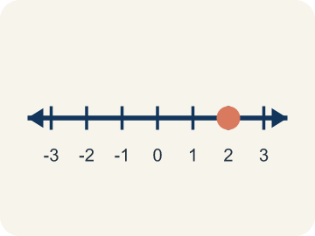 | Rational number Número racional  Any number you can write as a fraction. This includes fractions, decimals, and integers.  Example: 1/2 = 0.5, -3/4 = -0.75, 6 = 6/1 — all rational numbers
 | Fraction Fracción  A number that shows part of a whole, like 3/4.  Example: 3/4 means 3 out of 4 equal parts — like 3 slices of a pizza cut into 4
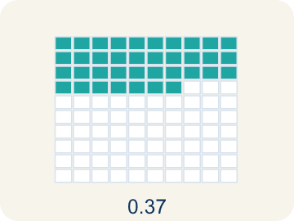 | Decimal Decimal  A number with a dot, like 0.5, that shows a part less than one.  Example: 0.5 = 1/2 (halfway between 0 and 1 on the number line)
 | Number line Recta numérica  A straight line where numbers are placed in order; numbers get smaller to the left and larger to the right.  Example: A line with marks at -2, -1.5, -1, -0.5, 0, 0.5, 1, 1.5, 2
 | Equivalent Equivalente  Having the same value, just written a different way.  Example: 1/2 = 0.5 = 2/4 — all name the same point on the number line
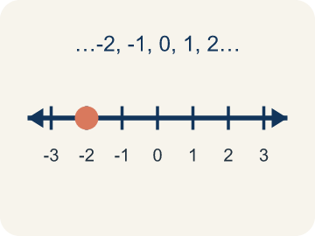 | Integer Número entero  Whole numbers and their opposites, like -2, -1, 0, 1, 2.  Example: ..., -3, -2, -1, 0, 1, 2, 3, ...

Guided Notes
Fill in each blank as we go. Use the Word Bank to help you.
WORD BANK
Rational Numbers on the Number Line • Rational number • Fraction • Decimal • Number line • Equivalent • Integer

1. Fractions, decimals and integers placed by value sit on the ________________ ________________.
2. Any number that can be written as a fraction, including integers and decimals, is a ________________.
3. A number that shows part of a whole, like 3/5, is a ________________.
4. A number that uses a point to show parts of a whole is a ________________.
5. A line with numbers in order used to place and compare values is a ________________.
6. Numbers that name the same value, like 1/2 and 0.5, are ________________.
7. A whole number or its opposite is an ________________.

Write About the Math
Use the support level you need. Every level answers the same math question.

1. Understand the Question explain
Put the four readings in order from lowest water to highest. How do the decimals let the keeper say something a whole number could not?
Your job: Answer the question. Use math evidence. Explain how the evidence proves your answer.
Responde la pregunta. Usa evidencia matemática. Explica cómo la evidencia demuestra tu respuesta.

2. Plan Your Math Words check at least two
☐ Rational Numbers on the Number Line — Fractions, decimals, and integers placed by value on a number line.
Números racionales en la recta numérica — Fracciones, decimales y enteros ubicados según su valor en una recta numérica.
☐ Rational number — Any number you can write as a fraction. This includes fractions, decimals, and integers.
Número racional — Cualquier número que puedes escribir como fracción. Incluye fracciones, decimales y enteros.
☐ Fraction — A number that shows part of a whole, like 3/4.
Fracción — Un número que muestra una parte de un todo, como 3/4.
☐ Decimal — A number with a dot, like 0.5, that shows a part less than one.
Decimal — Un número con un punto, como 0.5, que muestra una parte menor que uno.
☐ Number line — A straight line where numbers are placed in order; numbers get smaller to the left and larger to the right.
Recta numérica — Una recta donde los números se colocan en orden; los números son menores a la izquierda y mayores a la derecha.
Say it first: Say your idea to a partner or quietly to yourself before you write.
The lowest reading was ___ and the highest was ___. Tuesday's ___ ft means the water sat 1¼ feet ___ the mark, which is between −1 and ___ on the number line.
Di tu respuesta primero: Mi respuesta es ___ porque ___.

3. Build Your Explanation choose your support
This model shows the parts of an explanation. It does not answer your writing question.
Claim: All of these are rational numbers because each one can be ___.
Evidence: Student explains a rational number is any number that can be written as a fraction, including integers and decimals.
Reasoning: This evidence connects the definition of rational number to the mathematical claim.

Start Most language support
Complete the frames. Use the word bank.
Completa las oraciones. Usa el banco de palabras.
The lowest reading was ___ and the highest was ___. Tuesday's ___ ft means the water sat 1¼ feet ___ the mark, which is between −1 and ___ on the number line.
My answer is ___.
Mi respuesta es ___.

Build Some language support
Write two connected sentences. Use because, so, or but.
Escribe dos oraciones conectadas. Usa porque, entonces o pero.
My claim is ___.
Mi afirmación es ___.
I know because ___.
Lo sé porque ___.
So ___.
Entonces ___.

Explain Light language support
Write a claim, give math evidence, and explain your reasoning.
Escribe una afirmación, da evidencia matemática y explica tu razonamiento.
My claim is ___.
Mi afirmación es ___.
My math evidence is ___.
Mi evidencia matemática es ___.
This proves ___ because ___.
Esto demuestra ___ porque ___.

4. Check Your Explanation five quick checks
☐ I answered the question.
Respondí la pregunta.
☐ I used math evidence: numbers, an equation, a model, or a comparison.
Usé evidencia matemática: números, una ecuación, un modelo o una comparación.
☐ I explained how the evidence proves my answer.
Expliqué cómo la evidencia demuestra mi respuesta.
☐ I used at least two math words.
Usé por lo menos dos palabras matemáticas.
☐ I reread complete sentences and punctuation.
Volví a leer mis oraciones completas y la puntuación.

Worked Example

Watch & Read I Do — follow along with your teacher
Precise Treasure Coordinates
Captain Vega's advanced treasure map uses precise coordinates — not just whole numbers! One clue says the treasure is at -2.5 on the map (halfway between -2 and -3). Another clue points to 3/4 of the way from 0 to 1. A third clue leads to -1 1/2. To find each treasure, you must plot these exact rational numbers on the number line.

Think about:
• Where would -2.5 fall on a number line between -3 and -2?
• How is plotting 3/4 different from plotting a whole number?
• Can a negative number be a fraction or decimal?
• How many rational numbers exist between any two integers?
• Are there numbers that are NOT rational?

Solved Example I Do — watch each step
Problem: Which point is located between -1 and -2 on the number line?
A) -0.5
B) -1.5
C) -2.5
D) 1.5
Step 1: -1.5 is between -1 and -2 because it is 0.5 units to the left of -1 (or 0.5 units to the right of -2).
Answer: B. -1.5

Independent Practice

On Your Own You Do — show your work
Solve each problem. Show your thinking in the work box.

Level 2 Enrichment stretch your thinking
1. On a number line, point P is located at -2.5. Which statement describes its location best?
A) At -2
B) Halfway between -2 and -3
C) Halfway between 2 and 3
D) At -3

2. Which list of numbers is ordered from LEAST to GREATEST?
A) 3, 0, -2, -5
B) -2, -5, 0, 3
C) -5, -2, 0, 3
D) 0, -2, 3, -5

Exit Ticket
Answer on your own. This shows what you learned today.
★ Which rational number is located between -2 and -3 on the number line?
A) -1.5
B) -2.75
C) -3.5
D) 2.5

