7.1–7.3 Catch-Up — Homework
Lesson 7-3-catchup • Standard 6.NOS.8
Name: ______________________ Period: ______ Date: ____________

Today's Goals
Content: I can show I am caught up on Lessons 7.1–7.3 by using each lesson's big idea in mixed practice.
Language: I can explain which lesson's big idea I used and how, using key vocabulary from Lessons 7.1–7.3.

Key Words
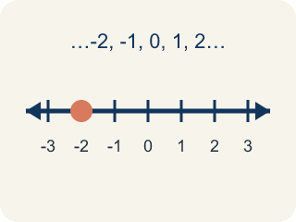
Integer (Número entero) — The counting numbers, their opposites, and 0.
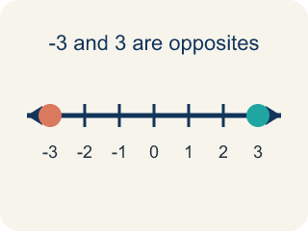
Opposite (Opuesto) — A number that is the same distance from 0 as another number, but on the other side of 0.
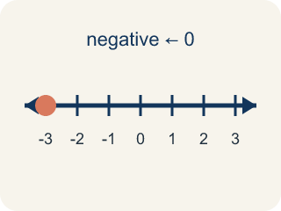
Negative number (Número negativo) — A number less than 0, written with a − sign. On a number line it sits to the left of 0.
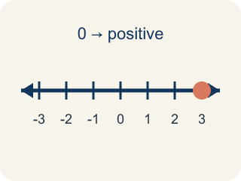
Positive number (Número positivo) — A number greater than 0. On a number line it sits to the right of 0.
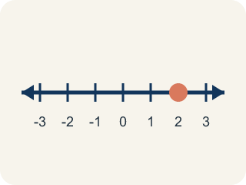
Number line (Recta numérica) — A straight line where numbers are placed in order. It extends to the left of 0 to show values less than 0.
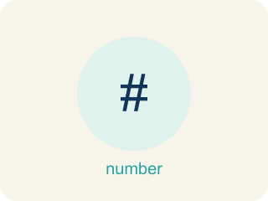
Rational Numbers on the Number Line (Números racionales en la recta numérica) — Every rational number has one exact spot on the number line. Writing it as a fraction, a decimal, or an integer does not change where it sits.

Rational number (Número racional) — A number that can be written as a fraction of two integers, with a bottom number that is not zero.
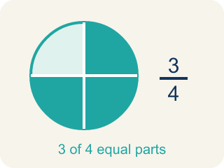
Fraction (Fracción) — A number that shows part of a whole, like 3/4.

Integers and Absolute Value (Enteros y valor absoluto) — Integers are whole numbers and their opposites; absolute value is their distance from zero.

Practice
Show your work. Use the blank space under each problem.
1. (Lesson 7.1) Badwater Basin is 86 meters below sea level, and sea level is 0. Which integer represents that elevation?
A. -86
B. 86
C. 0
D. -68
______________________________________________________________________
2. (Lesson 7.1) In Reykjavik the temperature was -9°C. What is the opposite of -9?
A. 9
B. -9
C. 0
D. -18
______________________________________________________________________
3. (Lesson 7.1) Which list of integers is ordered from LEAST to GREATEST?
A. -8, -3, 0, 5
B. -3, -8, 0, 5
C. 0, -3, -8, 5
D. 5, 0, -3, -8
______________________________________________________________________
4. (Lesson 7.1) Badwater Basin is at -86 meters. Which elevation is FARTHER below sea level than Badwater Basin?
A. -120 meters
B. -40 meters
C. 0 meters
D. 86 meters
______________________________________________________________________
5. (Lesson 7.2) Which rational number is closest to 0 on the number line?
A. -1/4
B. 0.5
C. -2
D. 1.75
______________________________________________________________________
6. (Lesson 7.2) Spot the Mistake: Plotting -2.25
Step 1 (Problem): Plot -2.25 on the number line.
Step 2 (Student thinking): It is negative, so I go past -2. The .25 is one quarter, so I count toward 0 (to the right) by a quarter unit and land between -2 and -1.
Step 3 (Student answer): Point plotted at -1.75, between -2 and -1.
Which step has the mistake? Explain and fix it:
______________________________________________________________________
______________________________________________________________________
______________________________________________________________________
7. (Lesson 7.3) Which statement about absolute value is TRUE?
A. |-4| = |4| because both are 4 units from zero
B. |-4| = -4 because the number is negative
C. |4| > |-4| because positive is always bigger
D. |-4| = 0 because negatives cancel out
______________________________________________________________________
8. (Lesson 7.3) Confusing Opposite with Absolute Value
Step 1 (Problem): Complete the table for the integer 9: find its absolute value and its opposite.
Step 2 (Student's thinking): Absolute value and opposite both just make a number positive, so they should give the same answer as each other.
Step 3 (Student's answer): Absolute value of 9 = 9, and opposite of 9 = 9.
Which step has the mistake? Explain and fix it:
______________________________________________________________________
______________________________________________________________________
______________________________________________________________________
9. (Lesson 7.2) The first trail marker sits between 0 and 1. Which rational number belongs there?
A. 3/4
B. 1.5
C. -1/2
D. 2
______________________________________________________________________
10. (Lesson 7.3) On a frosty morning at the mountain cache, the thermometer reads -8 degrees. What is the absolute value of -8?
A. 8
B. -8
C. 0
D. 16
______________________________________________________________________

Answer Key (Teacher)
1. A. -86
Below sea level means less than 0, so the elevation is written with a negative sign: -86 meters.
Watch for: A common mistake in Integers and Absolute Value is judging size by the digits alone instead of position on the number line — students think -8 is 'more' than -3 because 8 > 3, when really -8 sits farther left (colder, deeper, or lower) and is actually the SMALLER integer. Absolute value measures distance from zero and is always positive or zero, but that distance does not decide which integer is greater — only left-to-right order on the number line does. Before you submit, ask: am I comparing distance from zero (absolute value) or position on the number line (greater/less than)?
2. A. 9
The opposite of a number is the same distance from 0 on the other side, so the opposite of -9 is 9.
Watch for: A common mistake in Integers and Absolute Value is judging size by the digits alone instead of position on the number line — students think -8 is 'more' than -3 because 8 > 3, when really -8 sits farther left (colder, deeper, or lower) and is actually the SMALLER integer. Absolute value measures distance from zero and is always positive or zero, but that distance does not decide which integer is greater — only left-to-right order on the number line does. Before you submit, ask: am I comparing distance from zero (absolute value) or position on the number line (greater/less than)?
3. A. -8, -3, 0, 5
Least to greatest reads left to right on the number line: -8, then -3, then 0, then 5.
Watch for: A common mistake in Integers and Absolute Value is judging size by the digits alone instead of position on the number line — students think -8 is 'more' than -3 because 8 > 3, when really -8 sits farther left (colder, deeper, or lower) and is actually the SMALLER integer. Absolute value measures distance from zero and is always positive or zero, but that distance does not decide which integer is greater — only left-to-right order on the number line does. Before you submit, ask: am I comparing distance from zero (absolute value) or position on the number line (greater/less than)?
4. A. -120 meters
Farther below sea level means farther to the left of 0. -120 is 120 units below 0, which is deeper than 86 units below 0.
Watch for: A common mistake in Integers and Absolute Value is judging size by the digits alone instead of position on the number line — students think -8 is 'more' than -3 because 8 > 3, when really -8 sits farther left (colder, deeper, or lower) and is actually the SMALLER integer. Absolute value measures distance from zero and is always positive or zero, but that distance does not decide which integer is greater — only left-to-right order on the number line does. Before you submit, ask: am I comparing distance from zero (absolute value) or position on the number line (greater/less than)?
5. A. -1/4
|-1/4| = 0.25, |0.5| = 0.5, |-2| = 2, |1.75| = 1.75. Since 0.25 is the smallest absolute value, -1/4 is closest to zero.
Watch for: A common mistake in Integers and Absolute Value is judging size by the digits alone instead of position on the number line — students think -8 is 'more' than -3 because 8 > 3, when really -8 sits farther left (colder, deeper, or lower) and is actually the SMALLER integer. Absolute value measures distance from zero and is always positive or zero, but that distance does not decide which integer is greater — only left-to-right order on the number line does. Before you submit, ask: am I comparing distance from zero (absolute value) or position on the number line (greater/less than)?
6. (Lesson 7.2) Spot the Mistake: Plotting -2.25
The mistake is in Step 2.
Correct work: Going more negative means moving LEFT, not right. -2.25 is between -2 and -3 (it is a quarter of a unit to the LEFT of -2), not between -2 and -1. I split the space from -2 to -3 into 4 equal parts and place the dot at the first mark past -2, at -2.25.
Watch for: The "Student thinking" step moves right from −2, back toward zero, which makes the number less negative instead of more. The extra .25 has to be added to the negative direction, so −2.25 sits a quarter of a unit to the left of −2, between −2 and −3. Splitting that space into 4 equal parts and marking the first one past −2 puts the dot in the right place.
7. A. |-4| = |4| because both are 4 units from zero
Absolute value measures distance from zero. Both -4 and 4 are 4 units from zero, so |-4| = |4| = 4.
Watch for: A common mistake in Integers and Absolute Value is judging size by the digits alone instead of position on the number line — students think -8 is 'more' than -3 because 8 > 3, when really -8 sits farther left (colder, deeper, or lower) and is actually the SMALLER integer. Absolute value measures distance from zero and is always positive or zero, but that distance does not decide which integer is greater — only left-to-right order on the number line does. Before you submit, ask: am I comparing distance from zero (absolute value) or position on the number line (greater/less than)?
8. (Lesson 7.3) Confusing Opposite with Absolute Value
The mistake is in Step 2.
Correct work: Absolute value and opposite are different operations. Absolute value measures distance from zero and is never negative: |9| = 9. Opposite reflects a number to the other side of zero, flipping its sign: the opposite of 9 is -9, not 9. The two operations only give the same result for the number 0 — every other number has a different absolute value and opposite.
Watch for: The student's thinking step treats absolute value and opposite as the same operation, but they are not. Absolute value gives the distance from zero, so |9| = 9, while the opposite reflects the number across zero, so the opposite of 9 is -9 — the two only agree for the number 0.
9. A. 3/4
3/4 = 0.75, which lands between 0 and 1. 1.5 and 2 are larger, and -1/2 is to the left of 0.
Watch for: A common mistake in Integers and Absolute Value is judging size by the digits alone instead of position on the number line — students think -8 is 'more' than -3 because 8 > 3, when really -8 sits farther left (colder, deeper, or lower) and is actually the SMALLER integer. Absolute value measures distance from zero and is always positive or zero, but that distance does not decide which integer is greater — only left-to-right order on the number line does. Before you submit, ask: am I comparing distance from zero (absolute value) or position on the number line (greater/less than)?
10. A. 8
Absolute value is the distance from zero, so |-8| = 8.
Watch for: A common mistake in Integers and Absolute Value is judging size by the digits alone instead of position on the number line — students think -8 is 'more' than -3 because 8 > 3, when really -8 sits farther left (colder, deeper, or lower) and is actually the SMALLER integer. Absolute value measures distance from zero and is always positive or zero, but that distance does not decide which integer is greater — only left-to-right order on the number line does. Before you submit, ask: am I comparing distance from zero (absolute value) or position on the number line (greater/less than)?

