UNIT 7 · LESSON 3 STANDARD 6.NOS.8

Understand Absolute Value of Rational Numbers
Student Notes Packet
Name: ______________________ Date: ____________ Period: ________
Level 2 · Standard

Today's Goals
Content: I can find the absolute value of a rational number — an integer, fraction, or decimal — as its distance from zero.
Language: I can explain absolute value using the words distance, zero, opposite, and rational number.

Key Vocabulary
Look at the picture, read the word, then read what it means.
 | Integers and Absolute Value Enteros y valor absoluto  Integers are whole numbers and their opposites; absolute value is their distance from zero.  Example: |−6| = 6 because −6 is 6 units from zero.
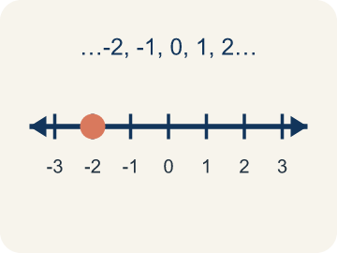 | Integer Número entero  Whole numbers and their opposites, like -2, -1, 0, 1, 2.  Example: ... -3, -2, -1, 0, 1, 2, 3 ... shown on a number line with 0 in the center
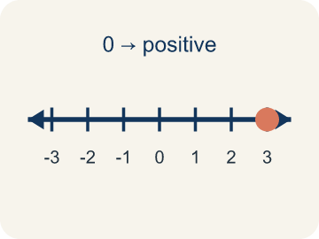 | Positive Positivo  A number bigger than zero, to the right of zero on a number line.  Example: +5 means 5 above zero, like 5 floors above ground level
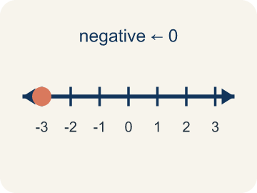 | Negative Negativo  A number smaller than zero, to the left of zero on a number line.  Example: -3 means 3 below zero, like 3 floors underground
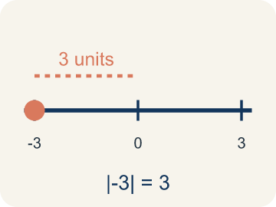 | Absolute value Valor absoluto  How far a number is from zero. It is never negative.  Example: |-5| = 5 and |5| = 5 — both are 5 units from 0
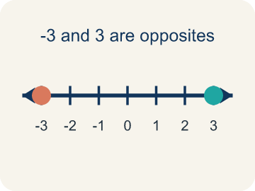 | Opposite Opuesto  Two numbers the same distance from zero, on opposite sides, like 3 and -3.  Example: 3 and -3 are opposites — both are 3 units from 0
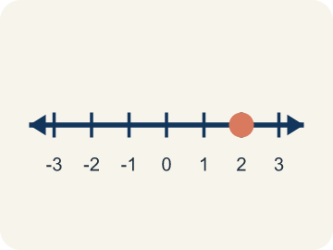 | Rational number Número racional  Any number that can be written as a fraction, including whole numbers, decimals, and negatives.  Example: −2.5, 3/4, and −4 are all rational numbers

Guided Notes
Fill in each blank as we go. Use the Word Bank to help you.
WORD BANK
Integers and Absolute Value • Integer • Positive • Negative • Absolute value • Opposite • Rational number

1. The distance of an integer from zero is its ________________ ________________.
2. A whole number or its opposite, like −2, 0, or 5, is an ________________.
3. A number greater than zero is ________________.
4. A number less than zero is ________________.
5. The distance of a number from zero, always positive, is its ________________.
6. Two numbers the same distance from zero but on different sides, like 4 and −4, are ________________.
7. Any number that can be written as a fraction is a ________________ ________________.

Write About the Math
Use the support level you need. Every level answers the same math question.

1. Understand the Question compare
How does absolute value help the rescue team compare the submarine and helicopter positions?
Your job: Answer the question. Use math evidence. Explain how the evidence proves your answer.
Responde la pregunta. Usa evidencia matemática. Explica cómo la evidencia demuestra tu respuesta.

2. Plan Your Math Words check at least two
☐ Integers and Absolute Value — Integers are whole numbers and their opposites; absolute value is their distance from zero.
Enteros y valor absoluto — Los enteros son números enteros y sus opuestos; el valor absoluto es su distancia desde cero.
☐ Integer — Whole numbers and their opposites, like -2, -1, 0, 1, 2.
Número entero — Un número entero que puede ser positivo, negativo o cero.
☐ Positive — A number bigger than zero, to the right of zero on a number line.
Positivo — Un número mayor que cero, a la derecha del cero en la recta numérica.
☐ Negative — A number smaller than zero, to the left of zero on a number line.
Negativo — Un número menor que cero, a la izquierda del cero en la recta numérica.
☐ Absolute value — How far a number is from zero. It is never negative.
Valor absoluto — Qué tan lejos está un número de cero. Nunca es negativo.
Say it first: Say your idea to a partner or quietly to yourself before you write.
The submarine is at ___ meters, and its absolute value is ___ because ___. The helicopter is at ___ meters, and its absolute value is ___. Absolute value helps the rescue team because ___.
Di tu respuesta primero: Mi respuesta es ___ porque ___.

3. Build Your Explanation choose your support
This model shows the parts of an explanation. It does not answer your writing question.
Claim: -5 and 5 are the same distance from zero because ___.
Evidence: Student says both are 5 units from zero (same absolute value) but are opposites because of their signs.
Reasoning: This evidence connects the definition of absolute value to the mathematical claim.

Start Most language support
Complete the frames. Use the word bank.
Completa las oraciones. Usa el banco de palabras.
The submarine is at ___ meters, and its absolute value is ___ because ___. The helicopter is at ___ meters, and its absolute value is ___. Absolute value helps the rescue team because ___.
My answer is ___.
Mi respuesta es ___.

Build Some language support
Write two connected sentences. Use because, so, or but.
Escribe dos oraciones conectadas. Usa porque, entonces o pero.
My claim is ___.
Mi afirmación es ___.
I know because ___.
Lo sé porque ___.
So ___.
Entonces ___.

Explain Light language support
Write a claim, give math evidence, and explain your reasoning.
Escribe una afirmación, da evidencia matemática y explica tu razonamiento.
My claim is ___.
Mi afirmación es ___.
My math evidence is ___.
Mi evidencia matemática es ___.
This proves ___ because ___.
Esto demuestra ___ porque ___.

4. Check Your Explanation five quick checks
☐ I answered the question.
Respondí la pregunta.
☐ I used math evidence: numbers, an equation, a model, or a comparison.
Usé evidencia matemática: números, una ecuación, un modelo o una comparación.
☐ I explained how the evidence proves my answer.
Expliqué cómo la evidencia demuestra mi respuesta.
☐ I used at least two math words.
Usé por lo menos dos palabras matemáticas.
☐ I reread complete sentences and punctuation.
Volví a leer mis oraciones completas y la puntuación.

Worked Example

Watch & Read I Do — follow along with your teacher
Treasure Map Elevation
Captain Vega's treasure map has clues hidden at different elevations! Some treasures are buried underground (below sea level) and some are on mountaintops (above sea level). Sea level is marked as 0. A treasure chest is at -4 (4 meters below sea level) and a lookout tower is at +6 (6 meters above sea level). How far is each from sea level?

Think about:
• What does the negative sign tell you about the treasure chest's location?
• Which location is farther from sea level — the chest at -4 or the tower at +6?
• How can you find the distance from sea level without worrying about direction?
• Can two different integers have the same absolute value?
• What happens to the absolute value as numbers get farther from zero?

Solved Example I Do — watch each step
Problem: What is the absolute value of -9?
A) 9
B) -9
C) 0
D) 1
Step 1: Absolute value is the distance from zero.
Step 2: -9 is 9 units from zero, so |-9| = 9.
Answer: A. 9

Guided Practice

Solve Together We Do — work with your class
Problem: Which integer has the GREATEST absolute value: -3, 7, -5, 2?
A) 7
B) -5
C) -3
D) 2
Step 1:

Step 2:

Answer:

A submarine is at -150 meters (below sea level) and a helicopter is at +200 meters (above sea level). A rescue team needs to know how far each is from sea level to plan a mission.
How does absolute value help the rescue team compare the submarine and helicopter positions?

Sentence frame: The submarine is at ___ meters, and its absolute value is ___ because ___. The helicopter is at ___ meters, and its absolute value is ___. Absolute value helps the rescue team because ___.

Turn & Talk discuss with a partner
1. [Launch] Why are -5 and 5 both the same distance from zero on the number line, even though one is negative and one is positive?
Start with: Both numbers are ___ units from zero.
Ambos numeros estan a ___ unidades del cero.
Word bank: integer, absolute value, opposite, positive, negative
2. [Explore] A diver is at -30 feet and a hawk is at +30 feet. How can absolute value help you describe how far each is from sea level?
Start with: The diver is ___ feet from sea level because |-30| = ___.
El buzo esta a ___ pies del nivel del mar porque |-30| = ___.
Word bank: integer, absolute value, positive, negative, opposite
3. [Connect] How is the opposite of a number different from the absolute value of a number?
Start with: The opposite of 7 is ___.
El opuesto de 7 es ___.
Word bank: integer, absolute value, opposite, positive, negative
4. [Reflect] Think of a real situation where a negative integer makes sense. What does zero mean in that situation?
Start with: A negative number could describe ___.
Un numero negativo podria describir ___.
Word bank: integer, negative, positive, absolute value, opposite
5. [Practice] During practice on Integers and Absolute Value, what strategy did you use when a problem felt tricky?
Start with: When a problem felt tricky, I ___ to find the absolute value.
Cuando un problema parecia dificil, yo ___ para hallar el valor absoluto.
Word bank: Integer, Positive, Negative, Absolute value

Independent Practice

On Your Own You Do — show your work
Solve each problem. Show your thinking in the work box.

On Level grade-level practice
1. Which statement about absolute value is TRUE?
A) |-4| = |4| because both are 4 units from zero
B) |-4| = -4 because the number is negative
C) |4| > |-4| because positive is always bigger
D) |-4| = 0 because negatives cancel out

Exit Ticket
Answer on your own. This shows what you learned today.
★ Which integer has an absolute value of 8 and is located to the LEFT of zero on the number line?
A) 8
B) -8
C) 0
D) -80

