UNIT 7 · LESSON 4 STANDARD 6.NOS.8

Compare and Order Integers and Rational Numbers
Student Notes Packet
Name: ______________________ Date: ____________ Period: ________
Level 2 · Standard

Today's Goals
Content: I can compare and order integers using a number line.
Language: I can explain my reasoning using the words compare, order, greater than, and less than.

Key Vocabulary
Look at the picture, read the word, then read what it means.
 | Compare and Order Integers Comparar y ordenar enteros  Use a number line to decide which integers are greater or less and place them in order.  Example: −5 < −2 < 0 < 3
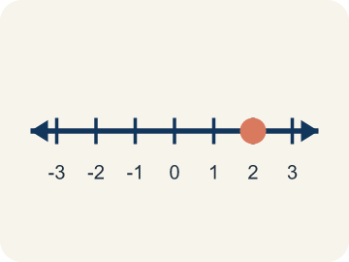 | Number line Recta numérica  A straight line where numbers are placed in order; numbers get smaller to the left and larger to the right.  Example: ← -3 -2 -1 0 1 2 3 →
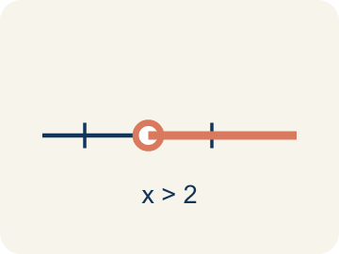 | Compare Comparar  To see if a number is bigger, smaller, or equal to another.  Example: -3 < 2 because -3 is farther left on the number line than 2
 | Order Ordenar  To arrange numbers by size, from least to greatest or greatest to least.  Example: Least to greatest: -5, -2, 0, 3, 7 (left to right on the number line)
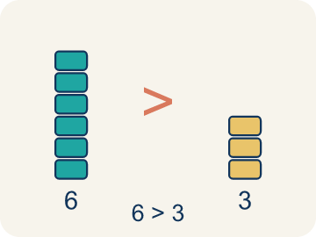 | Greater than Mayor que  The > sign, showing one number is bigger.  Example: 4 > -1 because 4 is to the right of -1 on the number line
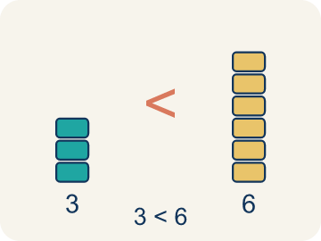 | Less than Menor que  The < sign, showing one number is smaller.  Example: -6 < -2 because -6 is farther left — it is farther from zero
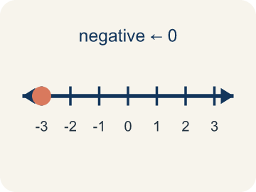 | Negative integer Entero negativo  A whole number smaller than zero, like -5.  Example: -4 is 4 units to the LEFT of zero on the number line
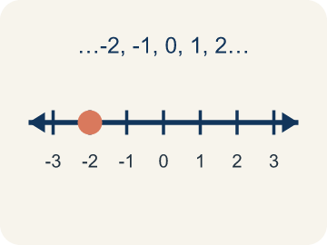 | Integer Número entero  Whole numbers and their opposites, like -2, -1, 0, 1, 2.  Example: ..., -3, -2, -1, 0, 1, 2, 3, ...

Guided Notes
Fill in each blank as we go. Use the Word Bank to help you.
WORD BANK
Compare and Order Integers • Number line • Compare • Order • Greater than • Less than • Negative integer • Integer

1. On a number line, the number farther to the ________________ is always less.
2. To plot integers in order, place them on a ________________.
3. To decide which number is larger or smaller is to ________________ them.
4. To arrange numbers from least to greatest or greatest to least is to ________________ them.
5. On a number line, a number farther to the right is ________________ another number.
6. On a number line, a number farther to the left is ________________ another number.
7. An integer less than zero, like −6, is a ________________.
8. A whole number or its opposite is an ________________.

Write About the Math
Use the support level you need. Every level answers the same math question.

1. Understand the Question explain
How do you use integer comparison to find the coldest and warmest days?
Your job: Answer the question. Use math evidence. Explain how the evidence proves your answer.
Responde la pregunta. Usa evidencia matemática. Explica cómo la evidencia demuestra tu respuesta.

2. Plan Your Math Words check at least two
☐ Compare and Order Integers — Use a number line to decide which integers are greater or less and place them in order.
Comparar y ordenar enteros — Usar una recta numérica para decidir cuáles enteros son mayores o menores y colocarlos en orden.
☐ Number line — A straight line where numbers are placed in order; numbers get smaller to the left and larger to the right.
Recta numérica — Una recta donde los números se colocan en orden; los números son menores a la izquierda y mayores a la derecha.
☐ Compare — To see if a number is bigger, smaller, or equal to another.
Comparar — Ver si un número es mayor, menor o igual que otro.
☐ Order — To arrange numbers by size, from least to greatest or greatest to least.
Ordenar — Acomodar números por tamaño, de menor a mayor o de mayor a menor.
☐ Greater than — The > sign, showing one number is bigger.
Mayor que — El signo >, que muestra que un número es mayor.
Say it first: Say your idea to a partner or quietly to yourself before you write.
The coldest day was ___ at ___°F because ___. The warmest day was ___ at ___°F. I ordered them from coldest to warmest by ___.
Di tu respuesta primero: Mi respuesta es ___ porque ___.

3. Build Your Explanation choose your support
This model shows the parts of an explanation. It does not answer your writing question.
Claim: -3 is less than 2 because on the number line ___.
Evidence: Student explains that -3 is farther left on the number line than 2, and numbers decrease moving left.
Reasoning: This evidence connects the definition of compare and order integers to the mathematical claim.

Start Most language support
Complete the frames. Use the word bank.
Completa las oraciones. Usa el banco de palabras.
The coldest day was ___ at ___°F because ___. The warmest day was ___ at ___°F. I ordered them from coldest to warmest by ___.
My answer is ___.
Mi respuesta es ___.

Build Some language support
Write two connected sentences. Use because, so, or but.
Escribe dos oraciones conectadas. Usa porque, entonces o pero.
My claim is ___.
Mi afirmación es ___.
I know because ___.
Lo sé porque ___.
So ___.
Entonces ___.

Explain Light language support
Write a claim, give math evidence, and explain your reasoning.
Escribe una afirmación, da evidencia matemática y explica tu razonamiento.
My claim is ___.
Mi afirmación es ___.
My math evidence is ___.
Mi evidencia matemática es ___.
This proves ___ because ___.
Esto demuestra ___ porque ___.

4. Check Your Explanation five quick checks
☐ I answered the question.
Respondí la pregunta.
☐ I used math evidence: numbers, an equation, a model, or a comparison.
Usé evidencia matemática: números, una ecuación, un modelo o una comparación.
☐ I explained how the evidence proves my answer.
Expliqué cómo la evidencia demuestra mi respuesta.
☐ I used at least two math words.
Usé por lo menos dos palabras matemáticas.
☐ I reread complete sentences and punctuation.
Volví a leer mis oraciones completas y la puntuación.

Worked Example

Watch & Read I Do — follow along with your teacher
Ranking Treasure Depths
Captain Vega's crew found treasures at different depths underwater! The deeper the treasure, the more negative the elevation. A gold coin is at -2 meters, a silver crown is at -7 meters, and a ruby ring is at -5 meters. The crew needs to rank them from the shallowest (closest to the surface) to the deepest.

Think about:
• Which treasure is closest to the surface?
• Is -7 greater than or less than -2?
• How does the number line help you compare negative numbers?
• Why does a bigger negative number mean a deeper location?
• What if one treasure was above water — how would you compare it to the underwater ones?

Solved Example I Do — watch each step
Problem: Which statement is TRUE?
A) -3 > -1
B) -5 < -2
C) -4 > 0
D) -1 < -6
Step 1: -5 is farther to the left on the number line than -2, so -5 < -2 is true.
Answer: B. -5 < -2

Guided Practice

Solve Together We Do — work with your class
Problem: Which integer is the LEAST: -3, 5, -8, 2, 0?
A) -8
B) -3
C) 0
D) 5
Step 1:

Step 2:

Answer:

A weather station recorded these temperatures during a winter week: Monday -4°F, Tuesday 2°F, Wednesday -7°F, Thursday -1°F, Friday 5°F. The station needs to report the coldest and warmest days.
How do you use integer comparison to find the coldest and warmest days?

Sentence frame: The coldest day was ___ at ___°F because ___. The warmest day was ___ at ___°F. I ordered them from coldest to warmest by ___.

Turn & Talk discuss with a partner
1. [Launch] Why is -3 less than 2, even though 3 looks like a bigger number than 2?
Start with: On the number line, -3 is to the ___ of 2.
En la recta numerica, -3 esta a la ___ de 2.
Word bank: integer, compare, number line, less than, greater than
2. [Explore] Order these temperatures from coldest to warmest: -8, 3, -1, 5. How does the number line help you put them in order?
Start with: The coldest temperature is ___ because it is farthest ___.
La temperatura mas fria es ___ porque esta mas a la ___.
Word bank: integer, order, compare, number line, least to greatest
3. [Connect] How does knowing a number's position on the number line tell you whether to use the < or > symbol?
Start with: The number on the left is ___ than the number on the right.
El numero de la izquierda es ___ que el numero de la derecha.
Word bank: compare, order, number line, less than, greater than
4. [Reflect] Two students disagree: one says -10 is greater than -2 because 10 is bigger. Who is right, and how do you know?
Start with: -10 is actually ___ than -2.
-10 en realidad es ___ que -2.
Word bank: integer, compare, number line, less than, greater than
5. [Practice] During practice on Compare and Order Integers, what strategy did you use when a problem felt tricky?
Start with: The coldest temperature is ___ because it is farthest ___.
La temperatura mas fria es ___ porque esta mas a la ___.
Word bank: Compare, Order, Greater than, Less than

Independent Practice

On Your Own You Do — show your work
Solve each problem. Show your thinking in the work box.

On Level grade-level practice
1. Three cities have temperatures of -12°F, -5°F, and 3°F. Which city is warmest?
A) 3°F
B) -5°F
C) -12°F
D) They are equal

Exit Ticket
Answer on your own. This shows what you learned today.
★ Which list shows the integers in order from LEAST to GREATEST?
A) -2, -5, 0, 3, 7
B) 7, 3, 0, -2, -5
C) -5, -2, 0, 3, 7
D) 0, -2, -5, 3, 7

