UNIT 7 · LESSON 5 STANDARD 6.NOS.6

Represent Rational Numbers on the Coordinate Plane (Flagship)
Student Notes Packet
Name: ______________________ Date: ____________ Period: ________
Level 2 · Standard

Today's Goals
Content: I can plot and identify points on the coordinate plane using ordered pairs.
Language: I can explain my work using the words coordinate plane, ordered pair, origin, and quadrant.

Key Vocabulary
Look at the picture, read the word, then read what it means.
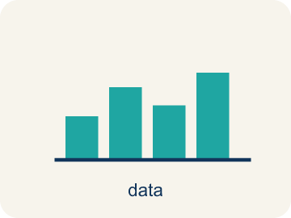 | Graph on the Coordinate Plane Representar en el plano de coordenadas  Plot a point by moving horizontally to its x-coordinate and vertically to its y-coordinate.  Example: For (3, −2), move right 3 and down 2.
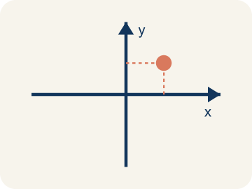 | Coordinate plane Plano cartesiano  A grid with a line going across and a line going up to plot points.  Example: A grid with a horizontal line (x-axis) crossing a vertical line (y-axis), making four sections
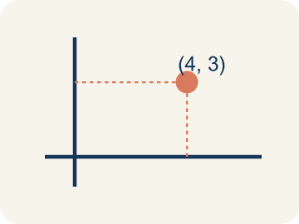 | Ordered pair Par ordenado  Two numbers (x, y) that tell where a point is on a grid.  Example: (3, 5) means move right 3 from the origin, then up 5
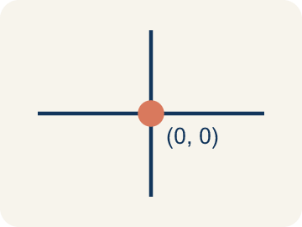 | Origin Origen  The point (0, 0) where the two grid lines cross.  Example: The starting point at the center where both axes cross — (0, 0)
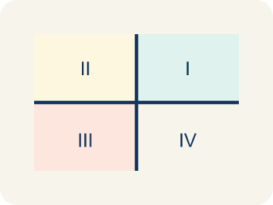 | Quadrant Cuadrante  One of the four parts of a coordinate grid, numbered I to IV.  Example: I (+,+) top-right, II (-,+) top-left, III (-,-) bottom-left, IV (+,-) bottom-right
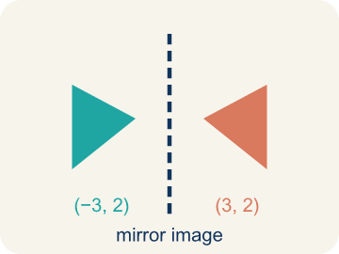 | Reflection Reflexión  A flipped, mirror image across a line.  Example: (3, 2) reflected over the x-axis becomes (3, -2) — same x, opposite y
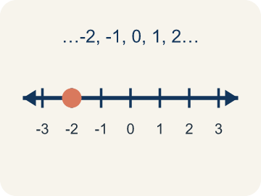 | Integer Número entero  Whole numbers and their opposites, like -2, -1, 0, 1, 2.  Example: ..., -3, -2, -1, 0, 1, 2, 3, ...

Guided Notes
Fill in each blank as we go. Use the Word Bank to help you.
WORD BANK
Graph on the Coordinate Plane • Coordinate plane • Ordered pair • Origin • Quadrant • Reflection • Integer

1. Plot a point by moving to its ________________-coordinate first, then its ________________-coordinate.
2. The grid made by a horizontal and a vertical number line is the ________________.
3. Two numbers (x, y) that tell the location of a point are an ________________.
4. The point (0, 0) where the x-axis and y-axis cross is the ________________.
5. One of the four regions of the coordinate plane is a ________________.
6. A flip of a point or shape over an axis is a ________________.
7. A whole number or its opposite, with no fraction part, is an ________________.

Write About the Math
Use the support level you need. Every level answers the same math question.

1. Understand the Question explain
How do ordered pairs help the drone navigate? What shape does the flight path make?
Your job: Answer the question. Use math evidence. Explain how the evidence proves your answer.
Responde la pregunta. Usa evidencia matemática. Explica cómo la evidencia demuestra tu respuesta.

2. Plan Your Math Words check at least two
☐ Graph on the Coordinate Plane — Plot a point by moving horizontally to its x-coordinate and vertically to its y-coordinate.
Representar en el plano de coordenadas — Ubicar un punto moviéndose horizontalmente hasta su coordenada x y verticalmente hasta su coordenada y.
☐ Coordinate plane — A grid with a line going across and a line going up to plot points.
Plano cartesiano — Una cuadrícula con una línea horizontal y una vertical para marcar puntos.
☐ Ordered pair — Two numbers (x, y) that tell where a point is on a grid.
Par ordenado — Dos números (x, y) que dicen dónde está un punto en una cuadrícula.
☐ Origin — The point (0, 0) where the two grid lines cross.
Origen — El punto (0, 0) donde se cruzan las dos líneas de la cuadrícula.
☐ Quadrant — One of the four parts of a coordinate grid, numbered I to IV.
Cuadrante — Una de las cuatro partes de una cuadrícula de coordenadas, numeradas I a IV.
Say it first: Say your idea to a partner or quietly to yourself before you write.
The drone uses ordered pairs because the first number controls ___ movement and the second controls ___. The path makes a ___ shape.
Di tu respuesta primero: Mi respuesta es ___ porque ___.

3. Build Your Explanation choose your support
This model shows the parts of an explanation. It does not answer your writing question.
Claim: We start at the origin and move along the x-axis first because ___.
Evidence: Student states the x-coordinate is the sideways (horizontal) move and the y-coordinate is the up/down (vertical) move, both starting from the origin.
Reasoning: This evidence connects the definition of coordinate plane to the mathematical claim.

Start Most language support
Complete the frames. Use the word bank.
Completa las oraciones. Usa el banco de palabras.
The drone uses ordered pairs because the first number controls ___ movement and the second controls ___. The path makes a ___ shape.
My answer is ___.
Mi respuesta es ___.

Build Some language support
Write two connected sentences. Use because, so, or but.
Escribe dos oraciones conectadas. Usa porque, entonces o pero.
My claim is ___.
Mi afirmación es ___.
I know because ___.
Lo sé porque ___.
So ___.
Entonces ___.

Explain Light language support
Write a claim, give math evidence, and explain your reasoning.
Escribe una afirmación, da evidencia matemática y explica tu razonamiento.
My claim is ___.
Mi afirmación es ___.
My math evidence is ___.
Mi evidencia matemática es ___.
This proves ___ because ___.
Esto demuestra ___ porque ___.

4. Check Your Explanation five quick checks
☐ I answered the question.
Respondí la pregunta.
☐ I used math evidence: numbers, an equation, a model, or a comparison.
Usé evidencia matemática: números, una ecuación, un modelo o una comparación.
☐ I explained how the evidence proves my answer.
Expliqué cómo la evidencia demuestra mi respuesta.
☐ I used at least two math words.
Usé por lo menos dos palabras matemáticas.
☐ I reread complete sentences and punctuation.
Volví a leer mis oraciones completas y la puntuación.

Worked Example

Watch & Read I Do — follow along with your teacher
Treasure Map Navigation
Captain Vega left a treasure map, but instead of an 'X marks the spot,' she hid the directions as ordered pairs! To find the treasure, you need to plot each point on the coordinate plane and connect them in order. The first clue says: Start at (2, 1), then go to (5, 4), then (8, 1).

Think about:
• What shape will the three points make when connected?
• Which number tells you how far right/left? Which tells you up/down?
• Why is the ORDER in an ordered pair important?
• What if one of the coordinates was negative?
• How would you describe a location without a coordinate plane?

Solved Example I Do — watch each step
Problem: Which ordered pair names a point 3 units right and 7 units up from the origin?
A) (3, 7)
B) (7, 3)
C) (3, 3)
D) (0, 7)
Step 1: The first coordinate is horizontal (right 3), the second is vertical (up 7).
Step 2: So (3, 7).
Answer: A. (3, 7)

Guided Practice

Solve Together We Do — work with your class
Problem: What are the coordinates of the origin?
A) (0, 0)
B) (1, 1)
C) (0, 1)
D) (1, 0)
Step 1:

Step 2:

Answer:

A drone delivery company programs flight paths using coordinate pairs. A drone starts at the warehouse (0, 0), flies to pickup at (3, 6), then delivers to (8, 2), then returns to base (0, 0).
How do ordered pairs help the drone navigate? What shape does the flight path make?

Sentence frame: The drone uses ordered pairs because the first number controls ___ movement and the second controls ___. The path makes a ___ shape.

Turn & Talk discuss with a partner
1. [Launch] On the coordinate plane, why do we always start at the origin (0, 0) and move sideways before we move up or down to plot a point?
Start with: The first number in (x, y) tells me to move ___.
El primer numero en (x, y) me dice que me mueva ___.
Word bank: coordinate plane, origin, ordered pair, x-axis, y-axis
2. [Explore] You need to plot (4, 2). Walk your partner through every move you make from the origin, using the words x-axis and y-axis.
Start with: I move ___ units along the x-axis.
Me muevo ___ unidades por el eje x.
Word bank: origin, ordered pair, x-axis, y-axis, coordinate plane
3. [Connect] How is reading a coordinate pair like reading directions on a map or in a video game?
Start with: The x-coordinate is like going ___.
La coordenada x es como ir ___.
Word bank: ordered pair, coordinate plane, x-axis, y-axis, origin
4. [Reflect] A classmate plotted (2, 6) but moved up 2 and over 6. What mistake did they make, and how would you coach them?
Start with: They mixed up the ___ and the ___.
Confundieron la ___ y la ___.
Word bank: ordered pair, x-axis, y-axis, origin, coordinate plane
5. [Practice] During practice on Graph on the Coordinate Plane, what strategy did you use when a problem felt tricky?
Start with: I move ___ units along the x-axis.
Me muevo ___ unidades por el eje x.
Word bank: Coordinate plane, Ordered pair, Origin, Quadrant

Exit Ticket
Answer on your own. This shows what you learned today.
★ Point P is located 6 units right and 3 units up from the origin. What ordered pair names point P?
A) (6, 3)
B) (3, 6)
C) (6, 0)
D) (0, 3)

Answer Key & Teacher Guide
Teacher reference — remove or fold back before distributing to students.

Guided Notes (Fill-in)
Notes 1: Graph on the Coordinate Plane
Notes 2: Coordinate plane
Notes 3: Ordered pair
Notes 4: Origin
Notes 5: Quadrant
Notes 6: Reflection
Notes 7: Integer

Worked Notes (I Do / We Do)
I Do: A. (3, 7)
We Do: A. (0, 0)

Independent Practice
Watch for this mistake: A common mistake in Graph on the Coordinate Plane is swapping the order of the coordinates — moving up/down first instead of right/left first. For example, when plotting (5, 2), students often move up 5 and right 2, landing on the wrong point (2, 5) instead of (5, 2). Remember: the x-coordinate (first number) always tells you how far to move right or left along the x-axis; the y-coordinate (second number) tells you how far up or down along the y-axis.

Level 1 Support
1. A) Move 6 units to the right — The first number (x-coordinate) tells you horizontal movement. 6 means go right 6 units from the origin.

Exit Ticket
A) (6, 3) — Right 6 = x-coordinate of 6, Up 3 = y-coordinate of 3. The ordered pair is (6, 3).

Math Writing Criteria
The support level changes the amount of language scaffolding, not the mathematical expectation.
☐ I answered the question.
☐ I used math evidence: numbers, an equation, a model, or a comparison.
☐ I explained how the evidence proves my answer.
☐ I used at least two math words.
☐ I reread complete sentences and punctuation.

