UNIT 7 · LESSON 6 STANDARD 6.NOS.9

Determine Distance on the Coordinate Plane
Student Notes Packet
Name: ______________________ Date: ____________ Period: ________
Level 3 · Enrichment

Today's Goals
Content: I can find the distance between two points on the coordinate plane using absolute value.
Language: I can explain my work using the words distance, absolute value, horizontal distance, and vertical distance.

Key Vocabulary
Look at the picture, read the word, then read what it means.
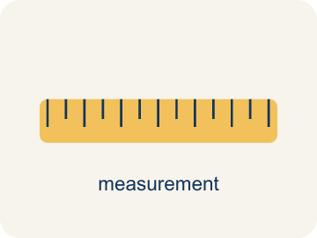 | Distance on the Coordinate Plane Distancia en el plano de coordenadas  The positive space between points, found from the absolute difference of coordinates on a horizontal or vertical line.  Example: From (−2, 3) to (5, 3): |5 − (−2)| = 7 units.
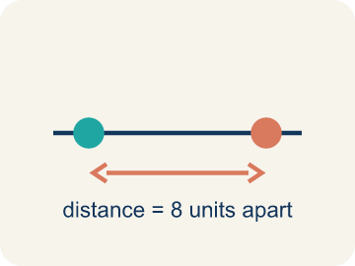 | Distance Distancia  How far apart two points are. It is never negative.  Example: The distance from -3 to 4 on a number line is |-3| + |4| = 3 + 4 = 7 units
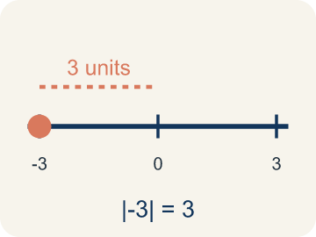 | Absolute value Valor absoluto  How far a number is from zero. It is never negative.  Example: |-3| = 3 and |4| = 4; to find distance: |4 - (-3)| = 7
 | Horizontal distance Distancia horizontal  How far apart two points are going left or right.  Example: From (-2, 3) to (5, 3): count from -2 to 5 = 7 units across
 | Vertical distance Distancia vertical  How far apart two points are going up or down.  Example: From (4, -1) to (4, 6): count from -1 to 6 = 7 units up
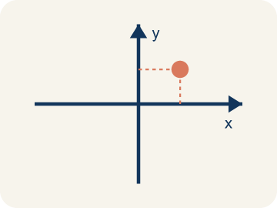 | Coordinate plane Plano cartesiano  A grid with a line going across and a line going up to plot points.  Example: Two number lines crossing at (0, 0), creating four quadrants
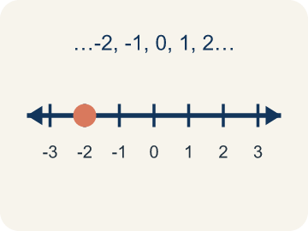 | Integer Número entero  Whole numbers and their opposites, like -2, -1, 0, 1, 2.  Example: ..., -3, -2, -1, 0, 1, 2, 3, ...

Guided Notes
Fill in each blank as we go. Use the Word Bank to help you.
WORD BANK
Distance on the Coordinate Plane • Distance • Absolute value • Horizontal distance • Vertical distance • Coordinate plane • Integer

1. When two points share a coordinate, the distance is the ________________ ________________ of the difference.
2. How far apart two points are on the coordinate plane is the ________________.
3. The distance of a number from zero, used to find distance between points, is its ________________.
4. The distance between two points along the x-direction is the ________________.
5. The distance between two points along the y-direction is the ________________.
6. The grid made by the x-axis and y-axis is the ________________.
7. A whole number or its opposite is an ________________.

Write About the Math
Use the support level you need. Every level answers the same math question.

1. Understand the Question explain
How does the drone use coordinate distance to calculate the total flight path?
Your job: Answer the question. Use math evidence. Explain how the evidence proves your answer.
Responde la pregunta. Usa evidencia matemática. Explica cómo la evidencia demuestra tu respuesta.

2. Plan Your Math Words check at least two
☐ Distance on the Coordinate Plane — The positive space between points, found from the absolute difference of coordinates on a horizontal or vertical line.
Distancia en el plano de coordenadas — El espacio positivo entre puntos, que se halla con la diferencia absoluta de las coordenadas en una línea horizontal o vertical.
☐ Distance — How far apart two points are. It is never negative.
Distancia — Qué tan separados están dos puntos. Nunca es negativo.
☐ Absolute value — How far a number is from zero. It is never negative.
Valor absoluto — Qué tan lejos está un número de cero. Nunca es negativo.
☐ Horizontal distance — How far apart two points are going left or right.
Distancia horizontal — Qué tan separados están dos puntos yendo a la izquierda o a la derecha.
☐ Vertical distance — How far apart two points are going up or down.
Distancia vertical — Qué tan separados están dos puntos yendo hacia arriba o hacia abajo.
Say it first: Say your idea to a partner or quietly to yourself before you write.
The horizontal distance from (-4, 0) to (3, 0) is ___ units because ___. The vertical distance from (3, 0) to (3, -5) is ___ units because ___. The total flight path is ___ units.
Di tu respuesta primero: Mi respuesta es ___ porque ___.

3. Build Your Explanation choose your support
This model shows the parts of an explanation. It does not answer your writing question.
Claim: I can find the distance by looking at the coordinates that ___.
Evidence: Student finds the distance by subtracting the x-coordinates (7 - 2 = 5) since the points share a horizontal line.
Reasoning: This evidence connects the definition of distance on the coordinate plane to the mathematical claim.

Start Most language support
Complete the frames. Use the word bank.
Completa las oraciones. Usa el banco de palabras.
The horizontal distance from (-4, 0) to (3, 0) is ___ units because ___. The vertical distance from (3, 0) to (3, -5) is ___ units because ___. The total flight path is ___ units.
My answer is ___.
Mi respuesta es ___.

Build Some language support
Write two connected sentences. Use because, so, or but.
Escribe dos oraciones conectadas. Usa porque, entonces o pero.
My claim is ___.
Mi afirmación es ___.
I know because ___.
Lo sé porque ___.
So ___.
Entonces ___.

Explain Light language support
Write a claim, give math evidence, and explain your reasoning.
Escribe una afirmación, da evidencia matemática y explica tu razonamiento.
My claim is ___.
Mi afirmación es ___.
My math evidence is ___.
Mi evidencia matemática es ___.
This proves ___ because ___.
Esto demuestra ___ porque ___.

4. Check Your Explanation five quick checks
☐ I answered the question.
Respondí la pregunta.
☐ I used math evidence: numbers, an equation, a model, or a comparison.
Usé evidencia matemática: números, una ecuación, un modelo o una comparación.
☐ I explained how the evidence proves my answer.
Expliqué cómo la evidencia demuestra mi respuesta.
☐ I used at least two math words.
Usé por lo menos dos palabras matemáticas.
☐ I reread complete sentences and punctuation.
Volví a leer mis oraciones completas y la puntuación.

Worked Example

Watch & Read I Do — follow along with your teacher
Treasure Distances
Captain Vega has two treasure locations on her map: a buried chest at (-3, 2) and a hidden cave at (4, 2). Both are at the same height (y = 2) on the map. She needs to figure out how far apart they are so she knows how much rope to bring. Another pair of treasures is at (1, -3) and (1, 5) — same column, different rows. How far apart is each pair?

Think about:
• What do the two points (-3, 2) and (4, 2) have in common?
• How can you count the distance between points in the same row?
• How does absolute value help when one point has a negative coordinate?
• What if the two points are NOT in the same row or column?
• Is the distance between -3 and 4 the same as the distance between 4 and -3?

Solved Example I Do — watch each step
Problem: What is the distance between (-4, 3) and (2, 3)?
A) 2 units
B) 4 units
C) 6 units
D) 8 units
Step 1: Both points have y = 3, so this is a horizontal distance.
Step 2: |2 - (-4)| = |2 + 4| = 6 units.
Answer: C. 6 units

Independent Practice

On Your Own You Do — show your work
Solve each problem. Show your thinking in the work box.

Level 2 Enrichment stretch your thinking
1. A rectangle has corners (1, 2), (1, 5), (5, 5), and (5, 2). What is its perimeter?
A) 7 units
B) 12 units
C) 14 units
D) 10 units

2. How far apart are the points (-2, 5) and (-2, -3)?
A) 2 units
B) 8 units
C) 15 units
D) -8 units

Exit Ticket
Answer on your own. This shows what you learned today.
★ What is the distance between the points (3, -2) and (3, 5)?
A) 3 units
B) 5 units
C) 7 units
D) 9 units

