UNIT 7 · LESSON 6 STANDARD 6.NOS.9

Determine Distance on the Coordinate Plane
Student Notes Packet
Name: ______________________ Date: ____________ Period: ________
Level 1 · Support

Today's Goals
Content: I can find the distance between two points on the coordinate plane using absolute value.
Language: I can explain my work using the words distance, absolute value, horizontal distance, and vertical distance.

Key Vocabulary
Look at the picture, read the word, then read what it means.
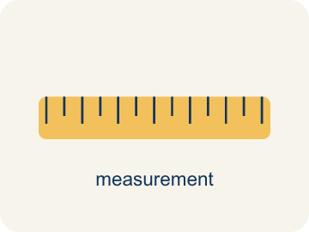 | Distance on the Coordinate Plane Distancia en el plano de coordenadas  The positive space between points, found from the absolute difference of coordinates on a horizontal or vertical line.  Example: From (−2, 3) to (5, 3): |5 − (−2)| = 7 units.
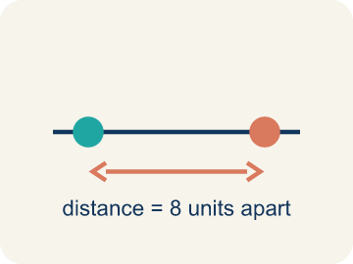 | Distance Distancia  How far apart two points are. It is never negative.  Example: The distance from -3 to 4 on a number line is |-3| + |4| = 3 + 4 = 7 units
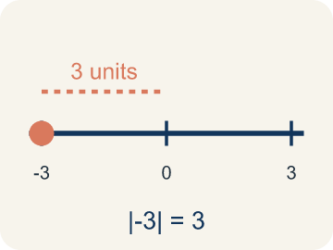 | Absolute value Valor absoluto  How far a number is from zero. It is never negative.  Example: |-3| = 3 and |4| = 4; to find distance: |4 - (-3)| = 7
 | Horizontal distance Distancia horizontal  How far apart two points are going left or right.  Example: From (-2, 3) to (5, 3): count from -2 to 5 = 7 units across
 | Vertical distance Distancia vertical  How far apart two points are going up or down.  Example: From (4, -1) to (4, 6): count from -1 to 6 = 7 units up
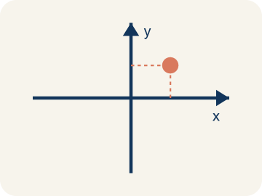 | Coordinate plane Plano cartesiano  A grid with a line going across and a line going up to plot points.  Example: Two number lines crossing at (0, 0), creating four quadrants
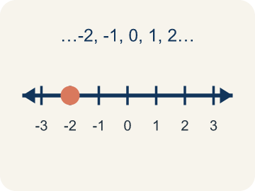 | Integer Número entero  Whole numbers and their opposites, like -2, -1, 0, 1, 2.  Example: ..., -3, -2, -1, 0, 1, 2, 3, ...

Guided Notes
Fill in each blank as we go. Use the Word Bank to help you.
WORD BANK
Distance on the Coordinate Plane • Distance • Absolute value • Horizontal distance • Vertical distance • Coordinate plane • Integer

1. When two points share a coordinate, the distance is the ________________ ________________ of the difference.
2. How far apart two points are on the coordinate plane is the ________________.
3. The distance of a number from zero, used to find distance between points, is its ________________.
4. The distance between two points along the x-direction is the ________________.
5. The distance between two points along the y-direction is the ________________.
6. The grid made by the x-axis and y-axis is the ________________.
7. A whole number or its opposite is an ________________.

Write About the Math
Use the support level you need. Every level answers the same math question.

1. Understand the Question explain
How does the drone use coordinate distance to calculate the total flight path?
Your job: Answer the question. Use math evidence. Explain how the evidence proves your answer.
Responde la pregunta. Usa evidencia matemática. Explica cómo la evidencia demuestra tu respuesta.

2. Plan Your Math Words check at least two
☐ Distance on the Coordinate Plane — The positive space between points, found from the absolute difference of coordinates on a horizontal or vertical line.
Distancia en el plano de coordenadas — El espacio positivo entre puntos, que se halla con la diferencia absoluta de las coordenadas en una línea horizontal o vertical.
☐ Distance — How far apart two points are. It is never negative.
Distancia — Qué tan separados están dos puntos. Nunca es negativo.
☐ Absolute value — How far a number is from zero. It is never negative.
Valor absoluto — Qué tan lejos está un número de cero. Nunca es negativo.
☐ Horizontal distance — How far apart two points are going left or right.
Distancia horizontal — Qué tan separados están dos puntos yendo a la izquierda o a la derecha.
☐ Vertical distance — How far apart two points are going up or down.
Distancia vertical — Qué tan separados están dos puntos yendo hacia arriba o hacia abajo.
Say it first: Say your idea to a partner or quietly to yourself before you write.
The horizontal distance from (-4, 0) to (3, 0) is ___ units because ___. The vertical distance from (3, 0) to (3, -5) is ___ units because ___. The total flight path is ___ units.
Di tu respuesta primero: Mi respuesta es ___ porque ___.

3. Build Your Explanation choose your support
This model shows the parts of an explanation. It does not answer your writing question.
Claim: I can find the distance by looking at the coordinates that ___.
Evidence: Student finds the distance by subtracting the x-coordinates (7 - 2 = 5) since the points share a horizontal line.
Reasoning: This evidence connects the definition of distance on the coordinate plane to the mathematical claim.

Start Most language support
Complete the frames. Use the word bank.
Completa las oraciones. Usa el banco de palabras.
The horizontal distance from (-4, 0) to (3, 0) is ___ units because ___. The vertical distance from (3, 0) to (3, -5) is ___ units because ___. The total flight path is ___ units.
My answer is ___.
Mi respuesta es ___.

Build Some language support
Write two connected sentences. Use because, so, or but.
Escribe dos oraciones conectadas. Usa porque, entonces o pero.
My claim is ___.
Mi afirmación es ___.
I know because ___.
Lo sé porque ___.
So ___.
Entonces ___.

Explain Light language support
Write a claim, give math evidence, and explain your reasoning.
Escribe una afirmación, da evidencia matemática y explica tu razonamiento.
My claim is ___.
Mi afirmación es ___.
My math evidence is ___.
Mi evidencia matemática es ___.
This proves ___ because ___.
Esto demuestra ___ porque ___.

4. Check Your Explanation five quick checks
☐ I answered the question.
Respondí la pregunta.
☐ I used math evidence: numbers, an equation, a model, or a comparison.
Usé evidencia matemática: números, una ecuación, un modelo o una comparación.
☐ I explained how the evidence proves my answer.
Expliqué cómo la evidencia demuestra mi respuesta.
☐ I used at least two math words.
Usé por lo menos dos palabras matemáticas.
☐ I reread complete sentences and punctuation.
Volví a leer mis oraciones completas y la puntuación.

Worked Example

Watch & Read I Do — follow along with your teacher
Treasure Distances
Captain Vega has two treasure locations on her map: a buried chest at (-3, 2) and a hidden cave at (4, 2). Both are at the same height (y = 2) on the map. She needs to figure out how far apart they are so she knows how much rope to bring. Another pair of treasures is at (1, -3) and (1, 5) — same column, different rows. How far apart is each pair?

Think about:
• What do the two points (-3, 2) and (4, 2) have in common?
• How can you count the distance between points in the same row?
• How does absolute value help when one point has a negative coordinate?
• What if the two points are NOT in the same row or column?
• Is the distance between -3 and 4 the same as the distance between 4 and -3?

Solved Example I Do — watch each step
Problem: What is the distance between (-4, 3) and (2, 3)?
A) 2 units
B) 4 units
C) 6 units
D) 8 units
Step 1: Both points have y = 3, so this is a horizontal distance.
Step 2: |2 - (-4)| = |2 + 4| = 6 units.
Answer: C. 6 units

Guided Practice

Solve Together We Do — work with your class
Problem: What is the distance between (5, -2) and (5, 4)?
A) 2 units
B) 4 units
C) 6 units
D) 10 units
Step 1:

Step 2:

Answer:

A drone starts at position (-4, 0) on a grid and needs to deliver a package to (3, 0), then fly to another delivery at (3, -5). It can only fly horizontally or vertically.
How does the drone use coordinate distance to calculate the total flight path?

Sentence frame: The horizontal distance from (-4, 0) to (3, 0) is ___ units because ___. The vertical distance from (3, 0) to (3, -5) is ___ units because ___. The total flight path is ___ units.

Turn & Talk discuss with a partner
1. [Launch] Two points sit on the same horizontal line: (2, 3) and (7, 3). How can you find the distance between them without counting every square?
Start with: The y-coordinates are the same, so I only compare the ___.
Las coordenadas y son iguales, asi que solo comparo las ___.
Word bank: distance, coordinate plane, absolute value, ordered pair, x-axis
2. [Explore] One point is at (-3, 1) and another is at (4, 1). How does absolute value help you find the distance across zero?
Start with: The distance is |4| + |-3|, which equals ___.
La distancia es |4| + |-3|, que es ___.
Word bank: distance, absolute value, coordinate plane, ordered pair, negative
3. [Connect] Why does distance on the coordinate plane always come out positive, even when the coordinates are negative?
Start with: Distance measures how ___ apart two points are.
La distancia mide que tan ___ estan dos puntos.
Word bank: distance, absolute value, coordinate plane, negative, ordered pair
4. [Reflect] A classmate found the distance from (-2, 5) to (6, 5) by computing 6 - 2 = 4. What did they do wrong?
Start with: They forgot that -2 is ___, not ___.
Olvidaron que -2 es ___, no ___.
Word bank: distance, absolute value, coordinate plane, negative, ordered pair
5. [Practice] During practice on Distance on the Coordinate Plane, what strategy did you use when a problem felt tricky?
Start with: The distance is |4| + |-3|, which equals ___.
La distancia es |4| + |-3|, que es ___.
Word bank: Distance, Absolute value, Horizontal distance, Vertical distance

Independent Practice

On Your Own You Do — show your work
Solve each problem. Show your thinking in the work box.

Level 1 Support extra scaffolding
1. A rectangle has vertices at (1, 1), (5, 1), (5, 4), (1, 4). What is its perimeter?
A) 14 units
B) 12 units
C) 20 units
D) 8 units

Exit Ticket
Answer on your own. This shows what you learned today.
★ What is the distance between the points (3, -2) and (3, 5)?
A) 3 units
B) 5 units
C) 7 units
D) 9 units

Answer Key & Teacher Guide
Teacher reference — remove or fold back before distributing to students.

Guided Notes (Fill-in)
Notes 1: Distance on the Coordinate Plane
Notes 2: Distance
Notes 3: Absolute value
Notes 4: Horizontal distance
Notes 5: Vertical distance
Notes 6: Coordinate plane
Notes 7: Integer

Worked Notes (I Do / We Do)
I Do: C. 6 units
We Do: C. 6 units

Independent Practice
Watch for this mistake: A common mistake in Distance on the Coordinate Plane is subtracting the coordinates as if both points were on the same side of zero, instead of adding their absolute values when the points are on opposite sides. For example, to find the distance between (-6, 3) and (2, 3), a student might subtract 6 − 2 = 4, but since -6 and 2 are on opposite sides of zero, the absolute values must be added instead: |-6| + |2| = 6 + 2 = 8. The correct distance is 8 units, not 4. Before you submit, ask: 'Are these two points on opposite sides of zero — and if so, did I add the absolute values instead of subtracting?'

Level 1 Support
1. A) 14 units — Width = 5 - 1 = 4. Height = 4 - 1 = 3. Perimeter = 2(4 + 3) = 14.

On Level
2. A) 12 units — Same x = -3. Distance = |5 - (-7)| = |5 + 7| = 12 units.
3. B) 5 units — The x-coordinates match, so distance = |8 - 3| = 5 units.
4. C) 7 units — The y-coordinates match, so distance = |3 - (-4)| = 7 units.

Level 2 Enrichment
5. C) 14 units — Width = |5 - 1| = 4, height = |5 - 2| = 3, so perimeter = 2(4 + 3) = 14 units. (Area would be 12 sq units, so perimeter and area are different here.)
6. B) 8 units — The x-coordinates match, so distance = |5 - (-3)| = 8 units.

Exit Ticket
C) 7 units — Both points share x = 3, so this is a vertical distance. |5 - (-2)| = |5 + 2| = 7 units.

Math Writing Criteria
The support level changes the amount of language scaffolding, not the mathematical expectation.
☐ I answered the question.
☐ I used math evidence: numbers, an equation, a model, or a comparison.
☐ I explained how the evidence proves my answer.
☐ I used at least two math words.
☐ I reread complete sentences and punctuation.

