UNIT 7 · LESSON 7 STANDARD 6.NOS.9

Represent Polygons on the Coordinate Plane
Student Notes Packet
Name: ______________________ Date: ____________ Period: ________
Level 3 · Enrichment

Today's Goals
Content: I can draw polygons from their vertex coordinates on the coordinate plane, and use coordinates to find side lengths and solve perimeter and area problems.
Language: I can explain how I found a distance using the words vertices, coordinates, and absolute value.

Key Vocabulary
Look at the picture, read the word, then read what it means.
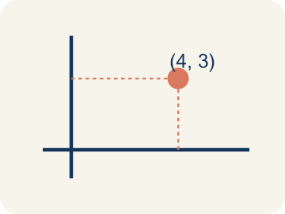 | vertex vértice  A corner point of a polygon, named by an ordered pair on the coordinate plane.  Example: The park's corner at (2, 4) — one corner, named by an ordered pair.
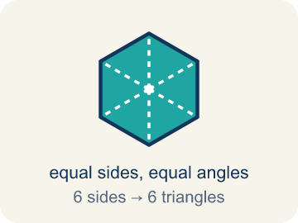 | polygon polígono  A closed figure made of line segments; on the plane you draw it by plotting the vertices and connecting them in order.  Example: Plot (2, 4), (5, 4), (5, −4), (2, −4) and join them — a rectangle appears.
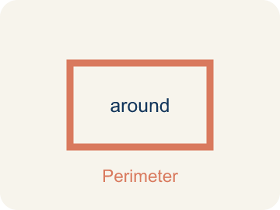 | perimeter perímetro  The total distance around a polygon — the sum of all its side lengths.  Example: 2(9.5) + 2(6.75) = 32.5 units around the deck.
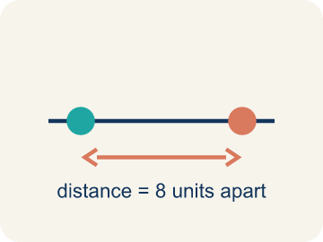 | distance between vertices distancia entre vértices  When two vertices share an x- or y-coordinate, the distance between them is the absolute difference of the other coordinates.  Example: (2, 4) and (5, 4) share y, so the side is |5 − 2| = 3 units.
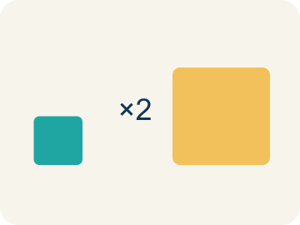 | scale escala  What one grid unit stands for in the real situation.  Example: Each grid unit = 100 feet, so 8 units of map is 800 real feet.

Guided Notes
Fill in each blank as we go. Use the Word Bank to help you.
WORD BANK
vertex • polygon • perimeter • distance between vertices • scale

1. A corner point of a polygon, named by an ordered pair, is a ________________.
2. A closed figure made of line segments is a ________________.
3. The total distance around a polygon is its ________________.
4. When two vertices share a coordinate, subtract the other and take the ________________ ________________.
5. What one grid unit stands for in the real situation is the ________________.

Write About the Math
Use the support level you need. Every level answers the same math question.

1. Understand the Question explain
Where do the other two vertices go — and how do the known coordinates, the scale, and the area work together to tell you?
Your job: Answer the question. Use math evidence. Explain how the evidence proves your answer.
Responde la pregunta. Usa evidencia matemática. Explica cómo la evidencia demuestra tu respuesta.

2. Plan Your Math Words check at least two
☐ vertex — A corner point of a polygon, named by an ordered pair on the coordinate plane.
vértice — Un punto de esquina de un polígono, nombrado por un par ordenado en el plano de coordenadas.
☐ polygon — A closed figure made of line segments; on the plane you draw it by plotting the vertices and connecting them in order.
polígono — Una figura cerrada hecha de segmentos; en el plano se dibuja marcando los vértices y conectándolos en orden.
☐ perimeter — The total distance around a polygon — the sum of all its side lengths.
perímetro — La distancia total alrededor de un polígono: la suma de todos sus lados.
☐ distance between vertices — When two vertices share an x- or y-coordinate, the distance between them is the absolute difference of the other coordinates.
distancia entre vértices — Cuando dos vértices comparten una coordenada x o y, la distancia es la diferencia absoluta de las otras coordenadas.
☐ scale — What one grid unit stands for in the real situation.
escala — Lo que representa una unidad de la cuadrícula en la situación real.
Say it first: Say your idea to a partner or quietly to yourself before you write.
The park's width is ___ feet. Using the area formula, its length is ___ feet, which is ___ units on the map — so the new vertices sit that many units below the known ones.
Di tu respuesta primero: Mi respuesta es ___ porque ___.

3. Build Your Explanation choose your support
This model shows the parts of an explanation. It does not answer your writing question.
Claim: When two vertices share the same y-coordinate, the segment between them is horizontal, so its length comes from the DIFFERENCE in the coordinate that changes — the x-coordinates.
Evidence: A strong answer explains that the SHARED coordinate tells you the direction of the side, and the DIFFERING coordinate is what you subtract. A weak answer just says 'subtract the numbers' without identifying which pair.
Reasoning: This evidence connects the definition of polygon to the mathematical claim.

Start Most language support
Complete the frames. Use the word bank.
Completa las oraciones. Usa el banco de palabras.
The park's width is ___ feet. Using the area formula, its length is ___ feet, which is ___ units on the map — so the new vertices sit that many units below the known ones.
My answer is ___.
Mi respuesta es ___.

Build Some language support
Write two connected sentences. Use because, so, or but.
Escribe dos oraciones conectadas. Usa porque, entonces o pero.
My claim is ___.
Mi afirmación es ___.
I know because ___.
Lo sé porque ___.
So ___.
Entonces ___.

Explain Light language support
Write a claim, give math evidence, and explain your reasoning.
Escribe una afirmación, da evidencia matemática y explica tu razonamiento.
My claim is ___.
Mi afirmación es ___.
My math evidence is ___.
Mi evidencia matemática es ___.
This proves ___ because ___.
Esto demuestra ___ porque ___.

4. Check Your Explanation five quick checks
☐ I answered the question.
Respondí la pregunta.
☐ I used math evidence: numbers, an equation, a model, or a comparison.
Usé evidencia matemática: números, una ecuación, un modelo o una comparación.
☐ I explained how the evidence proves my answer.
Expliqué cómo la evidencia demuestra mi respuesta.
☐ I used at least two math words.
Usé por lo menos dos palabras matemáticas.
☐ I reread complete sentences and punctuation.
Volví a leer mis oraciones completas y la puntuación.

Worked Example

Watch & Read I Do — follow along with your teacher
Unit 7 · Lesson 7
A polygon's vertices are given as coordinates: (-4.5, 3), (5, 3), (5, -3.75), and (-4.5, -3.75). What is its perimeter?

Solved Example I Do — watch each step
Problem: Vertices (-4.5, 3) and (5, 3) share y = 3. What is the distance between them?
A) 9.5 units
B) 0.5 units
C) 8 units
D) 1.5 units
Step 1: They differ only in x: |5 − (−4.5)| = 5 + 4.5 = 9.5 units.
Answer: A. 9.5 units

Independent Practice

On Your Own You Do — show your work
Solve each problem. Show your thinking in the work box.

Level 2 Enrichment stretch your thinking
1. Maria is choosing between two store spaces on a grid where each unit is 1 foot and each grid line is 5 feet apart. Space A is a rectangle 25 ft by 40 ft; Space B is 30 ft by 30 ft. Which has more floor area?
A) Space A — 1,000 sq ft vs 900 sq ft
B) Space B — 900 sq ft vs 850 sq ft
C) They are equal
D) Space B — because a square always beats a rectangle

2. A square has vertices (a, b) and (a, b + s) on one side. Which operation gives the side length for ANY values?
A) Subtract the y-coordinates and take the absolute value
B) Add all four coordinates
C) Multiply a × b
D) Average the coordinates

3. The park design used width from coordinates, then length from the area, then the scale to place the missing vertices. Design your own version: pick an area and a scale, mark two vertices, and show where the other two go.
4. Check the deck's perimeter of 32.5 units a DIFFERENT way than adding the four sides in order.

Exit Ticket
Answer on your own. This shows what you learned today.
★ A rectangle has vertices (-1, 4), (5, 4), (5, 1), (-1, 1). What is its perimeter?
A) 18 units
B) 9 units
C) 6 units
D) 18 square units

Answer Key & Teacher Guide
Teacher reference — remove or fold back before distributing to students.

Guided Notes (Fill-in)
Notes 1: vertex
Notes 2: polygon
Notes 3: perimeter
Notes 4: distance between vertices
Notes 5: scale

Worked Notes (I Do / We Do)
I Do: A. 9.5 units
We Do: A. 6.75 units

Independent Practice
Watch for this mistake: Subtracting coordinates without the absolute value — from y = 3 down to y = −3.75 the distance is 3 + 3.75 = 6.75 units, not 3.75 − 3 = 0.75. Distances that cross zero are the whole reason the absolute value is there.

Level 1 Support
1. A) 32.5 units — Perimeter = 2(9.5) + 2(6.75) = 19 + 13.5 = 32.5 units.
2. A) A rectangle's opposite sides are equal, so each length appears on two sides — The two 9.5 sides and the two 6.75 sides each come in pairs — that is what the 2 counts.
3. A) Plot each ordered pair, then connect them in order with segments — Graph the points on the plane and connect them in order — the closed figure that appears is the polygon.
4. Answers vary.

On Level
5. A) 300 feet — 3 units × 100 feet per unit = 300 feet.
6. A) 800 feet — Length = area ÷ width = 240,000 ÷ 300 = 800 feet.

Exit Ticket
A) 18 units — Width |5 − (−1)| = 6, height |4 − 1| = 3. Perimeter = 2(6) + 2(3) = 18 units.

Math Writing Criteria
The support level changes the amount of language scaffolding, not the mathematical expectation.
☐ I answered the question.
☐ I used math evidence: numbers, an equation, a model, or a comparison.
☐ I explained how the evidence proves my answer.
☐ I used at least two math words.
☐ I reread complete sentences and punctuation.

