UNIT 7 · LESSON 8 STANDARD 6.NOS.7

Ordered Pairs in All Four Quadrants
Student Notes Packet
Name: ______________________ Date: ____________ Period: ________
Level 2 · Standard

Today's Goals
Content: I can plot ordered pairs in all four quadrants of the coordinate plane.
Language: I can explain my work using the words quadrant, negative coordinate, reflection, and axis.

Key Vocabulary
Look at the picture, read the word, then read what it means.
 | Ordered Pairs in All Four Quadrants Pares ordenados en los cuatro cuadrantes  Points written as (x, y) whose positive or negative coordinates place them in one of four quadrants.  Example: (−3, 4) is in Quadrant II.
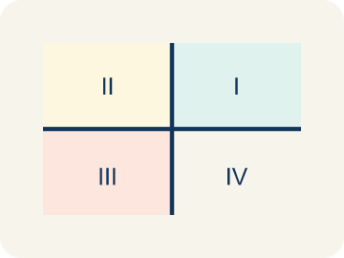 | Quadrant Cuadrante  One of the four parts of a coordinate grid, numbered I to IV.  Example: I (+, +) top-right, II (-, +) top-left, III (-, -) bottom-left, IV (+, -) bottom-right
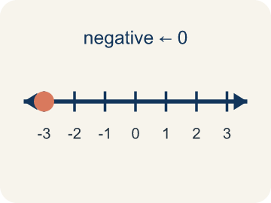 | Negative coordinate Coordenada negativa  A coordinate less than zero. It means left or below the center point.  Example: (-3, 2) means 3 left and 2 up from the origin
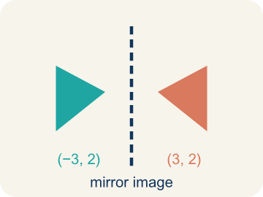 | Reflection Reflexión  A flipped, mirror image across a line.  Example: (3, 2) reflected over the y-axis is (-3, 2) — same distance, opposite side
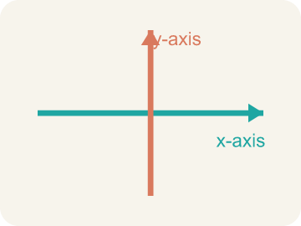 | Axis Eje  One of the two number lines that frame a graph: the x-axis runs across, the y-axis runs up and down.  Example: The x-axis goes left-right; the y-axis goes up-down; they cross at (0, 0)
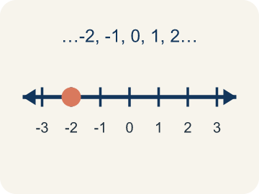 | Integer Número entero  Whole numbers and their opposites, like -2, -1, 0, 1, 2.  Example: ..., -3, -2, -1, 0, 1, 2, 3, ...

Guided Notes
Fill in each blank as we go. Use the Word Bank to help you.
WORD BANK
Ordered Pairs in All Four Quadrants • Quadrant • Negative coordinate • Reflection • Axis • Integer

1. The ________________ of a point's two coordinates decide which quadrant it lands in.
2. One of the four regions of the coordinate plane, numbered I to IV, is a ________________.
3. A coordinate less than zero, which places a point left of or below the origin, is a ________________.
4. A flip of a point over an axis is a ________________.
5. One of the two number lines, the x-axis or y-axis, that form the grid is an ________________.
6. A whole number or its opposite is an ________________.

Write About the Math
Use the support level you need. Every level answers the same math question.

1. Understand the Question explain
How do four-quadrant coordinates help a city map locations in every direction from the center?
Your job: Answer the question. Use math evidence. Explain how the evidence proves your answer.
Responde la pregunta. Usa evidencia matemática. Explica cómo la evidencia demuestra tu respuesta.

2. Plan Your Math Words check at least two
☐ Ordered Pairs in All Four Quadrants — Points written as (x, y) whose positive or negative coordinates place them in one of four quadrants.
Pares ordenados en los cuatro cuadrantes — Puntos escritos como (x, y) cuyas coordenadas positivas o negativas los ubican en uno de cuatro cuadrantes.
☐ Quadrant — One of the four parts of a coordinate grid, numbered I to IV.
Cuadrante — Una de las cuatro partes de una cuadrícula de coordenadas, numeradas I a IV.
☐ Negative coordinate — A coordinate less than zero. It means left or below the center point.
Coordenada negativa — Una coordenada menor que cero. Significa a la izquierda o debajo del centro.
☐ Reflection — A flipped, mirror image across a line.
Reflexión — Una imagen reflejada al otro lado de una línea.
☐ Axis — One of the two number lines that frame a graph: the x-axis runs across, the y-axis runs up and down.
Eje — Una de las dos rectas numéricas que enmarcan una gráfica: el eje x va horizontal y el eje y va vertical.
Say it first: Say your idea to a partner or quietly to yourself before you write.
The library is in Quadrant ___ because its x is ___ and its y is ___. The park is in Quadrant ___ because ___. Four-quadrant coordinates help because ___.
Di tu respuesta primero: Mi respuesta es ___ porque ___.

3. Build Your Explanation choose your support
This model shows the parts of an explanation. It does not answer your writing question.
Claim: The signs of the coordinates tell me the quadrant because ___.
Evidence: Student matches sign combinations to quadrants (e.g., (+,+) is I, (-,+) is II).
Reasoning: This evidence connects the definition of ordered pairs in all four quadrants to the mathematical claim.

Start Most language support
Complete the frames. Use the word bank.
Completa las oraciones. Usa el banco de palabras.
The library is in Quadrant ___ because its x is ___ and its y is ___. The park is in Quadrant ___ because ___. Four-quadrant coordinates help because ___.
My answer is ___.
Mi respuesta es ___.

Build Some language support
Write two connected sentences. Use because, so, or but.
Escribe dos oraciones conectadas. Usa porque, entonces o pero.
My claim is ___.
Mi afirmación es ___.
I know because ___.
Lo sé porque ___.
So ___.
Entonces ___.

Explain Light language support
Write a claim, give math evidence, and explain your reasoning.
Escribe una afirmación, da evidencia matemática y explica tu razonamiento.
My claim is ___.
Mi afirmación es ___.
My math evidence is ___.
Mi evidencia matemática es ___.
This proves ___ because ___.
Esto demuestra ___ porque ___.

4. Check Your Explanation five quick checks
☐ I answered the question.
Respondí la pregunta.
☐ I used math evidence: numbers, an equation, a model, or a comparison.
Usé evidencia matemática: números, una ecuación, un modelo o una comparación.
☐ I explained how the evidence proves my answer.
Expliqué cómo la evidencia demuestra mi respuesta.
☐ I used at least two math words.
Usé por lo menos dos palabras matemáticas.
☐ I reread complete sentences and punctuation.
Volví a leer mis oraciones completas y la puntuación.

Worked Example

Watch & Read I Do — follow along with your teacher
Expanding the Treasure Map
Captain Vega realized her treasure map only covered one corner of the island! She needs to expand the map in all directions — north, south, east, and west of the base camp at the origin (0, 0). Now clues can have negative coordinates: (-4, 3) means 4 units west and 3 units north. A clue at (2, -5) means 2 units east and 5 units south. Which quadrant is each clue in?

Think about:
• How do you know which quadrant a point is in by looking at the signs of its coordinates?
• What do negative x-values and negative y-values mean on the map?
• Where is the point (0, 0) on the expanded map?
• Can a point be in more than one quadrant?
• What quadrant is a point on if one of its coordinates is zero?

Solved Example I Do — watch each step
Problem: In which quadrant is the point (-4, 5)?
A) Quadrant I
B) Quadrant II
C) Quadrant III
D) Quadrant IV
Step 1: The x-coordinate is negative (left) and the y-coordinate is positive (up).
Step 2: Left and up is Quadrant II.
Answer: B. Quadrant II

Guided Practice

Solve Together We Do — work with your class
Problem: A point has a positive x-coordinate and a negative y-coordinate. Which quadrant is it in?
A) Quadrant I
B) Quadrant II
C) Quadrant III
D) Quadrant IV
Step 1:

Step 2:

Answer:

A city uses a coordinate grid to map locations. City Hall is at the origin (0, 0). The library is at (-3, 4), the park is at (5, -2), the school is at (2, 3), and the hospital is at (-4, -1).
How do four-quadrant coordinates help a city map locations in every direction from the center?

Sentence frame: The library is in Quadrant ___ because its x is ___ and its y is ___. The park is in Quadrant ___ because ___. Four-quadrant coordinates help because ___.

Turn & Talk discuss with a partner
1. [Launch] What do the signs of the coordinates in an ordered pair tell you about which quadrant the point is in?
Start with: If both coordinates are positive, the point is in quadrant ___.
Si ambas coordenadas son positivas, el punto esta en el cuadrante ___.
Word bank: quadrant, ordered pair, negative coordinate, x-axis, y-axis
2. [Explore] Plot (-3, -4). Which quadrant is it in, and how do the negative coordinates change the directions you move from the origin?
Start with: A negative x means I move ___.
Una x negativa significa que me muevo ___.
Word bank: quadrant, negative coordinate, ordered pair, x-axis, y-axis
3. [Connect] How are the four quadrants like a tic-tac-toe of positive and negative directions on the coordinate plane?
Start with: Quadrant ___ has both coordinates positive.
El cuadrante ___ tiene ambas coordenadas positivas.
Word bank: quadrant, negative coordinate, ordered pair, x-axis, y-axis
4. [Reflect] A point has coordinates (5, -2). Without plotting, how can you describe exactly where it is and which quadrant it is in?
Start with: The point is ___ of the y-axis and ___ of the x-axis.
El punto esta a la ___ del eje y y ___ del eje x.
Word bank: quadrant, ordered pair, negative coordinate, x-axis, y-axis
5. [Practice] During practice on Ordered Pairs in All Four Quadrants, what strategy did you use when a problem felt tricky?
Start with: A negative x means I move ___.
Una x negativa significa que me muevo ___.
Word bank: Quadrant, Negative coordinate, Reflection, Axis

Independent Practice

On Your Own You Do — show your work
Solve each problem. Show your thinking in the work box.

On Level grade-level practice
1. Point A is at (-5, 3). If you move 8 units to the right, what are the new coordinates?
A) (3, 3)
B) (-13, 3)
C) (-5, 11)
D) (-5, -5)

2. In which quadrant is the point (-3, 5)?
A) Quadrant I
B) Quadrant II
C) Quadrant III
D) Quadrant IV

3. What are the coordinates of a point 4 units right and 2 units down from the origin?
A) (-4, 2)
B) (2, -4)
C) (4, -2)
D) (-2, 4)

Exit Ticket
Answer on your own. This shows what you learned today.
★ A point has a negative x-coordinate and a negative y-coordinate. Which quadrant is it in?
A) Quadrant I
B) Quadrant II
C) Quadrant III
D) Quadrant IV

