UNIT 8 · LESSON 1 STANDARD 6.AT.8

Understand Equations and Their Solutions (Flagship)
Student Notes Packet
Name: ______________________ Date: ____________ Period: ________
Level 3 · Enrichment

Today's Goals
Content: I can write an equation for a real situation and check whether a given value is a solution by substituting it.
Language: I can explain a solution using the words substitute, solution, true, and equal sign.

Key Vocabulary
Look at the picture, read the word, then read what it means.
 | Write Equations Escribir ecuaciones  Represent a relationship with expressions joined by an equal sign.  Example: A $5 fee plus $3 per game for g games: 5 + 3g = total.
 | Equation Ecuación  A math sentence with an equal sign showing both sides are the same.  Example: n + 8 = 20 means 'some number plus 8 equals 20'
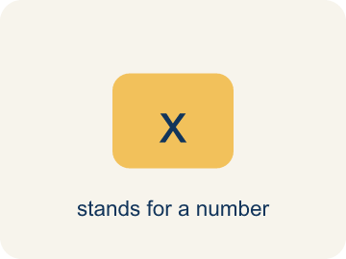 | Variable Variable  A letter that stands for a number that is unknown or can change.  Example: In n + 3 = 10, the letter n stands for the unknown number (n = 7)
 | Equal sign Signo igual  The = sign, showing both sides are the same.  Example: 7 + 3 = 10 — both sides equal 10
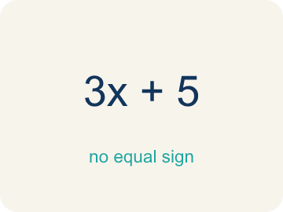 | Expression Expresión  A math phrase with numbers and letters, but no equal sign.  Example: 2x + 5 is an expression; it becomes an equation when you write 2x + 5 = 15
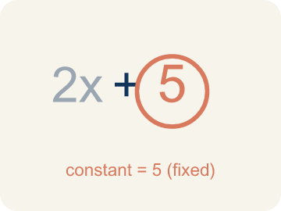 | Constant Constante  A fixed number in an expression or equation that does not change.  Example: In x + 7 = 12, the numbers 7 and 12 are constants; only x can change.
 | Unknown Incógnita  The value you are trying to find, usually shown with a variable.  Example: In n + 5 = 12, n is the unknown; you solve to find n = 7.
 | Solution Solución  A value that makes an equation true when it is substituted for the variable.  Example: n = 4 is the solution of n + 5 = 9
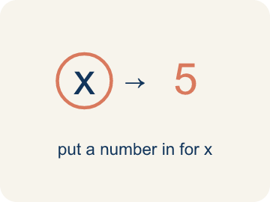 | Substitute Sustituir  To replace a variable with a number so the equation can be checked.  Example: n + 5 = 9 with n = 4 → 4 + 5 = 9 ✓

Guided Notes
Fill in each blank as we go. Use the Word Bank to help you.
WORD BANK
Write Equations • Equation • Variable • Equal sign • Expression • Constant • Unknown • Solution • Substitute

1. Two expressions joined by an ________________ ________________ make an equation.
2. A math sentence that says two amounts are equal, with an = sign, is an ________________.
3. A letter that stands for an unknown number is a ________________.
4. The symbol = that shows two amounts are the same is the ________________.
5. A group of numbers and variables with no equal sign is an ________________.
6. A fixed number that does not change is a ________________.
7. The value you are trying to find in an equation is the ________________.
8. A value that makes the equation true when ________________ for the variable is its solution.
9. Replace the variable with a number to ________________ whether it is a solution.

Write About the Math
Use the support level you need. Every level answers the same math question.

1. Understand the Question explain
How many paintings has the detective recovered? How did writing an equation help you understand the situation?
Your job: Answer the question. Use math evidence. Explain how the evidence proves your answer.
Responde la pregunta. Usa evidencia matemática. Explica cómo la evidencia demuestra tu respuesta.

2. Plan Your Math Words check at least two
☐ Write Equations — Represent a relationship with expressions joined by an equal sign.
Escribir ecuaciones — Representar una relación con expresiones unidas por un signo igual.
☐ Equation — A math sentence with an equal sign showing both sides are the same.
Ecuación — Una oración matemática con un signo igual que muestra que ambos lados son iguales.
☐ Variable — A letter that stands for a number that is unknown or can change.
Variable — Una letra que representa un número desconocido o que puede cambiar.
☐ Equal sign — The = sign, showing both sides are the same.
Signo igual — El signo =, que muestra que ambos lados son iguales.
☐ Expression — A math phrase with numbers and letters, but no equal sign.
Expresión — Una frase matemática con números y letras, pero sin signo igual.
Say it first: Say your idea to a partner or quietly to yourself before you write.
The detective recovered ___ paintings because p + 14 = 37 means p = 37 − ___ = ___.
Di tu respuesta primero: Mi respuesta es ___ porque ___.

3. Build Your Explanation choose your support
This model shows the parts of an explanation. It does not answer your writing question.
Claim: I let a variable stand for the unknown number of gems.
Evidence: Students choose a variable (such as n) for the unknown gems, build n + 8 = 20, and connect 'plus 8 more' to + 8 and 'equals 20 total' to = 20.
Reasoning: This evidence connects the definition of equation to the mathematical claim.

Start Most language support
Complete the frames. Use the word bank.
Completa las oraciones. Usa el banco de palabras.
The detective recovered ___ paintings because p + 14 = 37 means p = 37 − ___ = ___.
My answer is ___.
Mi respuesta es ___.

Build Some language support
Write two connected sentences. Use because, so, or but.
Escribe dos oraciones conectadas. Usa porque, entonces o pero.
My claim is ___.
Mi afirmación es ___.
I know because ___.
Lo sé porque ___.
So ___.
Entonces ___.

Explain Light language support
Write a claim, give math evidence, and explain your reasoning.
Escribe una afirmación, da evidencia matemática y explica tu razonamiento.
My claim is ___.
Mi afirmación es ___.
My math evidence is ___.
Mi evidencia matemática es ___.
This proves ___ because ___.
Esto demuestra ___ porque ___.

4. Check Your Explanation five quick checks
☐ I answered the question.
Respondí la pregunta.
☐ I used math evidence: numbers, an equation, a model, or a comparison.
Usé evidencia matemática: números, una ecuación, un modelo o una comparación.
☐ I explained how the evidence proves my answer.
Expliqué cómo la evidencia demuestra mi respuesta.
☐ I used at least two math words.
Usé por lo menos dos palabras matemáticas.
☐ I reread complete sentences and punctuation.
Volví a leer mis oraciones completas y la puntuación.

Worked Example

Watch & Read I Do — follow along with your teacher
Case File: Translate the Clues
Detective Ruiz received a tip: 'A number of stolen gems plus 8 more equals 20 total gems.' She needs to write an equation to represent this clue before she can solve the case. How would you write this situation as an equation?

Think about:
• What quantity is unknown in this situation?
• What does 'plus 8 more' tell you about the operation?
• What does 'equals 20 total' tell you?
• What if the clue said 'twice a number equals 20' instead?
• Could you use a different variable letter and still have the same equation?

Solved Example I Do — watch each step
Problem: Which equation represents: 'A number plus 12 equals 30'?
A) n + 12 = 30
B) n − 12 = 30
C) 12n = 30
D) n / 12 = 30
Step 1: 'Plus' means addition, so the equation is n + 12 = 30.
Answer: A. n + 12 = 30

Exit Ticket
Answer on your own. This shows what you learned today.
★ Which value is the solution of n + 5 = 9, and how do you know?
A) n = 4, because 4 + 5 = 9 is true
B) n = 14, because 9 + 5 = 14
C) n = 3, because 3 is close to 4
D) n = 5, because 5 appears in the equation

