UNIT 8 · LESSON 3 STANDARD 6.AT.8

Write and Solve Equations Using Multiplication or Division
Student Notes Packet
Name: ______________________ Date: ____________ Period: ________
Level 3 · Enrichment

Today's Goals
Content: I can solve one-step multiplication and division equations using inverse operations.
Language: I can explain my steps using the words inverse operation, multiply, divide, and isolate.

Key Vocabulary
Look at the picture, read the word, then read what it means.
 | Solve Multiplication and Division Equations Resolver ecuaciones de multiplicación y división  Use inverse multiplication or division to isolate the variable.  Example: 4x = 20 → x = 5
 | Inverse operation Operación inversa  Two math actions that undo each other, like × and ÷.  Example: Multiplication and division are inverses: 3 × 7 = 21, so 21 ÷ 3 = 7
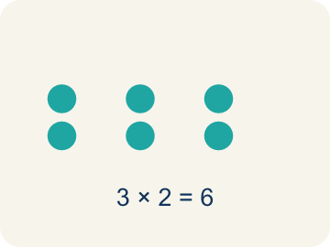 | Multiply Multiplicar  To add equal groups again and again.  Example: 3 × 7 = 21 means 3 groups of 7 equals 21
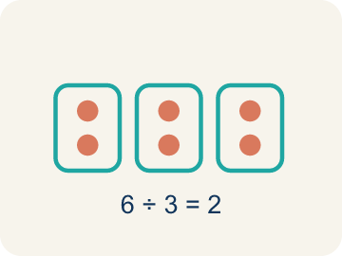 | Divide Dividir  To split into equal groups.  Example: 36 ÷ 4 = 9 means 36 split into 4 equal groups gives 9 per group
 | Isolate Despejar  To get the letter by itself on one side.  Example: 3x = 21 → divide both sides by 3 → x = 7 (x is alone)
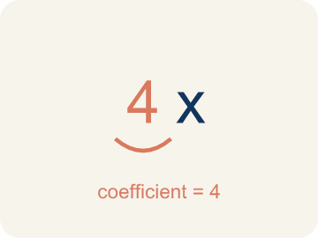 | Coefficient Coeficiente  The number in front of a letter, like the 3 in 3x.  Example: In 6x = 18, the coefficient is 6; divide both sides by 6 to get x = 3.
 | Solution Solución  A number that makes the equation or inequality true.  Example: x = 3 is the solution of 6x = 18 because 6 × 3 = 18.

Guided Notes
Fill in each blank as we go. Use the Word Bank to help you.
WORD BANK
Solve Multiplication and Division Equations • Inverse operation • Multiply • Divide • Isolate • Coefficient • Solution

1. Undo a multiplication by ________________ both sides by the same number.
2. An operation that undoes another, like division undoing multiplication, is an ________________.
3. To undo dividing by a number, I ________________ both sides by that number.
4. To undo multiplying by a number, I ________________ both sides by that number.
5. To get the variable alone on one side is to ________________ it.
6. The number multiplied by a variable is the ________________.
7. The value of the variable that makes an equation true is the ________________.

Write About the Math
Use the support level you need. Every level answers the same math question.

1. Understand the Question explain
How many kits did the detective order? How did inverse operations help you solve this?
Your job: Answer the question. Use math evidence. Explain how the evidence proves your answer.
Responde la pregunta. Usa evidencia matemática. Explica cómo la evidencia demuestra tu respuesta.

2. Plan Your Math Words check at least two
☐ Solve Multiplication and Division Equations — Use inverse multiplication or division to isolate the variable.
Resolver ecuaciones de multiplicación y división — Usar la multiplicación o división inversa para aislar la variable.
☐ Inverse operation — Two math actions that undo each other, like × and ÷.
Operación inversa — Dos operaciones que se deshacen entre sí, como × y ÷.
☐ Multiply — To add equal groups again and again.
Multiplicar — Sumar grupos iguales una y otra vez.
☐ Divide — To split into equal groups.
Dividir — Repartir en grupos iguales.
☐ Isolate — To get the letter by itself on one side.
Despejar — Dejar la letra sola en un lado.
Say it first: Say your idea to a partner or quietly to yourself before you write.
The detective ordered ___ kits because 7k = 63 means k = 63 ÷ ___ = ___.
Di tu respuesta primero: Mi respuesta es ___ porque ___.

3. Build Your Explanation choose your support
This model shows the parts of an explanation. It does not answer your writing question.
Claim: In 3x = 21 the variable is multiplied, so I undo it with division.
Evidence: Students read 3x as 3 groups of x, recognize multiplication, and contrast it with addition, knowing they will divide (not subtract) to solve.
Reasoning: This evidence connects the definition of solve multiplication and division equations to the mathematical claim.

Start Most language support
Complete the frames. Use the word bank.
Completa las oraciones. Usa el banco de palabras.
The detective ordered ___ kits because 7k = 63 means k = 63 ÷ ___ = ___.
My answer is ___.
Mi respuesta es ___.

Build Some language support
Write two connected sentences. Use because, so, or but.
Escribe dos oraciones conectadas. Usa porque, entonces o pero.
My claim is ___.
Mi afirmación es ___.
I know because ___.
Lo sé porque ___.
So ___.
Entonces ___.

Explain Light language support
Write a claim, give math evidence, and explain your reasoning.
Escribe una afirmación, da evidencia matemática y explica tu razonamiento.
My claim is ___.
Mi afirmación es ___.
My math evidence is ___.
Mi evidencia matemática es ___.
This proves ___ because ___.
Esto demuestra ___ porque ___.

4. Check Your Explanation five quick checks
☐ I answered the question.
Respondí la pregunta.
☐ I used math evidence: numbers, an equation, a model, or a comparison.
Usé evidencia matemática: números, una ecuación, un modelo o una comparación.
☐ I explained how the evidence proves my answer.
Expliqué cómo la evidencia demuestra mi respuesta.
☐ I used at least two math words.
Usé por lo menos dos palabras matemáticas.
☐ I reread complete sentences and punctuation.
Volví a leer mis oraciones completas y la puntuación.

Worked Example

Watch & Read I Do — follow along with your teacher
Case File: The Multiplied Evidence
Detective Park discovered that 3 identical locked boxes contain a total of 21 pieces of evidence. She writes the equation 3x = 21 to find how many pieces are in each box. How can she solve for x?

Think about:
• What does the 3 represent in the equation?
• What does x represent?
• What operation connects 3 and x?
• What if there were 5 boxes instead of 3?
• How is solving 3x = 21 different from solving x + 3 = 21?

Solved Example I Do — watch each step
Problem: Solve: 6x = 42
A) x = 7
B) x = 48
C) x = 36
D) x = 252
Step 1: Divide both sides by 6: x = 42 ÷ 6 = 7.
Step 2: Check: 6 × 7 = 42 ✓
Answer: A. x = 7

Exit Ticket
Answer on your own. This shows what you learned today.
★ Solve: w / 8 = 6
A) w = 48
B) w = 14
C) w = 0.75
D) w = 2

Answer Key & Teacher Guide
Teacher reference — remove or fold back before distributing to students.

Guided Notes (Fill-in)
Notes 1: Solve Multiplication and Division Equations
Notes 2: Inverse operation
Notes 3: Multiply
Notes 4: Divide
Notes 5: Isolate
Notes 6: Coefficient
Notes 7: Solution

Worked Notes (I Do / We Do)
I Do: A. x = 7
We Do: A. n = 24

Independent Practice
Watch for this mistake: A common mistake in Solve Multiplication and Division Equations is applying the SAME operation again instead of the inverse — for example, seeing 6x = 42 and multiplying both sides by 6 to get x = 252, instead of dividing by 6 to get x = 7. Before you submit, ask: did I use the OPPOSITE operation shown in the equation, and did I apply it to both sides?

Level 1 Support
1. A) m = 7 — Divide both sides by 9: m = 63 ÷ 9 = 7. Check: 9 × 7 = 63 ✓
2. A) y = 35 — Multiply both sides by 7: y = 5 × 7 = 35. Check: 35 / 7 = 5 ✓

On Level
3. A) c = 6 — Divide both sides by 9: c = 54 ÷ 9 = 6 clues per file.

Exit Ticket
A) w = 48 — Multiply both sides by 8: w = 6 × 8 = 48. Check: 48 / 8 = 6 ✓

Math Writing Criteria
The support level changes the amount of language scaffolding, not the mathematical expectation.
☐ I answered the question.
☐ I used math evidence: numbers, an equation, a model, or a comparison.
☐ I explained how the evidence proves my answer.
☐ I used at least two math words.
☐ I reread complete sentences and punctuation.

