UNIT 8 · LESSON 4 STANDARD 6.AT.9

Write and Represent Inequalities
Student Notes Packet
Name: ______________________ Date: ____________ Period: ________
Level 1 · Support

Today's Goals
Content: I can write inequalities to represent real-world situations.
Language: I can explain my inequality using the words inequality, greater than, less than, and at least / at most.

Key Vocabulary
Look at the picture, read the word, then read what it means.
 | Write Inequalities Escribir desigualdades  Represent a range of possible values with <, >, ≤, or ≥.  Example: You must be at least 12 years old: a ≥ 12.
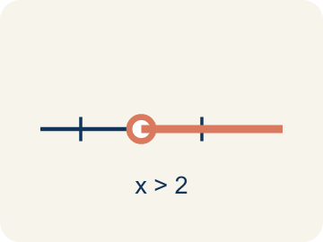 | Inequality Desigualdad  A math sentence that compares two sides with <, >, ≤, or ≥.  Example: x > 5 means x can be 6, 7, 8, ... — any number greater than 5
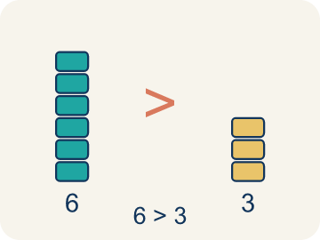 | Greater than Mayor que  The > sign, showing one number is bigger.  Example: 8 > 3 — eight is larger than three
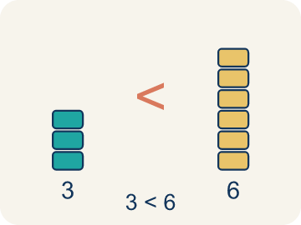 | Less than Menor que  The < sign, showing one number is smaller.  Example: 2 < 7 — two is smaller than seven
 | At least / At most Al menos / A lo más  'At least' means ≥. 'At most' means ≤.  Example: 'At least 10 players' → p ≥ 10 (could be 10, 11, 12, ...); 'At most 5 tries' → t ≤ 5 (could be 5, 4, 3, ...)
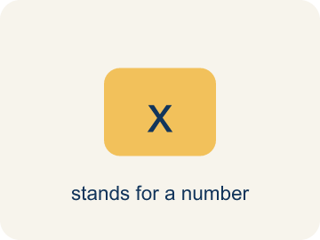 | Variable Variable  A letter that stands for a number that is unknown or can change.  Example: In x > 5, the letter x stands for any number greater than 5.
 | No more than No más de  A phrase meaning less than or equal to (≤).  Example: “No more than 8 people” means people ≤ 8.

Guided Notes
Fill in each blank as we go. Use the Word Bank to help you.
WORD BANK
Write Inequalities • Inequality • Greater than • Less than • At least / At most • Variable • No more than

1. Use <, >, ≤ or ≥ when the answer is a ________________ of values rather than one.
2. A math sentence comparing values with <, >, ≤, or ≥ is an ________________.
3. The symbol > that means one value is larger than another means ________________.
4. The symbol < that means one value is smaller than another means ________________.
5. 'At least' means greater than or equal to, and 'at most' means ________________ than or equal to.
6. A letter that stands for an unknown number is a ________________.
7. The phrase that means less than or equal to is "no more than," written with the ________________ symbol.

Write About the Math
Use the support level you need. Every level answers the same math question.

1. Understand the Question explain
What speeds are possible for the getaway car? How did the phrase 'at most' help you write the inequality?
Your job: Answer the question. Use math evidence. Explain how the evidence proves your answer.
Responde la pregunta. Usa evidencia matemática. Explica cómo la evidencia demuestra tu respuesta.

2. Plan Your Math Words check at least two
☐ Write Inequalities — Represent a range of possible values with <, >, ≤, or ≥.
Escribir desigualdades — Representar un rango de valores posibles con <, >, ≤ o ≥.
☐ Inequality — A math sentence that compares two sides with <, >, ≤, or ≥.
Desigualdad — Una oración matemática que compara dos lados con <, >, ≤ o ≥.
☐ Greater than — The > sign, showing one number is bigger.
Mayor que — El signo >, que muestra que un número es mayor.
☐ Less than — The < sign, showing one number is smaller.
Menor que — El signo <, que muestra que un número es menor.
☐ At least / At most — 'At least' means ≥. 'At most' means ≤.
Al menos / A lo más — 'Al menos' significa ≥. 'Como máximo' significa ≤.
Say it first: Say your idea to a partner or quietly to yourself before you write.
A speed of 65 mph is ___, a speed of 70 mph is ___, because 'at most 65' means the speed must be ___ 65.
Di tu respuesta primero: Mi respuesta es ___ porque ___.

3. Build Your Explanation choose your support
This model shows the parts of an explanation. It does not answer your writing question.
Claim: The age could be 18 or any number greater, so it is not a single value.
Evidence: Students explain that 'at least 18' allows many values (18 and up), so an inequality with ≥ captures it while an equation would force one value.
Reasoning: This evidence connects the definition of write inequalities to the mathematical claim.

Start Most language support
Complete the frames. Use the word bank.
Completa las oraciones. Usa el banco de palabras.
A speed of 65 mph is ___, a speed of 70 mph is ___, because 'at most 65' means the speed must be ___ 65.
My answer is ___.
Mi respuesta es ___.

Build Some language support
Write two connected sentences. Use because, so, or but.
Escribe dos oraciones conectadas. Usa porque, entonces o pero.
My claim is ___.
Mi afirmación es ___.
I know because ___.
Lo sé porque ___.
So ___.
Entonces ___.

Explain Light language support
Write a claim, give math evidence, and explain your reasoning.
Escribe una afirmación, da evidencia matemática y explica tu razonamiento.
My claim is ___.
Mi afirmación es ___.
My math evidence is ___.
Mi evidencia matemática es ___.
This proves ___ because ___.
Esto demuestra ___ porque ___.

4. Check Your Explanation five quick checks
☐ I answered the question.
Respondí la pregunta.
☐ I used math evidence: numbers, an equation, a model, or a comparison.
Usé evidencia matemática: números, una ecuación, un modelo o una comparación.
☐ I explained how the evidence proves my answer.
Expliqué cómo la evidencia demuestra mi respuesta.
☐ I used at least two math words.
Usé por lo menos dos palabras matemáticas.
☐ I reread complete sentences and punctuation.
Volví a leer mis oraciones completas y la puntuación.

Worked Example

Watch & Read I Do — follow along with your teacher
Case File: The Suspect Constraints
Detective Navarro is narrowing down suspects. A witness says the suspect is at least 18 years old. The detective writes the inequality a ≥ 18, where a is the suspect's age. How does this help eliminate suspects?

Think about:
• What does 'at least 18' mean about the suspect's age?
• Could the suspect be exactly 18?
• How is an inequality different from an equation?
• What if the witness said the suspect was less than 30 years old?
• Could you combine two inequalities to narrow it down even more?

Solved Example I Do — watch each step
Problem: Which inequality represents: 'The temperature is less than 40 degrees'?
A) t < 40
B) t > 40
C) t ≤ 40
D) t = 40
Step 1: 'Less than' means <, so the inequality is t < 40.
Answer: A. t < 40

Guided Practice

Solve Together We Do — work with your class
Problem: Which inequality represents: 'You must be at least 48 inches tall to ride'?
A) h ≥ 48
B) h > 48
C) h < 48
D) h ≤ 48
Step 1:

Step 2:

Answer:

A detective knows the getaway car was traveling at most 65 miles per hour on the highway. The inequality s ≤ 65 represents the car's speed s.
What speeds are possible for the getaway car? How did the phrase 'at most' help you write the inequality?

Sentence frame: A speed of 65 mph is ___, a speed of 70 mph is ___, because 'at most 65' means the speed must be ___ 65.

Turn & Talk discuss with a partner
1. [Launch] A witness says the suspect is 'at least 18 years old,' written as a ≥ 18. Why does the detective use an inequality here instead of an equation like a = 18?
Start with: An inequality fits better than an equation because ___.
Una desigualdad encaja mejor que una ecuación porque ___.
Word bank: inequality, greater than, less than, at least / at most
2. [Explore] How do the phrases 'at least' and 'at most' change which inequality symbol you choose compared to 'more than' and 'fewer than'?
Start with: 'At least' uses ___ because it ___ the number, but 'more than' uses ___.
'Al menos' usa ___ porque ___ el número, pero 'más que' usa ___.
Word bank: inequality, greater than, less than, at least / at most
3. [Connect] Where do you see inequalities in real life, such as age limits or speed limits?
Start with: I see an inequality when ___, and I would write ___.
Veo una desigualdad cuando ___, y escribiría ___.
Word bank: inequality, greater than, less than, at least / at most
4. [Practice] During practice on Write Inequalities, what strategy did you use when a problem felt tricky?
Start with: 'At least' uses ___ because it ___ the number, but 'more than' uses ___.
'Al menos' usa ___ porque ___ el número, pero 'más que' usa ___.
Word bank: Inequality, Greater than, Less than, At least / At most

Independent Practice

On Your Own You Do — show your work
Solve each problem. Show your thinking in the work box.

Level 1 Support extra scaffolding
1. Which inequality represents: 'A store can hold no more than 75 people'?
A) p ≤ 75
B) p < 75
C) p ≥ 75
D) p > 75

2. Which inequality represents: 'The speed limit is more than 25 mph'?
A) s > 25
B) s ≥ 25
C) s < 25
D) s = 25

Exit Ticket
Answer on your own. This shows what you learned today.
★ Which inequality represents: 'A number n is at least 14'?
A) n ≥ 14
B) n > 14
C) n ≤ 14
D) n < 14

Answer Key & Teacher Guide
Teacher reference — remove or fold back before distributing to students.

Guided Notes (Fill-in)
Notes 1: Write Inequalities
Notes 2: Inequality
Notes 3: Greater than
Notes 4: Less than
Notes 5: At least / At most
Notes 6: Variable
Notes 7: No more than

Worked Notes (I Do / We Do)
I Do: A. t < 40
We Do: A. h ≥ 48

Independent Practice
Watch for this mistake: A common mistake in Write Inequalities is using a strict symbol (> or <) for a phrase that actually includes the boundary value. For 'the suspect is at least 18 years old,' students often write a > 18 instead of the correct a ≥ 18 — this wrongly excludes 18 itself, even though 'at least 18' means 18 counts as a match. The same error happens in reverse with 'at most': for 'the getaway bag holds at most 12 items,' students write n < 12 instead of n ≤ 12. Always ask: does the key phrase include the number ('at least,' 'at most,' 'no more than,' 'no fewer than' → use ≥ or ≤) or exclude it ('more than,' 'fewer than' → use > or <)?

Level 1 Support
1. A) p ≤ 75 — 'No more than' means less than or equal to, so p ≤ 75.
2. A) s > 25 — 'More than' means strictly greater than, so s > 25.

On Level
3. A) t > 2 — 'More than 2 hours' means strictly greater than: t > 2. Exactly 2 hours is not charged.

Exit Ticket
A) n ≥ 14 — 'At least 14' means 14 or greater, so n ≥ 14.

Math Writing Criteria
The support level changes the amount of language scaffolding, not the mathematical expectation.
☐ I answered the question.
☐ I used math evidence: numbers, an equation, a model, or a comparison.
☐ I explained how the evidence proves my answer.
☐ I used at least two math words.
☐ I reread complete sentences and punctuation.

