UNIT 8 · LESSON 5 STANDARD 6.AT.9

Understand Inequalities and Their Solutions
Student Notes Packet
Name: ______________________ Date: ____________ Period: ________
Level 3 · Enrichment

Today's Goals
Content: I can graph the solutions of an inequality on a number line.
Language: I can explain my graph using the words number line, open circle, closed circle, and solution set.

Key Vocabulary
Look at the picture, read the word, then read what it means.
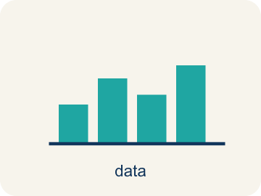 | Graph Inequalities Representar desigualdades en una recta numérica  Show every solution to an inequality on a number line with a boundary point and an arrow.  Example: x > 3 uses an open circle at 3 and an arrow to the right.
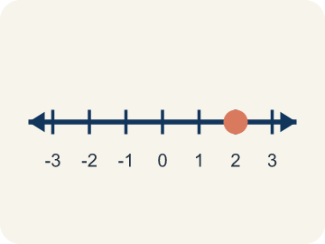 | Number line Recta numérica  A straight line where numbers are placed in order; numbers get smaller to the left and larger to the right.  Example: A horizontal line with marks at 0, 1, 2, 3, ... showing where values fall
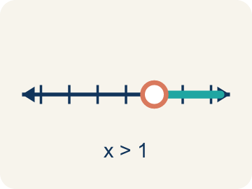 | Open circle Círculo abierto  An empty circle showing a number is NOT included.  Example: x > 5: open circle at 5 means 5 itself is NOT a solution, but 5.1, 6, 7, ... are
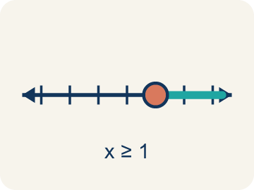 | Closed circle Círculo cerrado  A filled-in circle showing a number IS included.  Example: x ≥ 5: closed circle at 5 means 5 IS a solution, and so are 6, 7, 8, ...
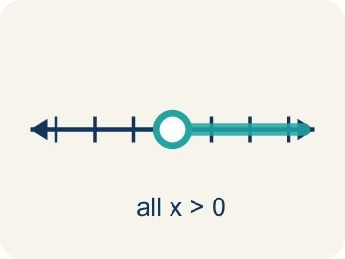 | Solution set Conjunto solución  All the numbers that make the inequality true.  Example: For x > 3, the solution set includes 3.1, 4, 5, 10, 100 — any number greater than 3
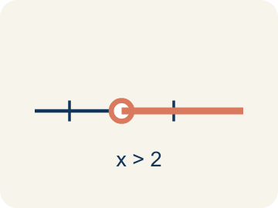 | Inequality Desigualdad  A math sentence that compares two sides with <, >, ≤, or ≥.  Example: x ≥ 3 is an inequality; it is graphed as a closed circle on 3 with an arrow to the right.
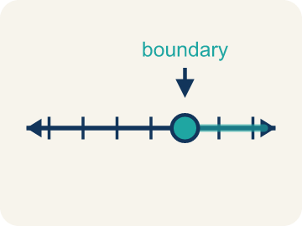 | Boundary point Punto límite  The number on the number line where the solution set starts.  Example: For x > 5, the boundary point is 5, shown with an open circle.

Guided Notes
Fill in each blank as we go. Use the Word Bank to help you.
WORD BANK
Graph Inequalities • Number line • Open circle • Closed circle • Solution set • Inequality • Boundary point

1. Mark the ________________ ________________, then shade every value that makes it true.
2. A line with numbers in order used to show values and solutions is a ________________.
3. A hollow circle that shows a value is NOT included, used for < or >, is an ________________.
4. A filled-in circle that shows a value IS included, used for ≤ or ≥, is a ________________.
5. All the values that make an inequality true form the ________________.
6. A math sentence comparing two amounts with <, >, ≤, or ≥ is an ________________.
7. The number where the solution set begins on the number line is the ________________.

Write About the Math
Use the support level you need. Every level answers the same math question.

1. Understand the Question explain
Why did the detective use an open circle instead of a closed circle? What values of p are possible?
Your job: Answer the question. Use math evidence. Explain how the evidence proves your answer.
Responde la pregunta. Usa evidencia matemática. Explica cómo la evidencia demuestra tu respuesta.

2. Plan Your Math Words check at least two
☐ Graph Inequalities — Show every solution to an inequality on a number line with a boundary point and an arrow.
Representar desigualdades en una recta numérica — Mostrar cada solución de una desigualdad en una recta numérica con un punto límite y una flecha.
☐ Number line — A straight line where numbers are placed in order; numbers get smaller to the left and larger to the right.
Recta numérica — Una recta donde los números se colocan en orden; los números son menores a la izquierda y mayores a la derecha.
☐ Open circle — An empty circle showing a number is NOT included.
Círculo abierto — Un círculo vacío que muestra que un número NO está incluido.
☐ Closed circle — A filled-in circle showing a number IS included.
Círculo cerrado — Un círculo relleno que muestra que un número SÍ está incluido.
☐ Solution set — All the numbers that make the inequality true.
Conjunto solución — Todos los números que hacen verdadera la desigualdad.
Say it first: Say your idea to a partner or quietly to yourself before you write.
The detective used an open circle because ___ means 12 is ___ included, so possible values are numbers ___ than 12.
Di tu respuesta primero: Mi respuesta es ___ porque ___.

3. Build Your Explanation choose your support
This model shows the parts of an explanation. It does not answer your writing question.
Claim: Because 2:00 itself counts, I use a closed circle at 2.
Evidence: Students choose a closed circle at 2 (because 'no earlier than' includes 2) and shade to the right since later times satisfy t ≥ 2.
Reasoning: This evidence connects the definition of graph inequalities to the mathematical claim.

Start Most language support
Complete the frames. Use the word bank.
Completa las oraciones. Usa el banco de palabras.
The detective used an open circle because ___ means 12 is ___ included, so possible values are numbers ___ than 12.
My answer is ___.
Mi respuesta es ___.

Build Some language support
Write two connected sentences. Use because, so, or but.
Escribe dos oraciones conectadas. Usa porque, entonces o pero.
My claim is ___.
Mi afirmación es ___.
I know because ___.
Lo sé porque ___.
So ___.
Entonces ___.

Explain Light language support
Write a claim, give math evidence, and explain your reasoning.
Escribe una afirmación, da evidencia matemática y explica tu razonamiento.
My claim is ___.
Mi afirmación es ___.
My math evidence is ___.
Mi evidencia matemática es ___.
This proves ___ because ___.
Esto demuestra ___ porque ___.

4. Check Your Explanation five quick checks
☐ I answered the question.
Respondí la pregunta.
☐ I used math evidence: numbers, an equation, a model, or a comparison.
Usé evidencia matemática: números, una ecuación, un modelo o una comparación.
☐ I explained how the evidence proves my answer.
Expliqué cómo la evidencia demuestra mi respuesta.
☐ I used at least two math words.
Usé por lo menos dos palabras matemáticas.
☐ I reread complete sentences and punctuation.
Volví a leer mis oraciones completas y la puntuación.

Worked Example

Watch & Read I Do — follow along with your teacher
Case File: The Timeline
Detective Okafor is building a timeline. The suspect was seen at the scene no earlier than 2:00 PM, meaning the arrival time t satisfies t ≥ 2. She needs to plot this on a timeline to share with her team. How should she mark the number line?

Think about:
• What does 'no earlier than 2:00 PM' mean about the time?
• Should 2:00 PM itself be included?
• Which direction on the number line would you shade?
• What would the graph look like if the suspect arrived before 2:00 PM?
• How would you show the difference between t > 2 and t ≥ 2 on a number line?

Solved Example I Do — watch each step
Problem: Which graph represents x < 5?
A) Open circle at 5, shaded left
B) Closed circle at 5, shaded left
C) Open circle at 5, shaded right
D) Closed circle at 5, shaded right
Step 1: x < 5 means 5 is NOT included (open circle) and values less than 5 are shaded (left).
Answer: A. Open circle at 5, shaded left

Exit Ticket
Answer on your own. This shows what you learned today.
★ How would you graph the inequality x ≥ 9?
A) Closed circle at 9, shaded right
B) Open circle at 9, shaded right
C) Closed circle at 9, shaded left
D) Open circle at 9, shaded left

