UNIT 8 · LESSON 7 STANDARD 6.AT.8

Equations and Inequalities Problem Solving
Student Notes Packet
Name: ______________________ Date: ____________ Period: ________
Level 2 · Standard

Today's Goals
Content: I can model and solve real-world problems using equations and inequalities.
Language: I can explain my reasoning using the words model, equation, inequality, and reasonableness.

Key Vocabulary
Look at the picture, read the word, then read what it means.
 | Equations and Inequalities Problem Solving Resolución de problemas con ecuaciones y desigualdades  Use an equation for one exact value or an inequality for a range of values in a real situation.  Example: Exactly $20: 4x = 20. At most $20: 4x ≤ 20.
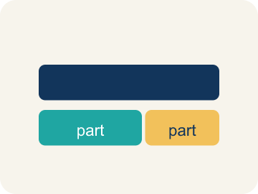 | Model Modelar  To show a real-life situation with an equation or inequality.  Example: 'Twice a number is 18' → 2n = 18 — the equation models the words
 | Equation Ecuación  A math sentence with an equal sign showing both sides are the same.  Example: x + 8 = 15 — exactly one answer: x = 7
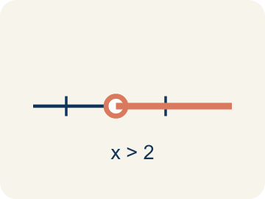 | Inequality Desigualdad  A math sentence that compares two sides with <, >, ≤, or ≥.  Example: x + 5 > 12 — many answers: x = 8, 9, 10, ...
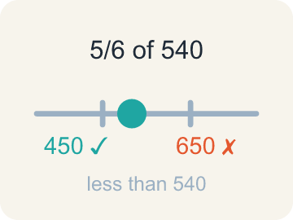 | Reasonableness Razonabilidad  Checking if your answer makes sense.  Example: If the problem asks for a number of people and you get x = −3, that is NOT reasonable
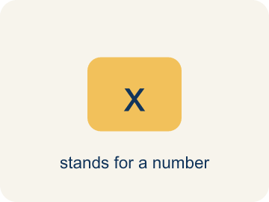 | Variable Variable  A letter that stands for a number that is unknown or can change.  Example: “5 less than a number is 12” becomes x − 5 = 12, where x is the variable.
 | Constraint Restricción  A limit in a problem that tells what values are allowed.  Example: “You can spend at most $20” is a constraint: cost ≤ 20.

Guided Notes
Fill in each blank as we go. Use the Word Bank to help you.
WORD BANK
Equations and Inequalities Problem Solving • Model • Equation • Inequality • Reasonableness • Variable • Constraint

1. Use an equation for one exact value and an ________________ for a range.
2. A drawing, equation, or diagram that represents a situation is a ________________.
3. A math sentence with an equal sign is an ________________.
4. A math sentence that compares values with <, >, ≤, or ≥ is an ________________.
5. Checking whether an answer makes sense for the problem is checking its ________________.
6. A letter that stands for the unknown amount in a problem is a ________________.
7. A limit that tells which values are allowed in a problem is a ________________.

Write About the Math
Use the support level you need. Every level answers the same math question.

1. Understand the Question explain
How much more can the detective spend? How much does each flashlight cost? When do you use an equation versus an inequality?
Your job: Answer the question. Use math evidence. Explain how the evidence proves your answer.
Responde la pregunta. Usa evidencia matemática. Explica cómo la evidencia demuestra tu respuesta.

2. Plan Your Math Words check at least two
☐ Equations and Inequalities Problem Solving — Use an equation for one exact value or an inequality for a range of values in a real situation.
Resolución de problemas con ecuaciones y desigualdades — Usar una ecuación para un valor exacto o una desigualdad para un rango de valores en una situación real.
☐ Model — To show a real-life situation with an equation or inequality.
Modelar — Mostrar una situación real con una ecuación o desigualdad.
☐ Equation — A math sentence with an equal sign showing both sides are the same.
Ecuación — Una oración matemática con un signo igual que muestra que ambos lados son iguales.
☐ Inequality — A math sentence that compares two sides with <, >, ≤, or ≥.
Desigualdad — Una oración matemática que compara dos lados con <, >, ≤ o ≥.
☐ Reasonableness — Checking if your answer makes sense.
Razonabilidad — Revisar si tu respuesta tiene sentido.
Say it first: Say your idea to a partner or quietly to yourself before you write.
The detective can spend at most $__ more because r ≤ 500 − ___ = ___. Each flashlight costs $__ because f = 60 ÷ ___ = ___.
Di tu respuesta primero: Mi respuesta es ___ porque ___.

3. Build Your Explanation choose your support
This model shows the parts of an explanation. It does not answer your writing question.
Claim: An exact total points to an equation; a limit or range points to an inequality.
Evidence: Students use signal words ('equals/total' for an equation; 'at least/at most/no more than' for an inequality) to choose the correct model.
Reasoning: This evidence connects the definition of equations and inequalities problem solving to the mathematical claim.

Start Most language support
Complete the frames. Use the word bank.
Completa las oraciones. Usa el banco de palabras.
The detective can spend at most $__ more because r ≤ 500 − ___ = ___. Each flashlight costs $__ because f = 60 ÷ ___ = ___.
My answer is ___.
Mi respuesta es ___.

Build Some language support
Write two connected sentences. Use because, so, or but.
Escribe dos oraciones conectadas. Usa porque, entonces o pero.
My claim is ___.
Mi afirmación es ___.
I know because ___.
Lo sé porque ___.
So ___.
Entonces ___.

Explain Light language support
Write a claim, give math evidence, and explain your reasoning.
Escribe una afirmación, da evidencia matemática y explica tu razonamiento.
My claim is ___.
Mi afirmación es ___.
My math evidence is ___.
Mi evidencia matemática es ___.
This proves ___ because ___.
Esto demuestra ___ porque ___.

4. Check Your Explanation five quick checks
☐ I answered the question.
Respondí la pregunta.
☐ I used math evidence: numbers, an equation, a model, or a comparison.
Usé evidencia matemática: números, una ecuación, un modelo o una comparación.
☐ I explained how the evidence proves my answer.
Expliqué cómo la evidencia demuestra mi respuesta.
☐ I used at least two math words.
Usé por lo menos dos palabras matemáticas.
☐ I reread complete sentences and punctuation.
Volví a leer mis oraciones completas y la puntuación.

Worked Example

Watch & Read I Do — follow along with your teacher
Case File: The Final Puzzle
Detective Santos is closing a complex case. She has collected equations and inequalities from different parts of the investigation. One clue says: 'The total value of stolen items divided equally among 4 accomplices gave each person $85.' Another says: 'The lookout earned less than $50.' She must model both clues mathematically and check if the answers are reasonable. Can you help?

Think about:
• Which clue leads to an equation and which leads to an inequality?
• What operation does 'divided equally among 4' suggest?
• What does 'less than $50' tell you about the inequality symbol?
• How do you decide when to use an equation versus an inequality?
• What would happen if the lookout earned exactly $50 — would the clue still work?

Solved Example I Do — watch each step
Problem: A museum has some paintings. After adding 12, they have 45. Which equation models this?
A) p + 12 = 45
B) p − 12 = 45
C) 12p = 45
D) p / 12 = 45
Step 1: 'Adding 12' to the original number gives 45: p + 12 = 45.
Step 2: Solve: p = 33.
Answer: A. p + 12 = 45

Guided Practice

Solve Together We Do — work with your class
Problem: A detective needs more than 8 hours to finish the investigation. She has already worked 3 hours. Which inequality represents the additional hours h she needs?
A) 3 + h > 8
B) 3 + h = 8
C) h > 3
D) 8 + h > 3
Step 1:

Step 2:

Answer:

A detective has a $500 budget for equipment. She has already spent $320. The inequality 320 + r ≤ 500 represents the remaining amount r she can spend. She also needs exactly 4 flashlights at $15 each, represented by the equation 4f = 60.
How much more can the detective spend? How much does each flashlight cost? When do you use an equation versus an inequality?

Sentence frame: The detective can spend at most $__ more because r ≤ 500 − ___ = ___. Each flashlight costs $__ because f = 60 ÷ ___ = ___.

Turn & Talk discuss with a partner
1. [Launch] Before solving a word problem, how do you decide whether to model it with an equation or an inequality?
Start with: I would model this with a(n) ___ because the problem says ___.
Modelaría esto con un(a) ___ porque el problema dice ___.
Word bank: model, equation, inequality, reasonableness
2. [Explore] What was your plan to solve this problem, and how did you check that your answer was reasonable?
Start with: My plan was to ___, and I knew to ___ because ___.
Mi plan fue ___, y supe ___ porque ___.
Word bank: model, equation, inequality, reasonableness
3. [Connect] Describe a real situation that an equation or inequality could model, and explain which one you would use.
Start with: A real situation is ___, which I would model with a(n) ___.
Una situación real es ___, que modelaría con un(a) ___.
Word bank: model, equation, inequality, reasonableness
4. [Practice] During practice on Equations and Inequalities Problem Solving, what strategy did you use when a problem felt tricky?
Start with: My plan was to ___, and I knew to ___ because ___.
Mi plan fue ___, y supe ___ porque ___.
Word bank: Model, Equation, Inequality, Reasonableness

Independent Practice

On Your Own You Do — show your work
Solve each problem. Show your thinking in the work box.

On Level grade-level practice
1. A student solved 4n = 52 and got n = 13. Is the answer reasonable if n represents the number of notebooks in a box?
A) Yes — 13 notebooks per box is reasonable
B) No — 13 is too many notebooks
C) No — the answer should be 48
D) Yes — but only if n is a fraction

Exit Ticket
Answer on your own. This shows what you learned today.
★ A box of donuts has some donuts. After giving away 7, there are fewer than 5 left. Which inequality represents the starting number of donuts d?
A) d − 7 < 5
B) d + 7 < 5
C) d − 7 > 5
D) d − 7 = 5

Answer Key & Teacher Guide
Teacher reference — remove or fold back before distributing to students.

Guided Notes (Fill-in)
Notes 1: Equations and Inequalities Problem Solving
Notes 2: Model
Notes 3: Equation
Notes 4: Inequality
Notes 5: Reasonableness
Notes 6: Variable
Notes 7: Constraint

Worked Notes (I Do / We Do)
I Do: A. p + 12 = 45
We Do: A. 3 + h > 8

Independent Practice
Watch for this mistake: A common mistake in Equations and Inequalities Problem Solving is matching the wrong model to a key phrase. For 'the getaway car held no more than 6 bags,' students often write the equation b = 6 instead of the inequality b ≤ 6, because they see one number and assume it must be exact. The same mistake happens in reverse: for 'the reward split equally among 5 people gave each $40,' students sometimes write the inequality 5p ≥ 40 instead of the equation 5p = 40, because 'split equally' sounds like it could mean a range. Before you submit, ask: does this phrase give one exact value (equation, =) or a limit/range (inequality, <, >, ≤, ≥)?

Level 1 Support
1. A) n / 6 = 7 — Divided by 6 is n / 6. Equals 7 means = 7. So n / 6 = 7.
2. A) 31 + p ≤ 48 — 'At most 48' means the total must be ≤ 48. So 31 + p ≤ 48. Solve: p ≤ 17.

On Level
3. A) Yes — 13 notebooks per box is reasonable — 4 × 13 = 52 ✓. 13 notebooks per box is a reasonable whole number answer.

Exit Ticket
A) d − 7 < 5 — Starting with d donuts and giving away 7 leaves fewer than 5: d − 7 < 5. Solve: d < 12. ✓

Math Writing Criteria
The support level changes the amount of language scaffolding, not the mathematical expectation.
☐ I answered the question.
☐ I used math evidence: numbers, an equation, a model, or a comparison.
☐ I explained how the evidence proves my answer.
☐ I used at least two math words.
☐ I reread complete sentences and punctuation.

