UNIT 9 · LESSON 1 STANDARD 6.AT.11

Explore Relationships Between Two Variables
Student Notes Packet
Name: ______________________ Date: ____________ Period: ________
Level 3 · Enrichment

Today's Goals
Content: I can recognize when two quantities change together, and identify which one is the independent variable and which is the dependent variable.
Language: I can explain which quantity depends on the other using the words independent variable, dependent variable, and depends on.

Key Vocabulary
Look at the picture, read the word, then read what it means.
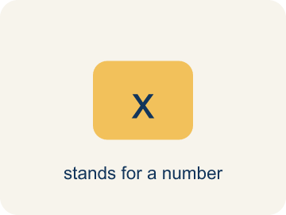 | independent variable variable independiente  The quantity that is subject to choice. It does not depend on the other quantity.  Example: Miguel picks the number of MONTHS — nothing else decides it for him.
 | dependent variable variable dependiente  The quantity that changes in response to the independent variable.  Example: Total cost = $24.95 × months — the cost RESPONDS to the months.
 | depends on depende de  One quantity depends on another when changing the first causes the second to change.  Example: “Total cost depends on the number of months.” Responder first, chooser last.
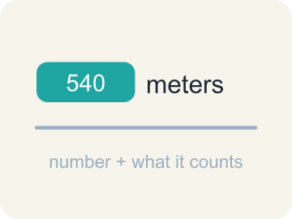 | quantity cantidad  Something that can be counted or measured.  Example: 24.95 dollars per month, 12 months — each is a number with a meaning.
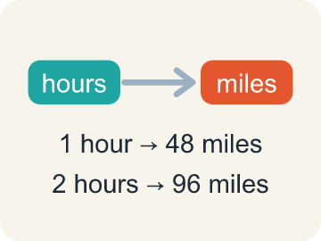 | relationship relación  How two quantities change together.  Example: 1 month → $24.95, 2 months → $49.90: the two quantities move together.

Guided Notes
Fill in each blank as we go. Use the Word Bank to help you.
WORD BANK
independent variable • dependent variable • depends on • quantity • relationship

1. The quantity that is subject to choice is the ________________ ________________.
2. The quantity that changes in response to the other is the ________________ ________________.
3. Say it in order: the responding quantity ________________ ________________ the chosen one.
4. Something that can be counted or measured is a ________________.
5. How two quantities change together is a ________________.

Write About the Math
Use the support level you need. Every level answers the same math question.

1. Understand the Question explain
Which two quantities in this shop are related, so that one depends on the other — and which quantity does NOT depend on the number of pizzas at all?
Your job: Answer the question. Use math evidence. Explain how the evidence proves your answer.
Responde la pregunta. Usa evidencia matemática. Explica cómo la evidencia demuestra tu respuesta.

2. Plan Your Math Words check at least two
☐ independent variable — The quantity that is subject to choice. It does not depend on the other quantity.
variable independiente — La cantidad que se elige. No depende de la otra cantidad.
☐ dependent variable — The quantity that changes in response to the independent variable.
variable dependiente — La cantidad que cambia en respuesta a la variable independiente.
☐ depends on — One quantity depends on another when changing the first causes the second to change.
depende de — Una cantidad depende de otra cuando cambiar la primera hace cambiar la segunda.
☐ quantity — Something that can be counted or measured.
cantidad — Algo que se puede contar o medir.
☐ relationship — How two quantities change together.
relación — Cómo dos cantidades cambian juntas.
Say it first: Say your idea to a partner or quietly to yourself before you write.
In this scenario, the ___ is the independent variable. The ___ and the ___ both depend on it. The number of ___ stays the same no matter how many pizzas are made.
Di tu respuesta primero: Mi respuesta es ___ porque ___.

3. Build Your Explanation choose your support
This model shows the parts of an explanation. It does not answer your writing question.
Claim: Akela chose where to place each tray, which set the hours of sunlight; the plant height was measured afterward, in response to the sunlight.
Evidence: A strong answer names sunlight as chosen (independent) and height as responding (dependent), and can say the sentence 'height depends on sunlight.' A weak answer just says 'height is bigger' without naming which quantity was chosen.
Reasoning: This evidence connects the definition of relationship to the mathematical claim.

Start Most language support
Complete the frames. Use the word bank.
Completa las oraciones. Usa el banco de palabras.
In this scenario, the ___ is the independent variable. The ___ and the ___ both depend on it. The number of ___ stays the same no matter how many pizzas are made.
My answer is ___.
Mi respuesta es ___.

Build Some language support
Write two connected sentences. Use because, so, or but.
Escribe dos oraciones conectadas. Usa porque, entonces o pero.
My claim is ___.
Mi afirmación es ___.
I know because ___.
Lo sé porque ___.
So ___.
Entonces ___.

Explain Light language support
Write a claim, give math evidence, and explain your reasoning.
Escribe una afirmación, da evidencia matemática y explica tu razonamiento.
My claim is ___.
Mi afirmación es ___.
My math evidence is ___.
Mi evidencia matemática es ___.
This proves ___ because ___.
Esto demuestra ___ porque ___.

4. Check Your Explanation five quick checks
☐ I answered the question.
Respondí la pregunta.
☐ I used math evidence: numbers, an equation, a model, or a comparison.
Usé evidencia matemática: números, una ecuación, un modelo o una comparación.
☐ I explained how the evidence proves my answer.
Expliqué cómo la evidencia demuestra mi respuesta.
☐ I used at least two math words.
Usé por lo menos dos palabras matemáticas.
☐ I reread complete sentences and punctuation.
Volví a leer mis oraciones completas y la puntuación.

Worked Example

Watch & Read I Do — follow along with your teacher
Unit 9 · Lesson 1
Akela planted three trays of bean seeds for a science experiment. Each tray sat in a different spot, so each got a different amount of sunlight per day. After three weeks she measured the average plant height in every tray. Two quantities in that experiment are related: change the sunlight and the height changes with it. One of them Akela chose, and the other one answered back. Today you will name which quantity is the independent one and which depends on it, and you will find pairs like this in a jogging tracker and a pizza shop.

Solved Example I Do — watch each step
Problem: Akela chooses how many hours of sunlight each tray gets. Which is the INDEPENDENT variable?
A) Hours of sunlight
B) Plant height
C) Number of trays
D) Number of seeds
Step 1: Akela chooses the sunlight, so sunlight is subject to choice — that makes it independent.
Answer: A. Hours of sunlight

Independent Practice

On Your Own You Do — show your work
Solve each problem. Show your thinking in the work box.

Level 2 Enrichment stretch your thinking
1. Two quantities are related. Which statement is ALWAYS true?
A) The independent variable is subject to choice
B) The independent variable is always the larger number
C) The dependent variable is always measured in dollars
D) The independent variable is always listed first in a table

2. Give an example where the SAME quantity can be independent in one problem and dependent in another.
A) Time: chosen when you pick how long to jog, but measured as a result when you run a set distance
B) Time is always independent
C) Time is always dependent
D) A quantity can never switch roles

3. The pizza shop spends $1.15 on cheese per pizza. Which weekly total is correct if it makes 200 pizzas?
A) $230
B) $115
C) $201.15
D) $1,150

4. Which relationship is NOT a case of one quantity depending on the other?
A) A student's height and their house number
B) Hours studied and quiz score
C) Minutes jogged and Calories burned
D) Pizzas made and cheese used

5. Write the relationship as a sentence: a printer prints 12 pages per minute.
A) Pages printed depends on minutes running
B) Minutes running depends on pages printed
C) 12 depends on the number of pages
D) The printer depends on the pages

Exit Ticket
Answer on your own. This shows what you learned today.
★ A dog walker charges by the hour. Which sentence is correct?
A) The total charge depends on the number of hours, so hours is the independent variable.
B) The number of hours depends on the total charge, so the charge is the independent variable.
C) Both quantities are independent variables.
D) Neither quantity depends on the other.

