UNIT 9 · LESSON 2 STANDARD 6.AT.11

Analyze Graphs of Relationships Between Two Variables
Student Notes Packet
Name: ______________________ Date: ____________ Period: ________
Level 2 · Standard

Today's Goals
Content: I can use a table and a graph to determine and analyze the relationship between two variable quantities.
Language: I can describe what a point on a graph represents using the words ordered pair, axis, and coordinates.

Key Vocabulary
Look at the picture, read the word, then read what it means.
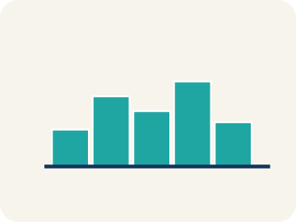 | graph gráfica  A picture on a coordinate plane that shows how two quantities are related.  Example: Points (1, 45), (2, 90), (3, 135) climbing left to right — cost by tickets.
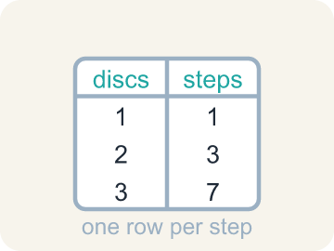 | table of values tabla de valores  A list of matched pairs of values that shows a relationship using numbers.  Example: months 1, 2, 4 beside cost 24.95, 49.90, 99.80 — one row per pair.
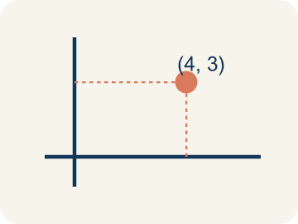 | ordered pair par ordenado  Two numbers written as (x, y) that name one point on a graph. The independent variable comes first.  Example: (3, 135): 3 tickets cost $135 — the independent quantity comes first.
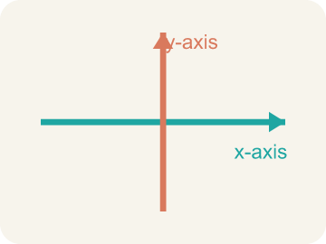 | axis eje  One of the two number lines that frame a graph. Each axis is labeled with a quantity from the problem.  Example: Horizontal axis: months. Vertical axis: total cost.
 | coordinates coordenadas  The numbers in an ordered pair that tell how far to move along each axis to reach a point.  Example: In (4, 105), 4 says how far across and 105 how far up.

Guided Notes
Fill in each blank as we go. Use the Word Bank to help you.
WORD BANK
graph • table of values • ordered pair • axis • coordinates

1. A picture on the coordinate plane showing how two quantities relate is a ________________.
2. A list of matched pairs that shows a relationship in numbers is a ________________ ________________ ________________.
3. Two numbers written (x, y) that name one point are an ________________ ________________.
4. Each number line framing a graph, labeled with a quantity, is an ________________.
5. The numbers in an ordered pair that tell how far to move are its ________________.

Write About the Math
Use the support level you need. Every level answers the same math question.

1. Understand the Question explain
What observations can you make about the data using the graph?
Your job: Answer the question. Use math evidence. Explain how the evidence proves your answer.
Responde la pregunta. Usa evidencia matemática. Explica cómo la evidencia demuestra tu respuesta.

2. Plan Your Math Words check at least two
☐ graph — A picture on a coordinate plane that shows how two quantities are related.
gráfica — Un dibujo en un plano de coordenadas que muestra cómo se relacionan dos cantidades.
☐ table of values — A list of matched pairs of values that shows a relationship using numbers.
tabla de valores — Una lista de pares de valores que muestra una relación usando números.
☐ ordered pair — Two numbers written as (x, y) that name one point on a graph. The independent variable comes first.
par ordenado — Dos números escritos como (x, y) que nombran un punto en la gráfica. La variable independiente va primero.
☐ axis — One of the two number lines that frame a graph. Each axis is labeled with a quantity from the problem.
eje — Una de las dos rectas numéricas que enmarcan una gráfica. Cada eje se rotula con una cantidad del problema.
☐ coordinates — The numbers in an ordered pair that tell how far to move along each axis to reach a point.
coordenadas — Los números de un par ordenado que indican cuánto avanzar por cada eje para llegar a un punto.
Say it first: Say your idea to a partner or quietly to yourself before you write.
___ is the independent variable, while ___ is the dependent variable. As the years go by, the interest earned ___, because each year adds $___ to the total.
Di tu respuesta primero: Mi respuesta es ___ porque ___.

3. Build Your Explanation choose your support
This model shows the parts of an explanation. It does not answer your writing question.
Claim: The number of tickets is the independent variable, and the independent variable always comes first in an ordered pair, so the point is (3, 135), not (135, 3).
Evidence: A strong answer names tickets as independent and explains that independent always goes first, then checks the arithmetic (3 × 45 = 135). A weak answer just says 'because that's the order' without connecting it to independent/dependent.
Reasoning: This evidence connects the definition of graph to the mathematical claim.

Start Most language support
Complete the frames. Use the word bank.
Completa las oraciones. Usa el banco de palabras.
___ is the independent variable, while ___ is the dependent variable. As the years go by, the interest earned ___, because each year adds $___ to the total.
My answer is ___.
Mi respuesta es ___.

Build Some language support
Write two connected sentences. Use because, so, or but.
Escribe dos oraciones conectadas. Usa porque, entonces o pero.
My claim is ___.
Mi afirmación es ___.
I know because ___.
Lo sé porque ___.
So ___.
Entonces ___.

Explain Light language support
Write a claim, give math evidence, and explain your reasoning.
Escribe una afirmación, da evidencia matemática y explica tu razonamiento.
My claim is ___.
Mi afirmación es ___.
My math evidence is ___.
Mi evidencia matemática es ___.
This proves ___ because ___.
Esto demuestra ___ porque ___.

4. Check Your Explanation five quick checks
☐ I answered the question.
Respondí la pregunta.
☐ I used math evidence: numbers, an equation, a model, or a comparison.
Usé evidencia matemática: números, una ecuación, un modelo o una comparación.
☐ I explained how the evidence proves my answer.
Expliqué cómo la evidencia demuestra mi respuesta.
☐ I used at least two math words.
Usé por lo menos dos palabras matemáticas.
☐ I reread complete sentences and punctuation.
Volví a leer mis oraciones completas y la puntuación.

Worked Example

Watch & Read I Do — follow along with your teacher
Unit 9 · Lesson 2
Tickets to a college football game cost $45 each. A table can pair each number of tickets with its total cost, and a graph can show the same pairs as points on a coordinate plane. The Sandia Peak tram in Albuquerque, New Mexico gives a second example: it travels 1,200 feet each minute, and the ascent takes 15 minutes.

Solved Example I Do — watch each step
Problem: Football tickets cost $45 each. What is the total cost of 3 tickets?
A) $135
B) $48
C) $90
D) $45
Step 1: The total cost is 45 times the number of tickets, and 3 × 45 = 135.
Answer: A. $135

Guided Practice

Solve Together We Do — work with your class
Problem: Which ordered pair belongs on the ticket graph for 2 tickets?
A) (2, 90)
B) (90, 2)
C) (2, 45)
D) (2, 47)
Step 1:

Step 2:

Answer:

Nakai opened a savings account with an initial deposit, or principal, of $750. The account earns 3.5% simple interest each year — interest is the amount earned for the use of the principal. A graph shows the interest Nakai has earned over a period of years, with points rising steadily.
What observations can you make about the data using the graph?

Sentence frame: ___ is the independent variable, while ___ is the dependent variable. As the years go by, the interest earned ___, because each year adds $___ to the total.

Turn & Talk discuss with a partner
1. [Launch] Football tickets cost $45 each: 1 ticket is $45, 2 tickets are $90, 3 tickets are $135. When you write the ordered pair for 3 tickets, which number goes first — 3 or 135 — and why?
Start with: The ordered pair is (___, ___) because ___ comes first.
El par ordenado es (___, ___) porque ___ va primero.
Word bank: ordered pair, independent variable, axis
2. [Explore] You sorted cards like '(4, 190) is a point on the graph' into matches and non-matches for cost = 45 × tickets. How did you check each one?
Start with: I checked (___, ___) by multiplying ___ × 45 and comparing it to ___.
Comprobé (___, ___) multiplicando ___ × 45 y comparándolo con ___.
Word bank: ordered pair, coordinates, matches
3. [Connect] Nakai's account starts with $750 and earns the same $26.25 every year. Why does the interest graph rise in a straight line instead of curving upward more steeply each year?
Start with: The graph is straight because every year adds exactly $___.
La gráfica es recta porque cada año se suman exactamente $___.
Word bank: simple interest, principal, graph
4. [Practice] Look back at a problem where you found coordinates for a point. What was your process from the rate to the final ordered pair?
Start with: I started with the rate, $___ per ___, then multiplied by ___ to get the total.
Empecé con la tasa, $___ por ___, luego multipliqué por ___ para obtener el total.
Word bank: rate, ordered pair, coordinates

Independent Practice

On Your Own You Do — show your work
Solve each problem. Show your thinking in the work box.

On Level grade-level practice
1. The Sandia Peak tram travels 1,200 feet each minute and the ascent takes 15 minutes. How long is the whole ascent in feet?
A) 18,000 feet
B) 1,215 feet
C) 12,000 feet
D) 16,800 feet

2. On the tram graph with minutes on the horizontal axis and feet on the vertical axis, which ordered pair lies on the graph?
A) (5, 6000)
B) (6000, 5)
C) (5, 1200)
D) (5, 5000)

3. A table pairs hours with kilometers: (1, 48), (2, 96), (5, 240). How many kilometers are traveled each hour?
A) 48
B) 96
C) 240
D) 24

4. Why is the line on the football ticket graph dashed instead of solid?
A) You can only buy whole numbers of tickets, so the points between whole numbers do not make sense
B) The graph is unfinished
C) Dashed lines always mean the cost is decreasing
D) The ticket price changes between points

5. The ticket table and ticket graph are two representations. Which statement about them is true?
A) Both show the same relationship — the table with numerical values, the graph in a more visual way
B) The graph shows a different relationship than the table
C) Only the table can show that cost increases with tickets
D) Only the graph is a real mathematical representation

6. Using the ticket table, what are the coordinates of the point for 4 tickets?
A) (4, 180)
B) (4, 160)
C) (180, 4)
D) (4, 49)

Exit Ticket
Answer on your own. This shows what you learned today.
★ On the football ticket graph, what does the point (3, 135) represent?
A) 3 tickets cost a total of $135
B) 135 tickets cost a total of $3
C) 3 tickets cost $135 each
D) The game lasts 135 minutes

Answer Key & Teacher Guide
Teacher reference — remove or fold back before distributing to students.

Guided Notes (Fill-in)
Notes 1: graph
Notes 2: table of values
Notes 3: ordered pair
Notes 4: axis
Notes 5: coordinates

Worked Notes (I Do / We Do)
I Do: A. $135
We Do: A. (2, 90)

Independent Practice
Watch for this mistake: Reversing the coordinates of a point — writing (cost, tickets) instead of (tickets, cost). The independent variable always comes first in the ordered pair.

Level 1 Support
1. A) Number of tickets and total cost — Each axis is labeled with one quantity from the problem — one axis shows the number of tickets and the other shows the total cost.
2. A) 3,600 feet — The tram covers 1,200 feet every minute, so after 3 minutes it has gone 3 × 1,200 = 3,600 feet.
3. A) 96 km — At 48 kilometers per hour, 2 hours gives 2 × 48 = 96 kilometers.
4. A) increases — Every extra ticket adds another $45, so the total cost rises as the number of tickets rises.

On Level
5. A) 18,000 feet — The total distance is 15 × 1,200 = 18,000 feet.
6. A) (5, 6000) — After 5 minutes the tram has traveled 5 × 1,200 = 6,000 feet, so the point is (5, 6000).

Exit Ticket
A) 3 tickets cost a total of $135 — The independent variable — number of tickets — comes first in the ordered pair, and 3 × $45 = $135, so the point pairs 3 tickets with a total cost of $135.

Math Writing Criteria
The support level changes the amount of language scaffolding, not the mathematical expectation.
☐ I answered the question.
☐ I used math evidence: numbers, an equation, a model, or a comparison.
☐ I explained how the evidence proves my answer.
☐ I used at least two math words.
☐ I reread complete sentences and punctuation.

