9.1–9.3 Catch-Up — Homework
Lesson 9-3-catchup • Standard 6.AT.11
Name: ______________________ Period: ______ Date: ____________

Today's Goals
Content: I can show I am caught up on Lessons 9.1–9.3 by using each lesson's big idea in mixed practice.
Language: I can explain which lesson's big idea I used and how, using key vocabulary from Lessons 9.1–9.3.

Key Words
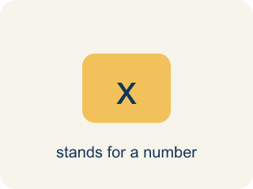
independent variable (variable independiente) — The quantity that is subject to choice. It does not depend on the other quantity.

dependent variable (variable dependiente) — The quantity that changes in response to the independent variable.

depends on (depende de) — One quantity depends on another when changing the first causes the second to change.
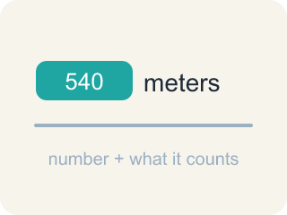
quantity (cantidad) — Something that can be counted or measured.
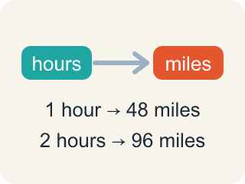
relationship (relación) — How two quantities change together.
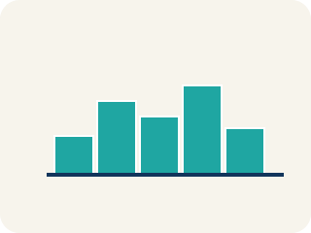
graph (gráfica) — A picture on a coordinate plane that shows how two quantities are related.
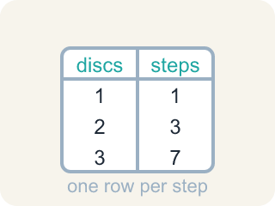
table of values (tabla de valores) — A list of matched pairs of values that shows a relationship using numbers.
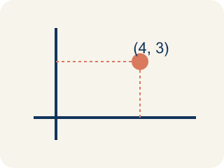
ordered pair (par ordenado) — Two numbers written as (x, y) that name one point on a graph. The independent variable comes first.
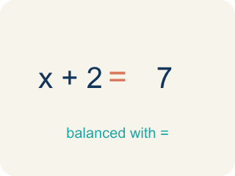
equation (ecuación) — A mathematical sentence with an equals sign that shows two amounts are the same.

variable (variable) — A letter that represents a quantity that can change, or vary.

Practice
Show your work. Use the blank space under each problem.
1. (Lesson 9.1) Akela chooses how many hours of sunlight each tray gets. Which is the INDEPENDENT variable?
A. Hours of sunlight
B. Plant height
C. Number of trays
D. Number of seeds
______________________________________________________________________
2. (Lesson 9.1) In Akela's experiment, which is the DEPENDENT variable?
A. Plant height
B. Hours of sunlight
C. The kind of seed
D. The size of the tray
______________________________________________________________________
3. (Lesson 9.1) A gym charges $24.95 per month. Which pair correctly names the variables?
A. Independent: months; Dependent: total cost
B. Independent: total cost; Dependent: months
C. Independent: $24.95; Dependent: months
D. Independent: months; Dependent: $24.95
______________________________________________________________________
4. (Lesson 9.1) Claire jogs 30 minutes and burns 123 Calories. At the same rate, how many Calories would a 90-minute jog burn?
A. 369
B. 246
C. 410
D. 300
______________________________________________________________________
5. (Lesson 9.2) The Sandia Peak tram travels 1,200 feet each minute and the ascent takes 15 minutes. How long is the whole ascent in feet?
A. 18,000 feet
B. 1,215 feet
C. 12,000 feet
D. 16,800 feet
______________________________________________________________________
6. (Lesson 9.2) On the tram graph with minutes on the horizontal axis and feet on the vertical axis, which ordered pair lies on the graph?
A. (5, 6000)
B. (6000, 5)
C. (5, 1200)
D. (5, 5000)
______________________________________________________________________
7. (Lesson 9.3) Using c = 24.95m, what is the total cost of 10 months of membership?
A. $249.50
B. $34.95
C. $224.55
D. $2,495.00
______________________________________________________________________
8. (Lesson 9.3) Using c = 15h, what is the total cost of a 5-hour canoe rental?
A. $75
B. $20
C. $60
D. $80
______________________________________________________________________

Answer Key (Teacher)
1. A. Hours of sunlight
Akela chooses the sunlight, so sunlight is subject to choice — that makes it independent.
Watch for: Writing the equation with addition — c = 24.95 + m — instead of multiplication. The fee is charged EVERY month, so the total is the rate times the number of months; always test the equation against a row of the table.
2. A. Plant height
Height responds to how much sunlight the tray received, so height is the dependent variable.
Watch for: Writing the equation with addition — c = 24.95 + m — instead of multiplication. The fee is charged EVERY month, so the total is the rate times the number of months; always test the equation against a row of the table.
3. A. Independent: months; Dependent: total cost
You choose how many months to stay a member. The total cost responds to that.
Watch for: Writing the equation with addition — c = 24.95 + m — instead of multiplication. The fee is charged EVERY month, so the total is the rate times the number of months; always test the equation against a row of the table.
4. A. 369
30 minutes burned 123 Calories, and 90 is 3 times 30, so the Calories are 3 times 123, which is 369.
Watch for: Writing the equation with addition — c = 24.95 + m — instead of multiplication. The fee is charged EVERY month, so the total is the rate times the number of months; always test the equation against a row of the table.
5. A. 18,000 feet
The total distance is 15 × 1,200 = 18,000 feet.
Watch for: Writing the equation with addition — c = 24.95 + m — instead of multiplication. The fee is charged EVERY month, so the total is the rate times the number of months; always test the equation against a row of the table.
6. A. (5, 6000)
After 5 minutes the tram has traveled 5 × 1,200 = 6,000 feet, so the point is (5, 6000).
Watch for: Writing the equation with addition — c = 24.95 + m — instead of multiplication. The fee is charged EVERY month, so the total is the rate times the number of months; always test the equation against a row of the table.
7. A. $249.50
Substitute m = 10: c = 24.95 × 10 = 249.50.
Watch for: Writing the equation with addition — c = 24.95 + m — instead of multiplication. The fee is charged EVERY month, so the total is the rate times the number of months; always test the equation against a row of the table.
8. A. $75
Substitute h = 5: c = 15 × 5 = 75.
Watch for: Writing the equation with addition — c = 24.95 + m — instead of multiplication. The fee is charged EVERY month, so the total is the rate times the number of months; always test the equation against a row of the table.

