UNIT 9 · LESSON 3 STANDARD 6.AT.11

Write Equations to Represent Relationships Between Two Variables
Student Notes Packet
Name: ______________________ Date: ____________ Period: ________
Level 3 · Enrichment

Today's Goals
Content: I can write an equation from a table or a graph to model the relationship between the dependent and independent variables.
Language: I can define the variables in my equation and explain what each part represents using the words equation, variable, and rate.

Key Vocabulary
Look at the picture, read the word, then read what it means.
 | equation ecuación  A mathematical sentence with an equals sign that shows two amounts are the same.  Example: c = 24.95m means the total cost equals $24.95 times the number of months
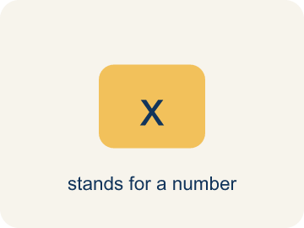 | variable variable  A letter that represents a quantity that can change, or vary.  Example: In c = 24.95m, the m can be 1, 2, or 12 — it varies.
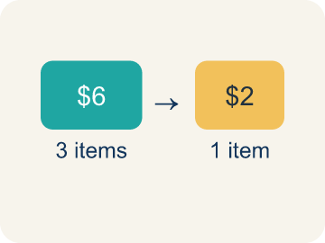 | rate tasa  A fixed amount of one quantity for every one unit of the other quantity.  Example: $24.95 for every 1 month — the amount attached to one unit.
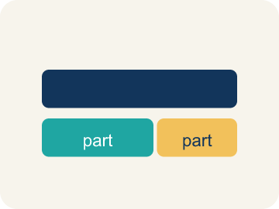 | represent representar  To show a relationship using a tool such as a table, a graph, or an equation.  Example: The same membership shown as a table, a graph, AND c = 24.95m.
 | define the variables definir las variables  To state exactly what quantity each letter in an equation stands for.  Example: “Let m = months and c = total cost” — written before you solve.

Guided Notes
Fill in each blank as we go. Use the Word Bank to help you.
WORD BANK
equation • variable • rate • represent • define the variables

1. A mathematical sentence with an equals sign is an ________________.
2. A letter standing for a quantity that can change is a ________________.
3. A fixed amount of one quantity for every one unit of the other is a ________________.
4. To show a relationship with a table, graph, or equation is to ________________ it.
5. To state what each letter stands for is to ________________ ________________ ________________.

Write About the Math
Use the support level you need. Every level answers the same math question.

1. Understand the Question explain
Would you recommend that Diamond purchase or stream songs from the online music service?
Your job: Answer the question. Use math evidence. Explain how the evidence proves your answer.
Responde la pregunta. Usa evidencia matemática. Explica cómo la evidencia demuestra tu respuesta.

2. Plan Your Math Words check at least two
☐ equation — A mathematical sentence with an equals sign that shows two amounts are the same.
ecuación — Una oración matemática con un signo igual que muestra que dos cantidades son iguales.
☐ variable — A letter that represents a quantity that can change, or vary.
variable — Una letra que representa una cantidad que puede cambiar o variar.
☐ rate — A fixed amount of one quantity for every one unit of the other quantity.
tasa — Una cantidad fija de una cantidad por cada unidad de la otra cantidad.
☐ represent — To show a relationship using a tool such as a table, a graph, or an equation.
representar — Mostrar una relación usando una herramienta como una tabla, una gráfica o una ecuación.
☐ define the variables — To state exactly what quantity each letter in an equation stands for.
definir las variables — Decir exactamente qué cantidad representa cada letra de una ecuación.
Say it first: Say your idea to a partner or quietly to yourself before you write.
Diamond should write an ___ for each option so she can ___ the costs. Each equation uses the ___ as the input and gives the ___ as the output.
Di tu respuesta primero: Mi respuesta es ___ porque ___.

3. Build Your Explanation choose your support
This model shows the parts of an explanation. It does not answer your writing question.
Claim: The fee is charged EVERY month, so the total must be the rate multiplied by the number of months, not added to it once.
Evidence: A strong answer tests the equation against a table row (2 months should give $49.90) rather than just stating a rule. A weak answer picks multiplication without checking it against the actual numbers.
Reasoning: This evidence connects the definition of equation to the mathematical claim.

Start Most language support
Complete the frames. Use the word bank.
Completa las oraciones. Usa el banco de palabras.
Diamond should write an ___ for each option so she can ___ the costs. Each equation uses the ___ as the input and gives the ___ as the output.
My answer is ___.
Mi respuesta es ___.

Build Some language support
Write two connected sentences. Use because, so, or but.
Escribe dos oraciones conectadas. Usa porque, entonces o pero.
My claim is ___.
Mi afirmación es ___.
I know because ___.
Lo sé porque ___.
So ___.
Entonces ___.

Explain Light language support
Write a claim, give math evidence, and explain your reasoning.
Escribe una afirmación, da evidencia matemática y explica tu razonamiento.
My claim is ___.
Mi afirmación es ___.
My math evidence is ___.
Mi evidencia matemática es ___.
This proves ___ because ___.
Esto demuestra ___ porque ___.

4. Check Your Explanation five quick checks
☐ I answered the question.
Respondí la pregunta.
☐ I used math evidence: numbers, an equation, a model, or a comparison.
Usé evidencia matemática: números, una ecuación, un modelo o una comparación.
☐ I explained how the evidence proves my answer.
Expliqué cómo la evidencia demuestra mi respuesta.
☐ I used at least two math words.
Usé por lo menos dos palabras matemáticas.
☐ I reread complete sentences and punctuation.
Volví a leer mis oraciones completas y la puntuación.

Worked Example

Watch & Read I Do — follow along with your teacher
Unit 9 · Lesson 3
Miguel is interested in joining a recreation center. Recreation World charges a monthly fee of $24.95. A table shows the total cost for 1, 2, 3, 4, and 10 months — but Miguel wants a way to find the cost for ANY number of months. Later, some friends want to rent a canoe that costs $15 per hour.

Solved Example I Do — watch each step
Problem: Recreation World charges $24.95 per month. What is the total cost of 2 months of membership?
A) $49.90
B) $26.95
C) $24.95
D) $74.85
Step 1: Two months at $24.95 each is 2 × 24.95 = 49.90.
Answer: A. $49.90

Independent Practice

On Your Own You Do — show your work
Solve each problem. Show your thinking in the work box.

Level 2 Enrichment stretch your thinking
1. Miguel wants the cost of a full year (12 months) at Recreation World. Using c = 24.95m, what is the total?
A) $299.40
B) $249.50
C) $36.95
D) $300.00

2. A different gym charges $19.95 per month. How does Miguel's equation change for this gym?
A) The rate changes: c = 19.95m instead of c = 24.95m
B) The variable changes: c = 24.95x instead of c = 24.95m
C) The operation changes: c = 19.95 + m
D) Nothing changes — all gyms have the same equation

3. What is the benefit of an equation over a table for the membership costs?
A) The equation gives the total cost for ANY number of months, not just the rows listed
B) The equation lists more rows than the table
C) The equation is the only representation that shows the cost increasing
D) The table is always wrong and the equation is always right

4. The friends spent exactly $120 on the canoe. Solve 15h = 120. How long was the rental?
A) 8 hours
B) 105 hours
C) 9 hours
D) 1,800 hours

Exit Ticket
Answer on your own. This shows what you learned today.
★ Recreation World charges $24.95 per month. Let m = number of months and c = total cost. Which equation represents the relationship?
A) c = 24.95m
B) c = 24.95 + m
C) m = 24.95c
D) c = m ÷ 24.95

Answer Key & Teacher Guide
Teacher reference — remove or fold back before distributing to students.

Guided Notes (Fill-in)
Notes 1: equation
Notes 2: variable
Notes 3: rate
Notes 4: represent
Notes 5: define the variables

Worked Notes (I Do / We Do)
I Do: A. $49.90
We Do: A. The number of months of membership

Independent Practice
Watch for this mistake: Writing the equation with addition — c = 24.95 + m — instead of multiplication. The fee is charged EVERY month, so the total is the rate times the number of months; always test the equation against a row of the table.

Level 1 Support
1. A) c = 15h — Each hour costs $15, so the total is 15 times the number of hours: c = 15h.
2. A) $45 — Substitute h = 3: c = 15 × 3 = 45.
3. A) The total cost — The total cost depends on the number of months of membership — Miguel chooses the months, and the cost responds.
4. A) $24.95 — Each row grows by the monthly fee: 49.90 − 24.95 = 24.95, and 74.85 − 49.90 = 24.95.

On Level
5. A) $249.50 — Substitute m = 10: c = 24.95 × 10 = 249.50.
6. A) $75 — Substitute h = 5: c = 15 × 5 = 75.

Exit Ticket
A) c = 24.95m — Each month costs $24.95, so the total cost is $24.95 multiplied by the number of months: c = 24.95m. Check: 2 months gives 24.95 × 2 = 49.90, which matches the table.

Math Writing Criteria
The support level changes the amount of language scaffolding, not the mathematical expectation.
☐ I answered the question.
☐ I used math evidence: numbers, an equation, a model, or a comparison.
☐ I explained how the evidence proves my answer.
☐ I used at least two math words.
☐ I reread complete sentences and punctuation.

