9.4–9.4 Catch-Up — Homework
Lesson 9-4-catchup • Standard 6.AT.11
Name: ______________________ Period: ______ Date: ____________

Today's Goals
Content: I can show I am caught up on Lessons 9.4–9.4 by using each lesson's big idea in mixed practice.
Language: I can explain which lesson's big idea I used and how, using key vocabulary from Lessons 9.4–9.4.

Key Words
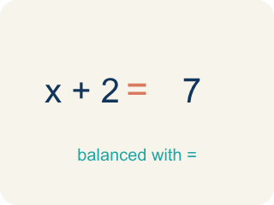
solution (solución) — A value of the variable that makes an equation true.
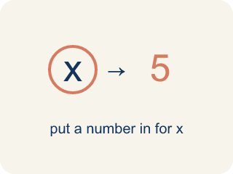
substitute (sustituir) — To replace a variable with a number so you can compute.
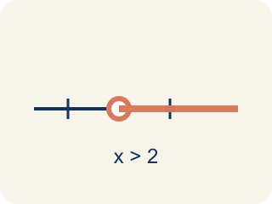
at least (al menos) — That amount or more — the smallest amount that still works.
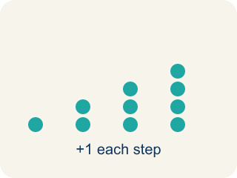
predict (predecir) — To make a reasonable guess about a future amount using information you already have.

justify (justificar) — To explain WHY an answer or recommendation makes sense, using the mathematics.

Practice
Show your work. Use the blank space under each problem.
1. (Lesson 9.4) The assembly line produces 2.5 cars per hour. How many cars does it produce in one 8-hour shift?
A. 20 cars
B. 10.5 cars
C. 16 cars
D. 25 cars
______________________________________________________________________
2. (Lesson 9.4) Let h = hours of operation and c = cars produced. Which equation represents the assembly line?
A. c = 2.5h
B. c = 2.5 + h
C. h = 2.5c
D. c = h ÷ 2.5
______________________________________________________________________
3. (Lesson 9.4) The order requires 1,000 cars. Using 2.5h = 1,000, how many hours will the plant need?
A. 400 hours
B. 2,500 hours
C. 997.5 hours
D. 40 hours
______________________________________________________________________
4. (Lesson 9.4) The plant needs 400 hours to fill the order. Running 24 hours a day, about how many days is that?
A. About 17 days
B. 400 days
C. 50 days
D. 4 days
______________________________________________________________________

Answer Key (Teacher)
1. A. 20 cars
Substitute 8 hours: 2.5 × 8 = 20 cars per shift.
Watch for: Adding the rate instead of multiplying — writing 2.5 + 8 = 10.5 cars for an 8-hour shift instead of 2.5 × 8 = 20. The rate applies to EVERY hour, so the total is always rate × amount.
2. A. c = 2.5h
Every hour the plant produces 2.5 cars, so the total is 2.5 times the hours: c = 2.5h. Check with the table: 8 hours gives 20 cars.
Watch for: Adding the rate instead of multiplying — writing 2.5 + 8 = 10.5 cars for an 8-hour shift instead of 2.5 × 8 = 20. The rate applies to EVERY hour, so the total is always rate × amount.
3. A. 400 hours
Divide both sides by 2.5: h = 1,000 ÷ 2.5 = 400 hours.
Watch for: Adding the rate instead of multiplying — writing 2.5 + 8 = 10.5 cars for an 8-hour shift instead of 2.5 × 8 = 20. The rate applies to EVERY hour, so the total is always rate × amount.
4. A. About 17 days
Divide the hours by the hours in a day: 400 ÷ 24 ≈ 16.7, which is about 17 days — about 2.5 weeks.
Watch for: Adding the rate instead of multiplying — writing 2.5 + 8 = 10.5 cars for an 8-hour shift instead of 2.5 × 8 = 20. The rate applies to EVERY hour, so the total is always rate × amount.

