UNIT 1 · LESSON 6 STANDARD 6.NOS.3

Multiply Decimals
Student Notes Packet
Name: ______________________ Date: ____________ Period: ________

Today's Goals
Content: I can multiply decimals and place the decimal point correctly in the product.
Language: I can explain my work using the words product, decimal point, estimate, and decimal places.

Key Vocabulary
Look at the picture, read the word, then read what it means.
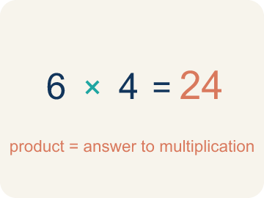 | Product Producto  The answer when you multiply.  Example: 4 × 7 = 28, so the product is 28
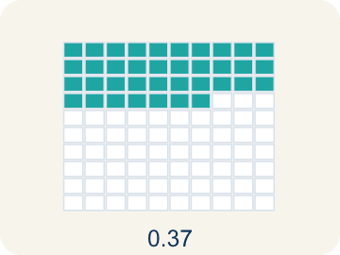 | Decimal point Punto decimal  The dot that splits the whole number from the part after it.  Example: In 3.25, the decimal point separates 3 (ones) from 25 (tenths and hundredths)
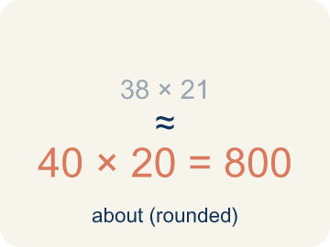 | Estimate Estimar  A close answer you get by rounding first.  Example: 3.7 × 4.2: round to 4 × 4 = 16, so the exact answer should be near 16
Place value Valor posicional
What a digit is worth based on where it sits in a number.
Example: In 0.36: the 3 is in the tenths place (0.3) and the 6 is in the hundredths place (0.06)
Decimal places Cifras decimales
How many digits come after the decimal point.
Example: 3.4 (1 place) × 2.6 (1 place) = 8.84 (2 places total)

Guided Notes
Fill in each blank as we go. Use the Word Bank to help you.
WORD BANK
Product • Decimal point • Estimate • Place value • Decimal places

1. The answer to a multiplication problem is the ___.
2. The dot that separates whole numbers from parts of a whole is the ___.
3. Finding an answer that is close but not exact, to check if a product is reasonable, is to ___.
4. The value a digit has based on its position is its ___.
5. To place the point in a product, I count the total number of ___ in both factors.

Write About the Math
Use the support level you need. Every level answers the same math question.

1. Understand the Question explain
When you multiplied 4.5 × 12.60, how did you decide where to put the decimal point in the product?
Your job: Answer the question. Use math evidence. Explain how the evidence proves your answer.
Responde la pregunta. Usa evidencia matemática. Explica cómo la evidencia demuestra tu respuesta.

2. Plan Your Math Words check at least two
☐ Product — The answer when you multiply.
Producto — La respuesta cuando multiplicas.
☐ Decimal point — The dot that splits the whole number from the part after it.
Punto decimal — El punto que separa el número entero de la parte que sigue.
☐ Estimate — A close answer you get by rounding first.
Estimar — Una respuesta cercana que obtienes al redondear primero.
☐ Place value — What a digit is worth based on where it sits in a number.
Valor posicional — Lo que vale un dígito según el lugar que ocupa en el número.
☐ Decimal places — How many digits come after the decimal point.
Cifras decimales — Cuántos dígitos hay después del punto decimal.
Say it first: Say your idea to a partner or quietly to yourself before you write.
I counted ___ decimal places in the factors.
Conté ___ lugares decimales en los factores.

3. Build Your Explanation choose your support
This model shows the parts of an explanation. It does not answer your writing question.
Claim: Rounding the factors gives a reasonable estimate of the product.
Evidence: Students round to about 5 × $13 = $65 (or 4 × $13) to predict the cost is in the $50-$65 range, naming 4.5 and 12.60 as the factors.
Reasoning: This evidence connects the definition of product to the mathematical claim.

Start Most language support
Complete the frames. Use the word bank.
Completa las oraciones. Usa el banco de palabras.
I counted ___ decimal places in the factors.
Conté ___ lugares decimales en los factores.
So my product has ___ decimal places, giving $___.
Entonces mi producto tiene ___ lugares decimales, dando $___.

Build Some language support
Write two connected sentences. Use because, so, or but.
Escribe dos oraciones conectadas. Usa porque, entonces o pero.
My claim is ___.
Mi afirmación es ___.
I know because ___.
Lo sé porque ___.
So ___.
Entonces ___.

Explain Light language support
Write a claim, give math evidence, and explain your reasoning.
Escribe una afirmación, da evidencia matemática y explica tu razonamiento.
My claim is ___.
Mi afirmación es ___.
My math evidence is ___.
Mi evidencia matemática es ___.
This proves ___ because ___.
Esto demuestra ___ porque ___.

4. Check Your Explanation five quick checks
☐ I answered the question.
Respondí la pregunta.
☐ I used math evidence: numbers, an equation, a model, or a comparison.
Usé evidencia matemática: números, una ecuación, un modelo o una comparación.
☐ I explained how the evidence proves my answer.
Expliqué cómo la evidencia demuestra mi respuesta.
☐ I used at least two math words.
Usé por lo menos dos palabras matemáticas.
☐ I reread complete sentences and punctuation.
Volví a leer mis oraciones completas y la puntuación.

Worked Example

Watch & Read I Do — follow along with your teacher
Space Station Material Costs
The station needs 4.5 meters of heat shielding that costs $12.60 per meter. Commander Diaz needs to calculate the total cost before submitting the supply order. What is the total cost of the shielding?

Think about:
• What two quantities are being multiplied?
• How many total decimal places do the two factors have?
• How can estimating help you check if your answer is reasonable?
• Where does the decimal point go in the product?

Solved Example I Do — watch each step
Problem: What is 3.4 × 2.6?
A) 8.84
B) 88.4
C) 0.884
D) 8.48
Step 1: 34 × 26 = 884.
Step 2: There are 2 total decimal places (1 + 1), so place the decimal to get 8.84.
Answer: A. 8.84

Guided Practice

Solve Together We Do — work with your class
Problem: What is 0.7 × 1.5?
A) 1.05
B) 10.5
C) 0.105
D) 1.50
Step 1:

Step 2:

Answer:

A family is buying 3.5 pounds of deli meat that costs $6.80 per pound at the grocery store.
How do you multiply decimals to find the total cost? How can estimation help you check?

Sentence frame: The total cost is $___ because 3.5 × $6.80 = $___, and I can estimate by rounding to ___ × ___ = ___.

Turn & Talk discuss with a partner
1. [Launch] The station needs 4.5 meters of heat shielding at $12.60 per meter. About how much will it cost, and how did you estimate before multiplying?
Start with: I estimate about $___ because 4.5 is close to ___ and $12.60 is close to ___.
Estimo unos $___ porque 4.5 está cerca de ___ y $12.60 está cerca de ___.
Word bank: product, decimal point, estimate, place value, decimal places
2. [Explore] When you multiplied 4.5 × 12.60, how did you decide where to put the decimal point in the product?
Start with: I counted ___ decimal places in the factors.
Conté ___ lugares decimales en los factores.
Word bank: product, decimal point, estimate, place value, decimal places
3. [Connect] A family buys 3.5 pounds of deli meat at $6.80 per pound. How do you multiply the decimals to find the total cost, and how can estimating check it?
Start with: The total cost is $___ because I multiplied ___ × ___.
El costo total es $___ porque multipliqué ___ × ___.
Word bank: product, decimal point, estimate, place value, decimal places
4. [Reflect] How is placing the decimal point in a product different from lining up decimals when adding? Why don't you line up the points to multiply?
Start with: To multiply I ___ the decimal places, but to add I ___ the decimal points.
Para multiplicar ___ los lugares decimales, pero para sumar ___ los puntos decimales.
Word bank: product, decimal point, estimate, place value, decimal places
5. [Practice] During practice on Multiply Decimals, what strategy did you use when a problem felt tricky?
Start with: I counted ___ decimal places in the factors.
Conté ___ lugares decimales en los factores.
Word bank: product, decimal point, estimate, place value, decimal places

Independent Practice

On Your Own You Do — show your work
Solve each problem. Show your thinking in the work box.

Level 1 Support extra scaffolding
1. What is 5.3 × 4?
A) 21.2
B) 2.12
C) 212
D) 20.12

2. Which estimate is closest to 4.8 × 3.2?
A) 5 × 3 = 15
B) 4 × 3 = 12
C) 5 × 4 = 20
D) 48 × 32 = 1,536

On Level grade-level practice
3. A car travels 55.5 miles per hour for 2.4 hours. How far does it go?
A) 133.2 miles
B) 13.32 miles
C) 1,332 miles
D) 57.9 miles

Exit Ticket
Answer on your own. This shows what you learned today.
★ What is 4.6 × 2.3?
A) 10.58
B) 105.8
C) 1.058
D) 10.48

