UNIT 10 · LESSON 3 STANDARD 6.GR.4

Surface Area Using Nets
Student Notes Packet
Name: ______________________ Date: ____________ Period: ________

Today's Goals
Content: I can find the surface area of a solid by using its net.
Language: I can explain my work using the words surface area, net, face, and two-dimensional.

Key Vocabulary
Look at the picture, read the word, then read what it means.
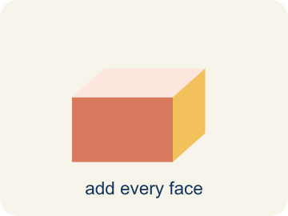 | Surface area Área de superficie  The total area of all the flat sides of a solid.  Example: A box 6 × 4 × 2: SA = 2(24) + 2(12) + 2(8) = 88 in² — like wrapping paper needed
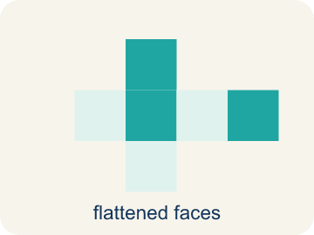 | Net Plantilla (desarrollo plano)  A flat shape that folds up into a solid.  Example: Cut along the edges of a cereal box and unfold it flat — you see all 6 faces
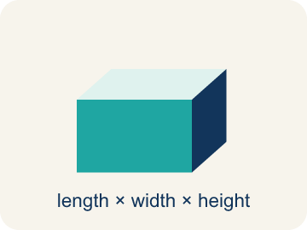 | Face Cara  One flat side of a solid shape.  Example: A rectangular prism has 6 faces: top, bottom, front, back, left, right
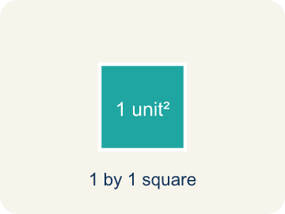 | Two-dimensional Bidimensional  A flat shape with length and width, but no thickness.  Example: A rectangle drawn on paper is 2D — it has length and width but no depth
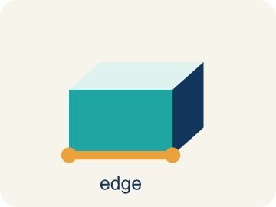 | Edge Arista  The line where two flat sides of a solid meet.  Example: A cube has 12 edges — the lines where two flat faces connect

Guided Notes
Fill in each blank as we go. Use the Word Bank to help you.
WORD BANK
Surface area • Net • Face • Two-dimensional • Edge

1. The total area of all the faces of a solid is its ___.
2. A flat pattern that folds up into a solid is a ___.
3. A flat surface of a solid figure is a ___.
4. A flat shape with length and width but no thickness is ___.
5. A line segment where two faces meet is an ___.

Write About the Math
Use the support level you need. Every level answers the same math question.

1. Understand the Question explain
For the box l = 8, w = 5, h = 3, you found three face pairs. How did you use the net to organize the faces into pairs, and which pair had the largest area?
Your job: Answer the question. Use math evidence. Explain how the evidence proves your answer.
Responde la pregunta. Usa evidencia matemática. Explica cómo la evidencia demuestra tu respuesta.

2. Plan Your Math Words check at least two
☐ Surface area — The total area of all the flat sides of a solid.
Área de superficie — El área total de todos los lados planos de un sólido.
☐ Net — A flat shape that folds up into a solid.
Plantilla (desarrollo plano) — Una figura plana que se dobla y forma un sólido.
☐ Face — One flat side of a solid shape.
Cara — Un lado plano de una figura sólida.
☐ Two-dimensional — A flat shape with length and width, but no thickness.
Bidimensional — Una figura plana con largo y ancho, pero sin grosor.
☐ Edge — The line where two flat sides of a solid meet.
Arista — La línea donde se unen dos lados planos de un sólido.
Say it first: Say your idea to a partner or quietly to yourself before you write.
The faces come in ___ pairs because opposite faces are ___.
Las caras vienen en ___ pares porque las caras opuestas son ___.

3. Build Your Explanation choose your support
This model shows the parts of an explanation. It does not answer your writing question.
Claim: A net lays every face flat so you can see and measure all six faces.
Evidence: Students explain a rectangular prism has 6 faces, and the net unfolds the solid into a flat (two-dimensional) pattern so every face is visible to measure.
Reasoning: This evidence connects the definition of surface area to the mathematical claim.

Start Most language support
Complete the frames. Use the word bank.
Completa las oraciones. Usa el banco de palabras.
The faces come in ___ pairs because opposite faces are ___.
Las caras vienen en ___ pares porque las caras opuestas son ___.
The largest pair is ___ × ___ = ___, counted twice for ___ in².
El par más grande es ___ × ___ = ___, contado dos veces para ___ in².

Build Some language support
Write two connected sentences. Use because, so, or but.
Escribe dos oraciones conectadas. Usa porque, entonces o pero.
My claim is ___.
Mi afirmación es ___.
I know because ___.
Lo sé porque ___.
So ___.
Entonces ___.

Explain Light language support
Write a claim, give math evidence, and explain your reasoning.
Escribe una afirmación, da evidencia matemática y explica tu razonamiento.
My claim is ___.
Mi afirmación es ___.
My math evidence is ___.
Mi evidencia matemática es ___.
This proves ___ because ___.
Esto demuestra ___ porque ___.

4. Check Your Explanation five quick checks
☐ I answered the question.
Respondí la pregunta.
☐ I used math evidence: numbers, an equation, a model, or a comparison.
Usé evidencia matemática: números, una ecuación, un modelo o una comparación.
☐ I explained how the evidence proves my answer.
Expliqué cómo la evidencia demuestra mi respuesta.
☐ I used at least two math words.
Usé por lo menos dos palabras matemáticas.
☐ I reread complete sentences and punctuation.
Volví a leer mis oraciones completas y la puntuación.

Worked Example

Watch & Read I Do — follow along with your teacher
Time Capsule Project
Your class is designing custom wrapping paper for time capsule boxes. To figure out how much paper you need, you have to find the total surface area of each box. The trick? Unfold the box into a net so you can see every face laid flat!

Think about:
• How many faces does a rectangular prism have?
• What shapes do you see when the box is unfolded?
• Are all the faces the same size?
• Is there more than one way to unfold a box into a net?
• How does a net help you find surface area more easily than looking at the 3D shape?

Solved Example I Do — watch each step
Problem: A rectangular prism has l = 6 in, w = 4 in, h = 2 in. What is its surface area?
A) 88 in²
B) 48 in²
C) 88 in³
D) 44 in²
Step 1: SA = 2(6×4) + 2(6×2) + 2(4×2) = 48 + 24 + 16 = 88 in².
Answer: A. 88 in²

Guided Practice

Solve Together We Do — work with your class
Problem: How many faces does a rectangular prism have?
A) 6
B) 4
C) 8
D) 12
Step 1:

Step 2:

Answer:

A gift shop wraps boxes with decorative paper. A box is 14 inches long, 10 inches wide, and 6 inches tall. One sheet of wrapping paper covers 400 square inches.
How many sheets of wrapping paper are needed to cover the entire box?

Sentence frame: The box's surface area is ___ in² because SA = 2(___×___) + 2(___×___) + 2(___×___) = ___ + ___ + ___ = ___. You need ___ sheets because ___ ÷ 400 ≈ ___.

Turn & Talk discuss with a partner
1. [Launch] To find how much wrapping paper a time capsule box needs, why is unfolding it into a net more helpful than looking at the 3D box?
Start with: A net helps because it shows all ___ faces laid ___.
Una red ayuda porque muestra las ___ caras puestas ___.
Word bank: surface area, net, face, two-dimensional, edge
2. [Explore] For the box l = 8, w = 5, h = 3, you found three face pairs. How did you use the net to organize the faces into pairs, and which pair had the largest area?
Start with: The faces come in ___ pairs because opposite faces are ___.
Las caras vienen en ___ pares porque las caras opuestas son ___.
Word bank: surface area, net, face, two-dimensional, edge
3. [Connect] A gift box is 14 × 10 × 6 in and one sheet of paper covers 400 in². Talk through how to find how many sheets are needed to cover the whole box.
Start with: The surface area is ___ in² because SA = 2(14×10) + 2(14×6) + 2(10×6).
El área de superficie es ___ in² porque SA = 2(14×10) + 2(14×6) + 2(10×6).
Word bank: surface area, net, face, two-dimensional, edge
4. [Reflect] A classmate found the surface area of a box but only multiplied two of the three face pairs by 2. How would you explain why every pair must be doubled?
Start with: Every face pair must be multiplied by ___ because each shape appears ___ times.
Cada par de caras debe multiplicarse por ___ porque cada forma aparece ___ veces.
Word bank: surface area, net, face, two-dimensional, edge
5. [Practice] During practice on Surface Area Using Nets, what strategy did you use when a problem felt tricky?
Start with: The faces come in ___ pairs because opposite faces are ___.
Las caras vienen en ___ pares porque las caras opuestas son ___.
Word bank: Surface area, Net, Face, Two-dimensional

Independent Practice

On Your Own You Do — show your work
Solve each problem. Show your thinking in the work box.

Level 1 Support extra scaffolding
1. Surface area is measured in which type of unit?
A) Square units (in², cm², ft²)
B) Cubic units (in³, cm³, ft³)
C) Linear units (in, cm, ft)
D) No units needed

On Level grade-level practice
2. A cube has edges of 5 cm. What is its surface area?
A) 150 cm²
B) 125 cm²
C) 150 cm³
D) 30 cm²

Exit Ticket
Answer on your own. This shows what you learned today.
★ A rectangular prism has l = 9 in, w = 5 in, h = 3 in. What is the surface area?
A) 174 in²
B) 135 in²
C) 174 in³
D) 87 in²

Answer Key & Teacher Guide
Teacher reference — remove or fold back before distributing to students.

Guided Notes (Fill-in)
Notes 1: Surface area
Notes 2: Net
Notes 3: Face
Notes 4: Two-dimensional
Notes 5: Edge

Worked Notes (I Do / We Do)
I Do: A. 88 in²
We Do: A. 6

Independent Practice
Watch for this mistake: A common mistake in Surface Area Using Nets is finding the area of only one face from each of the 3 matching pairs and forgetting to double it, instead of counting all 6 faces. For a box that is 9 in × 4 in × 5 in, a student might add just one face from each pair: (9×4) + (9×5) + (4×5) = 36 + 45 + 20 = 101 in², but the net actually has two of each face, so the correct total is 2(36) + 2(45) + 2(20) = 72 + 90 + 40 = 202 in² — exactly double. Before you submit, ask: 'Did I count both matching faces in each pair, or only one from each pair?'

Level 1 Support
1. A) Square units (in², cm², ft²) — Surface area measures flat surfaces, so it uses square units. Volume uses cubic units.

On Level
2. A) 150 cm² — A cube has 6 identical faces. Each face: 5 × 5 = 25 cm². Total SA = 6 × 25 = 150 cm².

Exit Ticket
A) 174 in² — SA = 2(9×5) + 2(9×3) + 2(5×3) = 90 + 54 + 30 = 174 in². Surface area uses square units (in²).

Math Writing Criteria
The support level changes the amount of language scaffolding, not the mathematical expectation.
☐ I answered the question.
☐ I used math evidence: numbers, an equation, a model, or a comparison.
☐ I explained how the evidence proves my answer.
☐ I used at least two math words.
☐ I reread complete sentences and punctuation.

