UNIT 5 · LESSON 4 STANDARD 6.GR.1

Area of Regular Polygons
Student Notes Packet
Name: ______________________ Date: ____________ Period: ________

Today's Goals
Content: I can find the area of a regular polygon by decomposing it into triangles.
Language: I can explain my steps using the words regular polygon, decompose, triangle, and composite.

Key Vocabulary
Look at the picture, read the word, then read what it means.
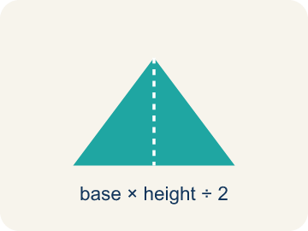 | Regular Polygon Polígono regular  A shape where all sides and all angles are equal.  Example: A stop sign is a regular octagon — all 8 sides are the same length and all 8 angles are equal
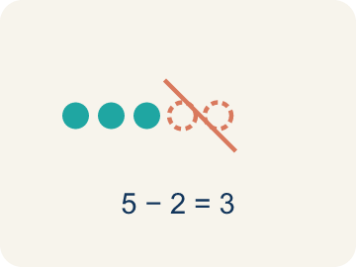 | Decompose Descomponer  To break a shape into smaller, simpler shapes.  Example: Draw lines from the center of a hexagon to each corner → you get 6 equal triangles you can find the area of
Triangle Triángulo
A shape with three sides.
Example: Each triangle inside a decomposed hexagon has a base = one side of the hexagon and height = distance from center to side
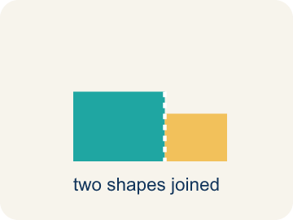 | Composite Compuesto  Made by putting two or more simple shapes together.  Example: 6 triangles, each with area 15 sq ft, combine to form a hexagon with total area = 6 × 15 = 90 sq ft
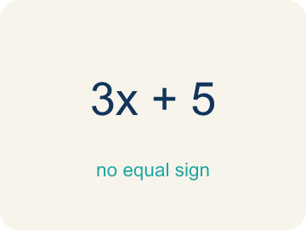 | Formula Fórmula  A math rule written with symbols.  Example: For a regular hexagon: Total Area = 6 × (½ × b × h), where b = side length and h = height of each triangle

Guided Notes
Fill in each blank as we go. Use the Word Bank to help you.
WORD BANK
Regular Polygon • Decompose • Triangle • Composite • Formula

1. A polygon with all sides and all angles equal is a ___.
2. To break a shape into smaller shapes is to ___ it.
3. A three-sided polygon is a ___.
4. Made of two or more shapes combined, a figure is ___.
5. A math rule written with symbols is a ___.

Write About the Math
Use the support level you need. Every level answers the same math question.

1. Understand the Question explain
You matched each regular polygon to its number of center triangles. What pattern connects the number of SIDES to the number of TRIANGLES, and why?
Your job: Answer the question. Use math evidence. Explain how the evidence proves your answer.
Responde la pregunta. Usa evidencia matemática. Explica cómo la evidencia demuestra tu respuesta.

2. Plan Your Math Words check at least two
☐ Regular Polygon — A shape where all sides and all angles are equal.
Polígono regular — Una figura donde todos los lados y ángulos son iguales.
☐ Decompose — To break a shape into smaller, simpler shapes.
Descomponer — Separar una figura en figuras más pequeñas y simples.
☐ Triangle — A shape with three sides.
Triángulo — Una figura de tres lados.
☐ Composite — Made by putting two or more simple shapes together.
Compuesto — Formada al juntar dos o más figuras simples.
☐ Formula — A math rule written with symbols.
Fórmula — Una regla matemática escrita con símbolos.
Say it first: Say your idea to a partner or quietly to yourself before you write.
I split each polygon into ___ triangles.
Dividí cada polígono en ___ triángulos.

3. Build Your Explanation choose your support
This model shows the parts of an explanation. It does not answer your writing question.
Claim: We decompose the hexagon into triangles because we already know how to find a triangle's area.
Evidence: Students explain that splitting the hexagon into 6 equal triangles lets them use the triangle area formula they already know, then combine the parts.
Reasoning: This evidence connects the definition of regular polygon to the mathematical claim.

Start Most language support
Complete the frames. Use the word bank.
Completa las oraciones. Usa el banco de palabras.
I split each polygon into ___ triangles.
Dividí cada polígono en ___ triángulos.
The number of triangles equals the number of ___ because ___.
El número de triángulos es igual al número de ___ porque ___.

Build Some language support
Write two connected sentences. Use because, so, or but.
Escribe dos oraciones conectadas. Usa porque, entonces o pero.
My claim is ___.
Mi afirmación es ___.
I know because ___.
Lo sé porque ___.
So ___.
Entonces ___.

Explain Light language support
Write a claim, give math evidence, and explain your reasoning.
Escribe una afirmación, da evidencia matemática y explica tu razonamiento.
My claim is ___.
Mi afirmación es ___.
My math evidence is ___.
Mi evidencia matemática es ___.
This proves ___ because ___.
Esto demuestra ___ porque ___.

4. Check Your Explanation five quick checks
☐ I answered the question.
Respondí la pregunta.
☐ I used math evidence: numbers, an equation, a model, or a comparison.
Usé evidencia matemática: números, una ecuación, un modelo o una comparación.
☐ I explained how the evidence proves my answer.
Expliqué cómo la evidencia demuestra mi respuesta.
☐ I used at least two math words.
Usé por lo menos dos palabras matemáticas.
☐ I reread complete sentences and punctuation.
Volví a leer mis oraciones completas y la puntuación.

Worked Example

Watch & Read I Do — follow along with your teacher
Blueprint Review
Your architecture firm is designing a hexagonal skylight for the lobby of a new museum. The glass fabricator needs to know the total area so they can cut the correct amount of glass. Each side of the hexagon is 6 feet, and the height of each triangle formed from the center is 5.2 feet.

Think about:
• What shape is the skylight?
• How many sides does a hexagon have?
• Can you see smaller shapes inside the hexagon?
• How can we break a hexagon into shapes whose area we already know?
• Does this strategy work for other regular polygons?

Solved Example I Do — watch each step
Problem: A regular hexagon is divided into 6 equal triangles from the center. Each triangle has a base of 6 ft and a height of 5.2 ft. What is the area of one triangle?
A) 15.6 sq ft
B) 31.2 sq ft
C) 11.2 sq ft
D) 15.6 ft
Step 1: A = ½ × b × h = ½ × 6 × 5.2 = 15.6 square feet.
Answer: A. 15.6 sq ft

Guided Practice

Solve Together We Do — work with your class
Problem: Using the triangle from the previous question, what is the total area of the hexagonal skylight?
A) 93.6 sq ft
B) 15.6 sq ft
C) 187.2 sq ft
D) 62.4 sq ft
Step 1:

Step 2:

Answer:

A city planner is building a regular octagonal gazebo in a park. Each of the 8 triangles formed from the center has a base of 5 feet and a height of 6 feet. The flooring costs $3 per square foot.
How much will the gazebo flooring cost?

Sentence frame: One triangle's area is ___ sq ft. The octagon has ___ triangles, so total area = ___ sq ft. The cost is ___ x $3 = $___.

Turn & Talk discuss with a partner
1. [Launch] The hexagonal skylight has sides of 6 feet, and each triangle from the center has a height of 5.2 feet. Why is it helpful to break a hexagon into triangles to find its area?
Start with: We decompose the hexagon into ___ because ___.
Descomponemos el hexágono en ___ porque ___.
Word bank: regular polygon, decompose, triangle, composite, formula
2. [Explore] You matched each regular polygon to its number of center triangles. What pattern connects the number of SIDES to the number of TRIANGLES, and why?
Start with: I split each polygon into ___ triangles.
Dividí cada polígono en ___ triángulos.
Word bank: regular polygon, decompose, triangle, composite, formula
3. [Connect] The octagonal gazebo has 8 center triangles, each with base 5 ft and height 6 ft, and flooring costs $3 per sq ft. Walk through finding the total cost.
Start with: One triangle's area is 1/2 times 5 times 6, which equals ___ square feet.
El área de un triángulo es 1/2 por 5 por 6, que es ___ pies cuadrados.
Word bank: regular polygon, decompose, triangle, composite, formula
4. [Practice] During practice on Area of Regular Polygons, what strategy did you use when a problem felt tricky?
Start with: I split each polygon into ___ triangles.
Dividí cada polígono en ___ triángulos.
Word bank: Regular Polygon, Decompose, Triangle, Composite

Independent Practice

On Your Own You Do — show your work
Solve each problem. Show your thinking in the work box.

Level 1 Support extra scaffolding
1. A regular hexagon is split into 6 triangles, each with base 4 cm and height 3.5 cm. What is the total area?
A) 42 sq cm
B) 21 sq cm
C) 84 sq cm
D) 14 sq cm

2. How many triangles can you make from the center of a regular pentagon?
A) 5
B) 3
C) 6
D) 10

Exit Ticket
Answer on your own. This shows what you learned today.
★ A regular pentagon is decomposed into 5 triangles from its center. Each triangle has a base of 7 inches and a height of 4.8 inches. What is the total area of the pentagon?
A) 84 sq in
B) 16.8 sq in
C) 168 sq in
D) 84 in

Answer Key & Teacher Guide
Teacher reference — remove or fold back before distributing to students.

Guided Notes (Fill-in)
Notes 1: Regular Polygon
Notes 2: Decompose
Notes 3: Triangle
Notes 4: Composite
Notes 5: Formula

Worked Notes (I Do / We Do)
I Do: A. 15.6 sq ft
We Do: A. 93.6 sq ft

Independent Practice
Watch for this mistake: A common mistake in Area of Regular Polygons is stopping after finding the area of ONE triangle and reporting that as the total area — or adding the number of triangles instead of multiplying. Remember: total area = (one triangle's area) × (number of sides), not (one triangle's area) + (number of sides).

Level 1 Support
1. A) 42 sq cm — Each triangle: ½ × 4 × 3.5 = 7 sq cm. Total: 6 × 7 = 42 sq cm.
2. A) 5 — A regular pentagon has 5 sides, so drawing lines from the center to each vertex creates 5 equal triangles.

Exit Ticket
A) 84 sq in — One triangle: A = 1/2 x 7 x 4.8 = 16.8 sq in. Total = 5 x 16.8 = 84 square inches.

Math Writing Criteria
The support level changes the amount of language scaffolding, not the mathematical expectation.
☐ I answered the question.
☐ I used math evidence: numbers, an equation, a model, or a comparison.
☐ I explained how the evidence proves my answer.
☐ I used at least two math words.
☐ I reread complete sentences and punctuation.

