UNIT 1 · LESSON 1 STANDARD 6.NOS.4

Prime Factorization
Student Notes Packet
Name: ______________________ Date: ____________ Period: ________

Today's Goals
Content: I can write a number as a product of its prime factors using a factor tree.
Language: I can explain how I broke a number down using the words prime number, composite number, factor, and exponent.

Key Vocabulary
Look at the picture, read the word, then read what it means.
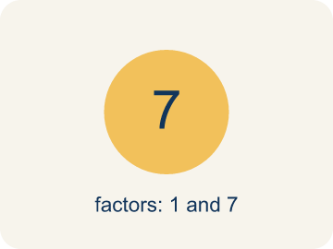 | Prime number Número primo  A number bigger than 1 that you can only divide by 1 and itself.  Example: 7 has only two factors: 1 × 7. So 7 is prime.
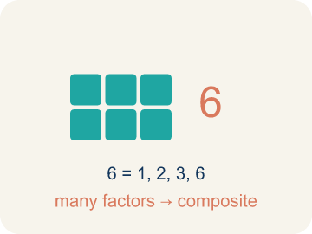 | Composite number Número compuesto  A number bigger than 1 that you can divide by more than just 1 and itself.  Example: 12 = 1 × 12, 2 × 6, 3 × 4 — six factors, so 12 is composite
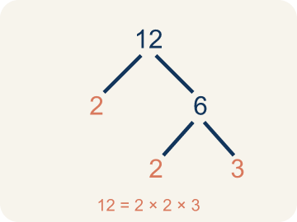 | Prime factorization Factorización prima  Writing a number as prime numbers multiplied together.  Example: 36 = 2 × 2 × 3 × 3 = 2² × 3²
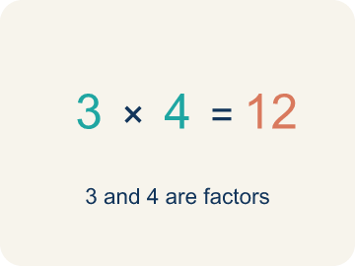 | Factor Factor  A number that divides evenly into another number, with no remainder.  Example: Factors of 12: 1, 2, 3, 4, 6, 12 — each divides 12 evenly.
Factor tree Árbol de factores
A picture that splits a number into its prime numbers, step by step.
Example: 24 → 4 × 6 → (2 × 2) × (2 × 3) → 2 × 2 × 2 × 3
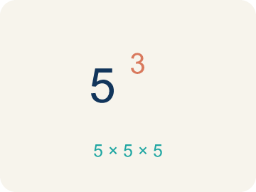 | Exponent Exponente  A small number that tells how many times to multiply a number by itself.  Example: 2³ means 2 × 2 × 2 = 8

Guided Notes
Fill in each blank as we go. Use the Word Bank to help you.
WORD BANK
Prime number • Composite number • Prime factorization • Factor • Factor tree • Exponent

1. A whole number greater than 1 with exactly two factors, 1 and itself, is a ___ number.
2. A whole number greater than 1 that has more than two factors is a ___ number.
3. __________ — Writing a number as prime numbers multiplied together.
4. A number that divides evenly into another number is called a ___.
5. I can break a number into its prime factors step by step using a ___.
6. In 2³, the small number 3 is the ___ and it shows 2 is multiplied 3 times.

Write About the Math
Use the support level you need. Every level answers the same math question.

1. Understand the Question explain
Look at your factor tree for 60. How did you decide which numbers to break apart first, and how do you know when to stop?
Your job: Answer the question. Use math evidence. Explain how the evidence proves your answer.
Responde la pregunta. Usa evidencia matemática. Explica cómo la evidencia demuestra tu respuesta.

2. Plan Your Math Words check at least two
☐ Prime number — A number bigger than 1 that you can only divide by 1 and itself.
Número primo — Un número mayor que 1 que solo se puede dividir entre 1 y sí mismo.
☐ Composite number — A number bigger than 1 that you can divide by more than just 1 and itself.
Número compuesto — Un número mayor que 1 que se puede dividir entre más números, no solo 1 y sí mismo.
☐ Prime factorization — Writing a number as prime numbers multiplied together.
Factorización prima — Escribir un número como números primos multiplicados.
☐ Factor — A number that divides evenly into another number, with no remainder.
Factor — Un número que divide exactamente a otro número, sin dejar residuo.
☐ Factor tree — A picture that splits a number into its prime numbers, step by step.
Árbol de factores — Un dibujo que separa un número en sus números primos, paso a paso.
Say it first: Say your idea to a partner or quietly to yourself before you write.
I broke ___ into ___ because ___.
Separé ___ en ___ porque ___.

3. Build Your Explanation choose your support
This model shows the parts of an explanation. It does not answer your writing question.
Claim: 60 is composite because it has more than two factors.
Evidence: Students say 60 is composite because it has more than two factors (it is divisible by numbers other than 1 and 60, such as 2, 3, 5, 6), so it can be broken down.
Reasoning: This evidence connects the definition of prime factorization to the mathematical claim.

Start Most language support
Complete the frames. Use the word bank.
Completa las oraciones. Usa el banco de palabras.
I broke ___ into ___ because ___.
Separé ___ en ___ porque ___.
I knew I was finished when every factor was ___.
Supe que terminé cuando cada factor era ___.

Build Some language support
Write two connected sentences. Use because, so, or but.
Escribe dos oraciones conectadas. Usa porque, entonces o pero.
My claim is ___.
Mi afirmación es ___.
I know because ___.
Lo sé porque ___.
So ___.
Entonces ___.

Explain Light language support
Write a claim, give math evidence, and explain your reasoning.
Escribe una afirmación, da evidencia matemática y explica tu razonamiento.
My claim is ___.
Mi afirmación es ___.
My math evidence is ___.
Mi evidencia matemática es ___.
This proves ___ because ___.
Esto demuestra ___ porque ___.

4. Check Your Explanation five quick checks
☐ I answered the question.
Respondí la pregunta.
☐ I used math evidence: numbers, an equation, a model, or a comparison.
Usé evidencia matemática: números, una ecuación, un modelo o una comparación.
☐ I explained how the evidence proves my answer.
Expliqué cómo la evidencia demuestra mi respuesta.
☐ I used at least two math words.
Usé por lo menos dos palabras matemáticas.
☐ I reread complete sentences and punctuation.
Volví a leer mis oraciones completas y la puntuación.

Worked Example

Watch & Read I Do — follow along with your teacher
Space Station Cargo Breakdown
The space station received 60 supply crates. Mission Control needs to break this quantity into its prime components so the sorting robots can distribute them into equally sized pods. Help the crew find the prime factorization of 60!

Think about:
• What number are we breaking down into factors?
• What's the difference between a factor and a prime factor?
• How many different ways can we start breaking 60 apart?
• Will we always get the same prime factors no matter how we start?

Solved Example I Do — watch each step
Problem: Which of the following is a prime number?
A) 17
B) 15
C) 21
D) 9
Step 1: 17 has exactly two factors: 1 and 17.
Step 2: 15 = 3 × 5, 21 = 3 × 7, and 9 = 3 × 3, so they are all composite.
Answer: A. 17

Practice — Level 0

One Step at a Time extra support — you can do this
Take your time. Some steps are started for you.
1. Which number is a prime number?
A) 7
B) 8
Circle the answer that is correct.
2. Finish the factor tree for 12.
Step 1: 12 = 2 × 6
Step 2:

Step 3:

3. A number with exactly two factors, 1 and itself, is a __________ number.
Hint: Starts with the letter “p”.

4. Breaking a number into a product of prime numbers is called prime __________.
Hint: Starts with the letter “f”.

Exit Ticket
Answer on your own. This shows what you learned today.
★ What is the prime factorization of 40?
A) 2 × 2 × 2 × 5
B) 4 × 10
C) 5 × 8
D) 2 × 20

