UNIT 9 · LESSON 4 STANDARD 6.NOS.6

Rational Numbers on the Number Line
Student Notes Packet
Name: ______________________ Date: ____________ Period: ________

Today's Goals
Content: I can place rational numbers, including fractions and decimals, on a number line.
Language: I can explain my reasoning using the words rational number, fraction, decimal, and number line.

Key Vocabulary
Look at the picture, read the word, then read what it means.
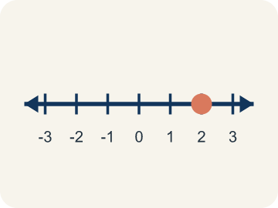 | Rational number Número racional  Any number you can write as a fraction. This includes fractions, decimals, and integers.  Example: 1/2 = 0.5, -3/4 = -0.75, 6 = 6/1 — all rational numbers
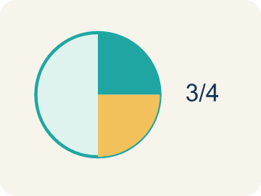 | Fraction Fracción  A number that shows part of a whole, like 3/4.  Example: 3/4 means 3 out of 4 equal parts — like 3 slices of a pizza cut into 4
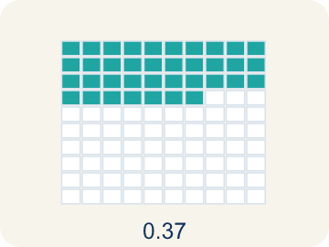 | Decimal Decimal  A number with a dot, like 0.5, that shows a part less than one.  Example: 0.5 = 1/2 (halfway between 0 and 1 on the number line)
Number line Recta numérica
A straight line with numbers spaced out evenly.
Example: A line with marks at -2, -1.5, -1, -0.5, 0, 0.5, 1, 1.5, 2
Equivalent Equivalente
Having the same value, just written a different way.
Example: 1/2 = 0.5 = 2/4 — all name the same point on the number line
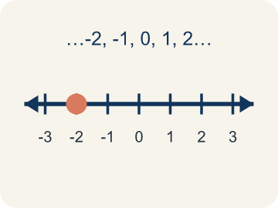 | Integer Número entero  Whole numbers and their opposites, like -2, -1, 0, 1, 2.  Example: ..., -3, -2, -1, 0, 1, 2, 3, ...

Guided Notes
Fill in each blank as we go. Use the Word Bank to help you.
WORD BANK
Rational number • Fraction • Decimal • Number line • Equivalent • Integer

1. Any number that can be written as a fraction, including integers and decimals, is a ___.
2. A number that shows part of a whole, like 3/5, is a ___.
3. A number that uses a point to show parts of a whole is a ___.
4. A line with numbers in order used to place and compare values is a ___.
5. Numbers that name the same value, like 1/2 and 0.5, are ___.
6. A whole number or its opposite is an ___.

Write About the Math
Use the support level you need. Every level answers the same math question.

1. Understand the Question explain
Where would you place -1 1/2 on the number line, and how do you decide between which two integers it falls?
Your job: Answer the question. Use math evidence. Explain how the evidence proves your answer.
Responde la pregunta. Usa evidencia matemática. Explica cómo la evidencia demuestra tu respuesta.

2. Plan Your Math Words check at least two
☐ Rational number — Any number you can write as a fraction. This includes fractions, decimals, and integers.
Número racional — Cualquier número que puedes escribir como fracción. Incluye fracciones, decimales y enteros.
☐ Fraction — A number that shows part of a whole, like 3/4.
Fracción — Un número que muestra una parte de un todo, como 3/4.
☐ Number line — A straight line with numbers spaced out evenly.
Recta numérica — Una línea recta con números separados de forma pareja.
☐ Integer — Whole numbers and their opposites, like -2, -1, 0, 1, 2.
Número entero — Números enteros y sus opuestos, como -2, -1, 0, 1, 2.
☐ Decimal — A number with a dot, like 0.5, that shows a part less than one.
Decimal — Un número con un punto, como 0.5, que muestra una parte menor que uno.
Say it first: Say your idea to a partner or quietly to yourself before you write.
-1 1/2 is between ___ and ___.
-1 1/2 esta entre ___ y ___.

3. Build Your Explanation choose your support
This model shows the parts of an explanation. It does not answer your writing question.
Claim: All of these are rational numbers because each one can be ___.
Evidence: Student explains a rational number is any number that can be written as a fraction, including integers and decimals.
Reasoning: This evidence connects the definition of rational number to the mathematical claim.

Start Most language support
Complete the frames. Use the word bank.
Completa las oraciones. Usa el banco de palabras.
-1 1/2 is between ___ and ___.
-1 1/2 esta entre ___ y ___.
It is closer to ___ because ___.
Esta mas cerca de ___ porque ___.

Build Some language support
Write two connected sentences. Use because, so, or but.
Escribe dos oraciones conectadas. Usa porque, entonces o pero.
My claim is ___.
Mi afirmación es ___.
I know because ___.
Lo sé porque ___.
So ___.
Entonces ___.

Explain Light language support
Write a claim, give math evidence, and explain your reasoning.
Escribe una afirmación, da evidencia matemática y explica tu razonamiento.
My claim is ___.
Mi afirmación es ___.
My math evidence is ___.
Mi evidencia matemática es ___.
This proves ___ because ___.
Esto demuestra ___ porque ___.

4. Check Your Explanation five quick checks
☐ I answered the question.
Respondí la pregunta.
☐ I used math evidence: numbers, an equation, a model, or a comparison.
Usé evidencia matemática: números, una ecuación, un modelo o una comparación.
☐ I explained how the evidence proves my answer.
Expliqué cómo la evidencia demuestra mi respuesta.
☐ I used at least two math words.
Usé por lo menos dos palabras matemáticas.
☐ I reread complete sentences and punctuation.
Volví a leer mis oraciones completas y la puntuación.

Worked Example

Watch & Read I Do — follow along with your teacher
Precise Treasure Coordinates
Captain Vega's advanced treasure map uses precise coordinates — not just whole numbers! One clue says the treasure is at -2.5 on the map (halfway between -2 and -3). Another clue points to 3/4 of the way from 0 to 1. A third clue leads to -1 1/2. To find each treasure, you must plot these exact rational numbers on the number line.

Think about:
• Where would -2.5 fall on a number line between -3 and -2?
• How is plotting 3/4 different from plotting a whole number?
• Can a negative number be a fraction or decimal?
• How many rational numbers exist between any two integers?
• Are there numbers that are NOT rational?

Solved Example I Do — watch each step
Problem: Which point is located between -1 and -2 on the number line?
A) -0.5
B) -1.5
C) -2.5
D) 1.5
Step 1: -1.5 is between -1 and -2 because it is 0.5 units to the left of -1 (or 0.5 units to the right of -2).
Answer: B. -1.5

Guided Practice

Solve Together We Do — work with your class
Problem: Which fraction is equivalent to 0.25?
A) 1/4
B) 1/2
C) 2/5
D) 1/3
Step 1:

Step 2:

Answer:

A scientist measures the water level of a lake relative to normal level (0). Monday: +0.75 ft, Tuesday: -1.25 ft, Wednesday: -0.5 ft, Thursday: +1.5 ft. She needs to plot these on a graph to track changes.
How do rational numbers help the scientist describe water levels more precisely than integers alone?

Sentence frame: Rational numbers help because ___. For example, -1.25 ft means the water is ___ below normal, which is between ___ and ___ on the number line. Without fractions and decimals, the scientist could only say ___.

Turn & Talk discuss with a partner
1. [Launch] How can a fraction like 1/2, a decimal like 0.75, and an integer like -3 all be rational numbers?
Start with: A rational number is any number you can write as ___.
Un numero racional es cualquier numero que puedes escribir como ___.
Word bank: rational number, fraction, decimal, integer, number line
2. [Explore] Where would you place -1 1/2 on the number line, and how do you decide between which two integers it falls?
Start with: -1 1/2 is between ___ and ___.
-1 1/2 esta entre ___ y ___.
Word bank: rational number, fraction, number line, integer, negative
3. [Connect] How can rewriting a fraction as a decimal (or a decimal as a fraction) help you compare two rational numbers?
Start with: If I turn 3/4 into a decimal, I get ___.
Si convierto 3/4 en decimal, obtengo ___.
Word bank: rational number, fraction, decimal, compare, number line
4. [Reflect] Is every integer a rational number? Is every rational number an integer? Explain your thinking.
Start with: Every integer is rational because it can be written as ___.
Todo entero es racional porque se puede escribir como ___.
Word bank: rational number, integer, fraction, decimal, number line
5. [Practice] During practice on Rational Numbers on the Number Line, what strategy did you use when a problem felt tricky?
Start with: -1 1/2 is between ___ and ___.
-1 1/2 esta entre ___ y ___.
Word bank: Rational number, Fraction, Decimal, Number line

Independent Practice

On Your Own You Do — show your work
Solve each problem. Show your thinking in the work box.

Level 1 Support extra scaffolding
1. Where is -3/4 located on the number line?
A) Between 0 and -1
B) Between -3 and -4
C) Between -1 and -2
D) Between 0 and 1

On Level grade-level practice
2. Which rational number is closest to 0 on the number line?
A) -1/4
B) 0.5
C) -2
D) 1.75

3. Which number is farthest to the LEFT on a number line?
A) -1
B) 0
C) -4
D) 2

4. What is the opposite of -3/4?
A) 3/4
B) -3/4
C) 4/3
D) 0

Level 2 Enrichment stretch your thinking
5. On a number line, point P is located at -2.5. Which statement describes its location best?
A) At -2
B) Halfway between -2 and -3
C) Halfway between 2 and 3
D) At -3

6. Which list of numbers is ordered from LEAST to GREATEST?
A) 3, 0, -2, -5
B) -2, -5, 0, 3
C) -5, -2, 0, 3
D) 0, -2, 3, -5

Exit Ticket
Answer on your own. This shows what you learned today.
★ Which rational number is located between -2 and -3 on the number line?
A) -1.5
B) -2.75
C) -3.5
D) 2.5

Answer Key & Teacher Guide
Teacher reference — remove or fold back before distributing to students.

Guided Notes (Fill-in)
Notes 1: Rational number
Notes 2: Fraction
Notes 3: Decimal
Notes 4: Number line
Notes 5: Equivalent
Notes 6: Integer

Worked Notes (I Do / We Do)
I Do: B. -1.5
We Do: A. 1/4

Independent Practice
Watch for this mistake: A common mistake in Rational Numbers on the Number Line is treating the numerator and denominator of a negative fraction as two separate whole numbers instead of one value between two integers — for example, plotting -3/4 by going to -3 and then counting 4 more units to the left, landing (incorrectly) at -7, instead of recognizing that -3/4 = -0.75, which sits between 0 and -1. Before you submit an answer, find the two whole numbers your value falls between, then split that space into equal parts.

Level 1 Support
1. A) Between 0 and -1 — -3/4 = -0.75, which is between 0 and -1. It is 3/4 of the way from 0 toward -1.

On Level
2. A) -1/4 — |-1/4| = 0.25, |0.5| = 0.5, |-2| = 2, |1.75| = 1.75. Since 0.25 is the smallest absolute value, -1/4 is closest to zero.
3. C) -4 — Farther left means more negative: -4 < -1 < 0 < 2, so -4 is farthest left.
4. A) 3/4 — The opposite of a number is its reflection across 0, so the opposite of -3/4 is 3/4.

Level 2 Enrichment
5. B) Halfway between -2 and -3 — -2.5 sits exactly halfway between -2 and -3.
6. C) -5, -2, 0, 3 — Least to greatest runs most-negative to most-positive: -5, -2, 0, 3.

Exit Ticket
B) -2.75 — -2.75 is between -2 and -3 because it is 0.75 units to the left of -2. -1.5 is between -1 and -2, and -3.5 is between -3 and -4.

Math Writing Criteria
The support level changes the amount of language scaffolding, not the mathematical expectation.
☐ I answered the question.
☐ I used math evidence: numbers, an equation, a model, or a comparison.
☐ I explained how the evidence proves my answer.
☐ I used at least two math words.
☐ I reread complete sentences and punctuation.

