UNIT 7 · LESSON 1 STANDARD 6.AT.8

Write Equations
Student Notes Packet
Name: ______________________ Date: ____________ Period: ________

Today's Goals
Content: I can write an equation to represent a real-world situation.
Language: I can explain my equation using the words equation, variable, equal sign, and expression.

Key Vocabulary
Look at the picture, read the word, then read what it means.
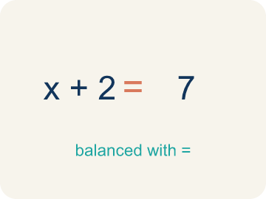 | Equation Ecuación  A math sentence with an equal sign showing both sides are the same.  Example: x + 5 = 12 means 'some number plus 5 equals 12'
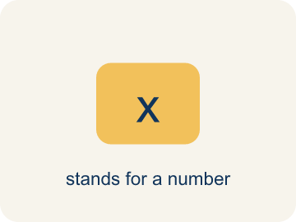 | Variable Variable  A letter that stands for an unknown number.  Example: In n + 3 = 10, the letter n stands for the unknown number (n = 7)
Equal sign Signo igual
The = sign, showing both sides are the same.
Example: 7 + 3 = 10 — both sides equal 10
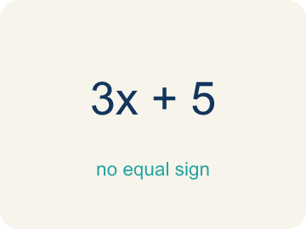 | Expression Expresión  A math phrase with numbers and letters, but no equal sign.  Example: 2x + 5 is an expression; it becomes an equation when you write 2x + 5 = 15
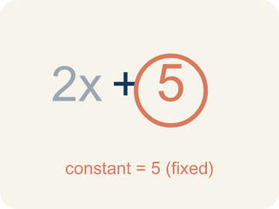 | Constant Constante  A fixed number in an expression or equation that does not change.  Example: In x + 7 = 12, the numbers 7 and 12 are constants; only x can change.
Unknown Incógnita
The value you are trying to find, usually shown with a variable.
Example: In n + 5 = 12, n is the unknown; you solve to find n = 7.

Guided Notes
Fill in each blank as we go. Use the Word Bank to help you.
WORD BANK
Equation • Variable • Equal sign • Expression • Constant • Unknown

1. A math sentence that says two amounts are equal, with an = sign, is an ___.
2. A letter that stands for an unknown number is a ___.
3. The symbol = that shows two amounts are the same is the ___.
4. A group of numbers and variables with no equal sign is an ___.
5. A fixed number that does not change is a ___.
6. The value you are trying to find in an equation is the ___.

Write About the Math
Use the support level you need. Every level answers the same math question.

1. Understand the Question explain
On the balance scale you put n + 8 on one side and 20 on the other. How did you decide what belongs on each side of the equal sign?
Your job: Answer the question. Use math evidence. Explain how the evidence proves your answer.
Responde la pregunta. Usa evidencia matemática. Explica cómo la evidencia demuestra tu respuesta.

2. Plan Your Math Words check at least two
☐ Equation — A math sentence with an equal sign showing both sides are the same.
Ecuación — Una oración matemática con un signo igual que muestra que ambos lados son iguales.
☐ Variable — A letter that stands for an unknown number.
Variable — Una letra que representa un número desconocido.
☐ Equal sign — The = sign, showing both sides are the same.
Signo igual — El signo =, que muestra que ambos lados son iguales.
☐ Expression — A math phrase with numbers and letters, but no equal sign.
Expresión — Una frase matemática con números y letras, pero sin signo igual.
☐ Constant — A fixed number in an expression or equation that does not change.
Constante — Un número fijo en una expresión o ecuación que no cambia.
Say it first: Say your idea to a partner or quietly to yourself before you write.
I put ___ on the left side because ___.
Puse ___ en el lado izquierdo porque ___.

3. Build Your Explanation choose your support
This model shows the parts of an explanation. It does not answer your writing question.
Claim: I let a variable stand for the unknown number of gems.
Evidence: Students choose a variable (such as n) for the unknown gems, build n + 8 = 20, and connect 'plus 8 more' to + 8 and 'equals 20 total' to = 20.
Reasoning: This evidence connects the definition of equation to the mathematical claim.

Start Most language support
Complete the frames. Use the word bank.
Completa las oraciones. Usa el banco de palabras.
I put ___ on the left side because ___.
Puse ___ en el lado izquierdo porque ___.
The equal sign means both sides are ___.
El signo igual significa que ambos lados son ___.

Build Some language support
Write two connected sentences. Use because, so, or but.
Escribe dos oraciones conectadas. Usa porque, entonces o pero.
My claim is ___.
Mi afirmación es ___.
I know because ___.
Lo sé porque ___.
So ___.
Entonces ___.

Explain Light language support
Write a claim, give math evidence, and explain your reasoning.
Escribe una afirmación, da evidencia matemática y explica tu razonamiento.
My claim is ___.
Mi afirmación es ___.
My math evidence is ___.
Mi evidencia matemática es ___.
This proves ___ because ___.
Esto demuestra ___ porque ___.

4. Check Your Explanation five quick checks
☐ I answered the question.
Respondí la pregunta.
☐ I used math evidence: numbers, an equation, a model, or a comparison.
Usé evidencia matemática: números, una ecuación, un modelo o una comparación.
☐ I explained how the evidence proves my answer.
Expliqué cómo la evidencia demuestra mi respuesta.
☐ I used at least two math words.
Usé por lo menos dos palabras matemáticas.
☐ I reread complete sentences and punctuation.
Volví a leer mis oraciones completas y la puntuación.

Worked Example

Watch & Read I Do — follow along with your teacher
Case File: Translate the Clues
Detective Ruiz received a tip: 'A number of stolen gems plus 8 more equals 20 total gems.' She needs to write an equation to represent this clue before she can solve the case. How would you write this situation as an equation?

Think about:
• What quantity is unknown in this situation?
• What does 'plus 8 more' tell you about the operation?
• What does 'equals 20 total' tell you?
• What if the clue said 'twice a number equals 20' instead?
• Could you use a different variable letter and still have the same equation?

Solved Example I Do — watch each step
Problem: Which equation represents: 'A number plus 12 equals 30'?
A) n + 12 = 30
B) n − 12 = 30
C) 12n = 30
D) n / 12 = 30
Step 1: 'Plus' means addition, so the equation is n + 12 = 30.
Answer: A. n + 12 = 30

Guided Practice

Solve Together We Do — work with your class
Problem: Which equation represents: 'Seven less than a number is 18'?
A) n − 7 = 18
B) 7 − n = 18
C) n + 7 = 18
D) n / 7 = 18
Step 1:

Step 2:

Answer:

A detective is tracking stolen paintings. She knows that the number of paintings recovered plus 14 paintings still missing equals the 37 total stolen. The equation p + 14 = 37 represents this situation.
How many paintings has the detective recovered? How did writing an equation help you understand the situation?

Sentence frame: The detective recovered ___ paintings because p + 14 = 37 means p = 37 − ___ = ___.

Turn & Talk discuss with a partner
1. [Launch] Detective Ruiz's clue says 'a number of stolen gems plus 8 more equals 20 total.' How would you turn this clue into an equation, and what does each part stand for?
Start with: The unknown is ___, so I write the variable ___.
La incógnita es ___, así que escribo la variable ___.
Word bank: equation, variable, equal sign, expression
2. [Explore] On the balance scale you put n + 8 on one side and 20 on the other. How did you decide what belongs on each side of the equal sign?
Start with: I put ___ on the left side because ___.
Puse ___ en el lado izquierdo porque ___.
Word bank: equation, variable, equal sign, expression
3. [Connect] When would writing an equation help you solve a real problem instead of just guessing?
Start with: Writing an equation helps me because ___.
Escribir una ecuación me ayuda porque ___.
Word bank: equation, variable, expression, equal sign
4. [Practice] During practice on Write Equations, what strategy did you use when a problem felt tricky?
Start with: I put ___ on the left side because ___.
Puse ___ en el lado izquierdo porque ___.
Word bank: Equation, Variable, Equal sign, Expression

Independent Practice

On Your Own You Do — show your work
Solve each problem. Show your thinking in the work box.

Level 1 Support extra scaffolding
1. Which equation represents: 'Three times a number equals 21'?
A) 3n = 21
B) n + 3 = 21
C) n − 3 = 21
D) n / 3 = 21

2. Which equation represents: 'A number divided by 4 equals 8'?
A) n / 4 = 8
B) 4n = 8
C) n − 4 = 8
D) n + 4 = 8

On Level grade-level practice
3. A detective found some fingerprints on Monday and 14 more on Tuesday, for a total of 30. Which equation represents this?
A) f + 14 = 30
B) f − 14 = 30
C) 14f = 30
D) f / 14 = 30

Exit Ticket
Answer on your own. This shows what you learned today.
★ Which equation represents: 'A number divided by 6 equals 9'?
A) n / 6 = 9
B) 6n = 9
C) n − 6 = 9
D) n + 6 = 9

