Math is Exploring and Thinking — Homework
Lesson 1-2 • Standard 5.NF.B.4
Name: ______________________ Period: ______ Date: ____________

Today's Goals
Content: I can make sense of a problem, plan a strategy, and use fractions of a whole number to compare quantities.
Language: I can explain my plan using the words we know, we don't know, and my strategy is ___ .

Key Words
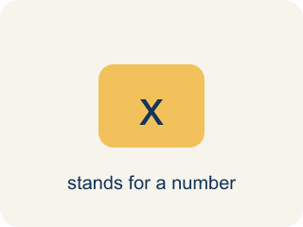
quantity (cantidad) — An amount in a problem — a number with a meaning attached, like 540 meters.
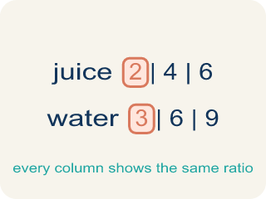
relationship (relación) — How two quantities compare or connect to each other.

strategy (estrategia) — A plan for how to solve a problem before you start computing.
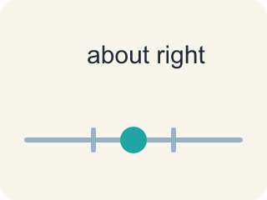
reasonable (razonable) — A solution that makes sense in the context of the problem.

persevere (perseverar) — To keep working on a problem, checking your progress and adjusting your plan when you get stuck.

Practice
Show your work. Use the blank space under each problem.
1. Which of these is a correct way to decompose 105.76?
A. 100 + 5.76
B. 100 + 5.076
C. 105 + 7.6
D. 10 + 5.76
______________________________________________________________________
2. Which is another correct decomposition of 105.76?
A. 110 − 4.24
B. 110 − 5.24
C. 106 − 0.34
D. 110 + 4.24
______________________________________________________________________
3. The Rio de Janeiro building will be 9/10 as tall as One World Trade Center (540 meters). How tall will it be?
A. 486 meters
B. 54 meters
C. 4,860 meters
D. 594 meters
______________________________________________________________________
4. The Tokyo building will be 6/5 as tall as One World Trade Center (540 meters). How tall will it be?
A. 648 meters
B. 450 meters
C. 108 meters
D. 432 meters
______________________________________________________________________
5. Without calculating, which new building must be TALLER than One World Trade Center, and why?
A. Tokyo, because 6/5 is greater than 1
B. London, because 5/6 has a 6 in it
C. Rio de Janeiro, because 9/10 is close to 1
D. None — a fraction of 540 is always less than 540
______________________________________________________________________
6.
______________________________________________________________________
______________________________________________________________________
______________________________________________________________________
______________________________________________________________________
7. You calculate 5/6 × 540 and get 650 meters. What does the checking step of your plan tell you?
A. The answer is unreasonable — 5/6 of 540 must be LESS than 540
B. The answer is fine because it is close to 540
C. The answer is fine because 650 is a bigger number than 5/6
D. Checking is only needed when the problem asks for it
______________________________________________________________________
8.
______________________________________________________________________
______________________________________________________________________
______________________________________________________________________
______________________________________________________________________

Answer Key (Teacher)
1. A. 100 + 5.76
100 + 5.76 = 105.76. Decomposing means the parts must rebuild the original number exactly.
Watch for: Expecting a fraction of a number to be bigger than the number — 5/6 × 540 must be LESS than 540 because 5/6 is less than 1; only a fraction greater than 1, like 6/5, makes the product bigger.
2. A. 110 − 4.24
110 − 4.24 = 105.76. A decomposition can use subtraction, not only addition.
Watch for: Expecting a fraction of a number to be bigger than the number — 5/6 × 540 must be LESS than 540 because 5/6 is less than 1; only a fraction greater than 1, like 6/5, makes the product bigger.
3. A. 486 meters
9/10 × 540: one tenth of 540 is 54, and 9 tenths is 9 × 54 = 486 meters.
Watch for: Expecting a fraction of a number to be bigger than the number — 5/6 × 540 must be LESS than 540 because 5/6 is less than 1; only a fraction greater than 1, like 6/5, makes the product bigger.
4. A. 648 meters
6/5 × 540: one fifth of 540 is 108, and 6 fifths is 6 × 108 = 648 meters — taller than 540, because 6/5 is greater than 1.
Watch for: Expecting a fraction of a number to be bigger than the number — 5/6 × 540 must be LESS than 540 because 5/6 is less than 1; only a fraction greater than 1, like 6/5, makes the product bigger.
5. A. Tokyo, because 6/5 is greater than 1
Multiplying 540 by a fraction greater than 1 gives more than 540. Only 6/5 is greater than 1; 5/6 and 9/10 are both less than 1.
Watch for: Expecting a fraction of a number to be bigger than the number — 5/6 × 540 must be LESS than 540 because 5/6 is less than 1; only a fraction greater than 1, like 6/5, makes the product bigger.
6. Open response — answers will vary.
7. A. The answer is unreasonable — 5/6 of 540 must be LESS than 540
5/6 is less than 1, so 5/6 of 540 must land below 540. Getting 650 means the plan needs adjusting — which is exactly what checking is for.
Watch for: Expecting a fraction of a number to be bigger than the number — 5/6 × 540 must be LESS than 540 because 5/6 is less than 1; only a fraction greater than 1, like 6/5, makes the product bigger.
8. Open response — answers will vary.

