Explore Integers and Their Opposites — Homework
Lesson 7-1 • Standard 6.NOS.6
Name: ______________________ Period: ______ Date: ____________

Today's Goals
Content: I can use integers to represent quantities in everyday life, explain what 0 means in each situation, and name the opposite of an integer on the number line.
Language: I can explain my reasoning using the words integer, opposite, negative, positive, and number line.

Key Words
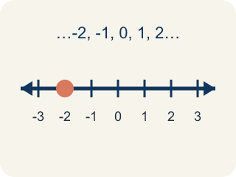
Integer (Número entero) — The counting numbers, their opposites, and 0.
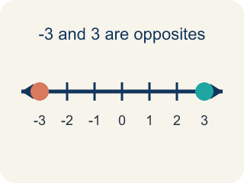
Opposite (Opuesto) — A number that is the same distance from 0 as another number, but on the other side of 0.
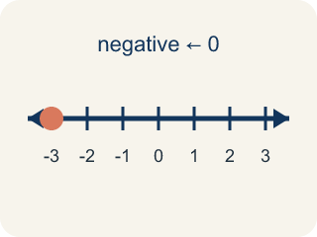
Negative number (Número negativo) — A number less than 0, written with a − sign. On a number line it sits to the left of 0.
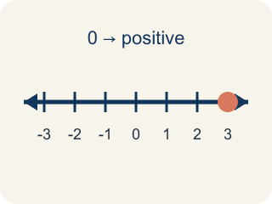
Positive number (Número positivo) — A number greater than 0. On a number line it sits to the right of 0.
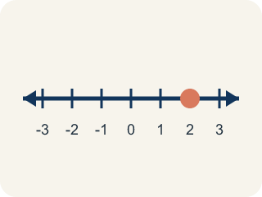
Number line (Recta numérica) — A straight line where numbers are placed in order. It extends to the left of 0 to show values less than 0.

Practice
Show your work. Use the blank space under each problem.
1. Badwater Basin is 86 meters below sea level, and sea level is 0. Which integer represents that elevation?
A. -86
B. 86
C. 0
D. -68
______________________________________________________________________
2. In Reykjavik the temperature was -9°C. What is the opposite of -9?
A. 9
B. -9
C. 0
D. -18
______________________________________________________________________
3. Which list of integers is ordered from LEAST to GREATEST?
A. -8, -3, 0, 5
B. -3, -8, 0, 5
C. 0, -3, -8, 5
D. 5, 0, -3, -8
______________________________________________________________________
4. Badwater Basin is at -86 meters. Which elevation is FARTHER below sea level than Badwater Basin?
A. -120 meters
B. -40 meters
C. 0 meters
D. 86 meters
______________________________________________________________________
5. Write the opposite of each integer.
Integer | Opposite
-15
8
0
-100
______________________________________________________________________
6. Spot the Mistake: Reykjavik's Temperature Swing
Step 1 (Problem): At 6 a.m. in Reykjavik the temperature was -12°C. At 2 p.m. it was the opposite of the 6 a.m. temperature. What was the temperature at 2 p.m.?
Step 2 (Student thinking): The opposite of a temperature should still be a cold temperature, so I keep the negative sign and just make the number bigger. That gives a temperature farther from 0.
Step 3 (Student answer): The temperature at 2 p.m. was -24°C.
Which step has the mistake? Explain and fix it:
______________________________________________________________________
______________________________________________________________________
______________________________________________________________________
7. Which statement about 0 is TRUE?
A. 0 is an integer, and it is its own opposite
B. 0 is a negative integer because it is not positive
C. 0 is a positive integer because it has no negative sign
D. 0 is not an integer at all
______________________________________________________________________

Answer Key (Teacher)
1. A. -86
Below sea level means less than 0, so the elevation is written with a negative sign: -86 meters.
Watch for: The most common mistake in this lesson is thinking that the opposite of a negative integer is still negative — for example, saying the opposite of -7 is -7, or that the opposite of -12 is -24. Opposites are the same DISTANCE from 0 but on OPPOSITE sides of 0, so taking an opposite always changes the direction and never changes the distance: the opposite of -7 is 7 and the opposite of -12 is 12. The one exception is 0, which is 0 units from itself and is therefore its own opposite. Before you submit, count the units from 0 and check that your answer is on the other side.
2. A. 9
The opposite of a number is the same distance from 0 on the other side, so the opposite of -9 is 9.
Watch for: The most common mistake in this lesson is thinking that the opposite of a negative integer is still negative — for example, saying the opposite of -7 is -7, or that the opposite of -12 is -24. Opposites are the same DISTANCE from 0 but on OPPOSITE sides of 0, so taking an opposite always changes the direction and never changes the distance: the opposite of -7 is 7 and the opposite of -12 is 12. The one exception is 0, which is 0 units from itself and is therefore its own opposite. Before you submit, count the units from 0 and check that your answer is on the other side.
3. A. -8, -3, 0, 5
Least to greatest reads left to right on the number line: -8, then -3, then 0, then 5.
Watch for: The most common mistake in this lesson is thinking that the opposite of a negative integer is still negative — for example, saying the opposite of -7 is -7, or that the opposite of -12 is -24. Opposites are the same DISTANCE from 0 but on OPPOSITE sides of 0, so taking an opposite always changes the direction and never changes the distance: the opposite of -7 is 7 and the opposite of -12 is 12. The one exception is 0, which is 0 units from itself and is therefore its own opposite. Before you submit, count the units from 0 and check that your answer is on the other side.
4. A. -120 meters
Farther below sea level means farther to the left of 0. -120 is 120 units below 0, which is deeper than 86 units below 0.
Watch for: The most common mistake in this lesson is thinking that the opposite of a negative integer is still negative — for example, saying the opposite of -7 is -7, or that the opposite of -12 is -24. Opposites are the same DISTANCE from 0 but on OPPOSITE sides of 0, so taking an opposite always changes the direction and never changes the distance: the opposite of -7 is 7 and the opposite of -12 is 12. The one exception is 0, which is 0 units from itself and is therefore its own opposite. Before you submit, count the units from 0 and check that your answer is on the other side.
5. Write the opposite of each integer.
-15 — Opposite: 15
8 — Opposite: -8
0 — Opposite: 0
-100 — Opposite: 100

6. Spot the Mistake: Reykjavik's Temperature Swing
The mistake is in Step 2.
Correct work: An opposite never changes the distance from 0 — it changes only the side. -12 is 12 units to the left of 0, so its opposite is 12 units to the RIGHT of 0, which is 12°C. The 2 p.m. temperature was 12°C. (If you then take the opposite again for 11 p.m., you come back to -12°C.)
Watch for: The "Student thinking" step changes the distance from 0 instead of the side, so it produces a number twice as far from zero rather than its mirror image. The definition of opposite fixes the distance at 12 units and moves the point across 0, giving 12°C.
7. A. 0 is an integer, and it is its own opposite
Integers are the counting numbers, their opposites, and 0. Zero is 0 units from itself, so it is its own opposite.
Watch for: The most common mistake in this lesson is thinking that the opposite of a negative integer is still negative — for example, saying the opposite of -7 is -7, or that the opposite of -12 is -24. Opposites are the same DISTANCE from 0 but on OPPOSITE sides of 0, so taking an opposite always changes the direction and never changes the distance: the opposite of -7 is 7 and the opposite of -12 is 12. The one exception is 0, which is 0 units from itself and is therefore its own opposite. Before you submit, count the units from 0 and check that your answer is on the other side.

