Represent Polygons on the Coordinate Plane — Homework
Lesson 7-7 • Standard 6.NOS.9
Name: ______________________ Period: ______ Date: ____________

Today's Goals
Content: I can draw polygons from their vertex coordinates on the coordinate plane, and use coordinates to find side lengths and solve perimeter and area problems.
Language: I can explain how I found a distance using the words vertices, coordinates, and absolute value.

Key Words
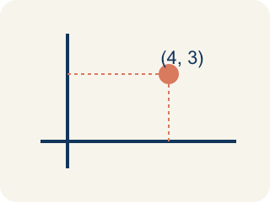
vertex (vértice) — A corner point of a polygon, named by an ordered pair on the coordinate plane.
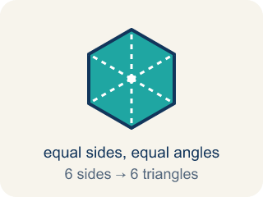
polygon (polígono) — A closed figure made of line segments; on the plane you draw it by plotting the vertices and connecting them in order.
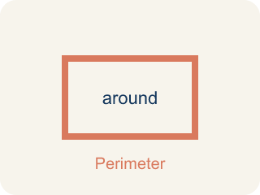
perimeter (perímetro) — The total distance around a polygon — the sum of all its side lengths.
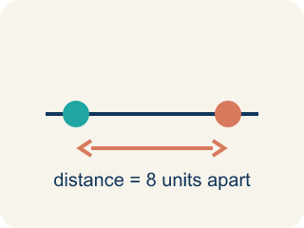
distance between vertices (distancia entre vértices) — When two vertices share an x- or y-coordinate, the distance between them is the absolute difference of the other coordinates.
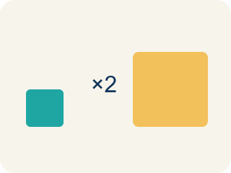
scale (escala) — What one grid unit stands for in the real situation.

Practice
Show your work. Use the blank space under each problem.
1. Vertices (-4.5, 3) and (5, 3) share y = 3. What is the distance between them?
A. 9.5 units
B. 0.5 units
C. 8 units
D. 1.5 units
______________________________________________________________________
2. Vertices (5, 3) and (5, -3.75) share x = 5. What is the distance between them?
A. 6.75 units
B. 0.75 units
C. 5 units
D. 8.75 units
______________________________________________________________________
3. The park's marked vertices are 3 units apart and each unit is 100 feet. What is the park's width?
A. 300 feet
B. 3 feet
C. 103 feet
D. 30 feet
______________________________________________________________________
4. The park's area must be 240,000 sq ft and its width is 300 ft. What is its length?
A. 800 feet
B. 80,000 feet
C. 720 feet
D. 240,300 feet
______________________________________________________________________
5. The length is 800 feet and each unit represents 100 feet. How many units long is the park on the map?
A. 8 units
B. 80 units
C. 800 units
D. 0.8 units
______________________________________________________________________
6. The known vertices of the park are at (2, 4) and (5, 4), and the length runs DOWNWARD 8 units. Where are the other two vertices?
A. (2, -4) and (5, -4)
B. (2, 12) and (5, 12)
C. (10, 4) and (13, 4)
D. (2, -8) and (5, -8)
______________________________________________________________________
7. A rectangle has vertices (-3, 2), (4, 2), (4, -1), (-3, -1). What is its perimeter?
A. 20 units
B. 10 units
C. 21 units
D. 13 units
______________________________________________________________________
8.
______________________________________________________________________
______________________________________________________________________
______________________________________________________________________
______________________________________________________________________
9. Vertices (−2, 6) and (−2, −6): the distance between them is
A. 12 units
B. 0 units
C. 4 units
D. 36 units
______________________________________________________________________

Answer Key (Teacher)
1. A. 9.5 units
They differ only in x: |5 − (−4.5)| = 5 + 4.5 = 9.5 units.
Watch for: Subtracting coordinates without the absolute value — from y = 3 down to y = −3.75 the distance is 3 + 3.75 = 6.75 units, not 3.75 − 3 = 0.75. Distances that cross zero are the whole reason the absolute value is there.
2. A. 6.75 units
They differ only in y: |3 − (−3.75)| = 3 + 3.75 = 6.75 units.
Watch for: Subtracting coordinates without the absolute value — from y = 3 down to y = −3.75 the distance is 3 + 3.75 = 6.75 units, not 3.75 − 3 = 0.75. Distances that cross zero are the whole reason the absolute value is there.
3. A. 300 feet
3 units × 100 feet per unit = 300 feet.
Watch for: Subtracting coordinates without the absolute value — from y = 3 down to y = −3.75 the distance is 3 + 3.75 = 6.75 units, not 3.75 − 3 = 0.75. Distances that cross zero are the whole reason the absolute value is there.
4. A. 800 feet
Length = area ÷ width = 240,000 ÷ 300 = 800 feet.
Watch for: Subtracting coordinates without the absolute value — from y = 3 down to y = −3.75 the distance is 3 + 3.75 = 6.75 units, not 3.75 − 3 = 0.75. Distances that cross zero are the whole reason the absolute value is there.
5. A. 8 units
800 ÷ 100 = 8 units on the map.
Watch for: Subtracting coordinates without the absolute value — from y = 3 down to y = −3.75 the distance is 3 + 3.75 = 6.75 units, not 3.75 − 3 = 0.75. Distances that cross zero are the whole reason the absolute value is there.
6. A. (2, -4) and (5, -4)
8 units below y = 4 is y = 4 − 8 = −4, keeping each x the same: (2, −4) and (5, −4).
Watch for: Subtracting coordinates without the absolute value — from y = 3 down to y = −3.75 the distance is 3 + 3.75 = 6.75 units, not 3.75 − 3 = 0.75. Distances that cross zero are the whole reason the absolute value is there.
7. A. 20 units
Width |4 − (−3)| = 7, height |2 − (−1)| = 3, so P = 2(7) + 2(3) = 20 units.
Watch for: Subtracting coordinates without the absolute value — from y = 3 down to y = −3.75 the distance is 3 + 3.75 = 6.75 units, not 3.75 − 3 = 0.75. Distances that cross zero are the whole reason the absolute value is there.
8. Open response — answers will vary.
9. A. 12 units
Same x, so distance = |6 − (−6)| = 12 units.
Watch for: Subtracting coordinates without the absolute value — from y = 3 down to y = −3.75 the distance is 3 + 3.75 = 6.75 units, not 3.75 − 3 = 0.75. Distances that cross zero are the whole reason the absolute value is there.

