Explore Relationships Between Two Variables — Homework
Lesson 9-1 • Standard 6.AT.11
Name: ______________________ Period: ______ Date: ____________

Today's Goals
Content: I can recognize when two quantities change together, and identify which one is the independent variable and which is the dependent variable.
Language: I can explain which quantity depends on the other using the words independent variable, dependent variable, and depends on.

Key Words
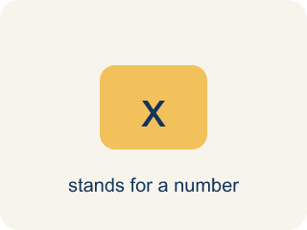
independent variable (variable independiente) — The quantity that is subject to choice. It does not depend on the other quantity.

dependent variable (variable dependiente) — The quantity that changes in response to the independent variable.

depends on (depende de) — One quantity depends on another when changing the first causes the second to change.

quantity (cantidad) — Something that can be counted or measured.
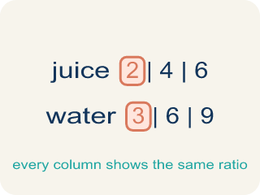
relationship (relación) — How two quantities change together.

Practice
Show your work. Use the blank space under each problem.
1. Akela chooses how many hours of sunlight each tray gets. Which is the INDEPENDENT variable?
A. Hours of sunlight
B. Plant height
C. Number of trays
D. Number of seeds
______________________________________________________________________
2. In Akela's experiment, which is the DEPENDENT variable?
A. Plant height
B. Hours of sunlight
C. The kind of seed
D. The size of the tray
______________________________________________________________________
3. A gym charges $24.95 per month. Which pair correctly names the variables?
A. Independent: months; Dependent: total cost
B. Independent: total cost; Dependent: months
C. Independent: $24.95; Dependent: months
D. Independent: months; Dependent: $24.95
______________________________________________________________________
4. Claire jogs 30 minutes and burns 123 Calories. At the same rate, how many Calories would a 90-minute jog burn?
A. 369
B. 246
C. 410
D. 300
______________________________________________________________________
5. Which of these pairs is NOT a dependent relationship?
A. Number of pizzas sold and number of employees the shop has
B. Number of pizzas sold and weekly cost of cheese
C. Hours jogged and Calories burned
D. Tickets bought and total cost
______________________________________________________________________
6. A plant grows 2 cm for every hour of daily sunlight. Which table row is correct?
A. 4 hours to 8 cm
B. 4 hours to 6 cm
C. 4 hours to 2 cm
D. 4 hours to 4 cm
______________________________________________________________________
7. Which question would you ask to find the DEPENDENT variable?
A. Which quantity responds when the other one changes?
B. Which quantity is larger?
C. Which quantity has units?
D. Which quantity comes first alphabetically?
______________________________________________________________________
8. Claire decides to walk instead of jog for the same 30 minutes. What happens to the two variables?
A. Time stays the independent variable; Calories burned still depends on it
B. Calories burned becomes the independent variable
C. Neither is a variable any more
D. Time becomes the dependent variable
______________________________________________________________________
9. If Claire runs exactly 3 miles and records how long it takes, which is the independent variable now?
A. Distance (3 miles)
B. Time it takes
C. Her speed
D. Calories burned
______________________________________________________________________

Answer Key (Teacher)
1. A. Hours of sunlight
Akela chooses the sunlight, so sunlight is subject to choice — that makes it independent.
Watch for: Naming the variables backward — calling the responding quantity 'independent' because it is the one the question asks about.
2. A. Plant height
Height responds to how much sunlight the tray received, so height is the dependent variable.
Watch for: Naming the variables backward — calling the responding quantity 'independent' because it is the one the question asks about.
3. A. Independent: months; Dependent: total cost
You choose how many months to stay a member. The total cost responds to that.
Watch for: Naming the variables backward — calling the responding quantity 'independent' because it is the one the question asks about.
4. A. 369
30 minutes burned 123 Calories, and 90 is 3 times 30, so the Calories are 3 times 123, which is 369.
Watch for: Naming the variables backward — calling the responding quantity 'independent' because it is the one the question asks about.
5. A. Number of pizzas sold and number of employees the shop has
The shop has 6 employees whether it sells 5 pizzas or 500. That count does not respond to pizza sales.
Watch for: Naming the variables backward — calling the responding quantity 'independent' because it is the one the question asks about.
6. A. 4 hours to 8 cm
At 2 cm per hour, 4 hours of sunlight gives 4 times 2, which is 8 cm.
Watch for: Naming the variables backward — calling the responding quantity 'independent' because it is the one the question asks about.
7. A. Which quantity responds when the other one changes?
The dependent variable is defined by its response to the independent variable — not by size, units, or name.
Watch for: Naming the variables backward — calling the responding quantity 'independent' because it is the one the question asks about.
8. A. Time stays the independent variable; Calories burned still depends on it
Changing the activity changes how many Calories each minute burns, but time is still the quantity she chooses.
Watch for: Naming the variables backward — calling the responding quantity 'independent' because it is the one the question asks about.
9. A. Distance (3 miles)
This time she fixes the distance by choice and the time is whatever results, so distance is independent and time is dependent.
Watch for: Naming the variables backward — calling the responding quantity 'independent' because it is the one the question asks about.

