Apply Two-Variable Relationships to Solve Problems — Homework
Lesson 9-4 • Standard 6.AT.11
Name: ______________________ Period: ______ Date: ____________

Today's Goals
Content: I can write an equation to represent the relationship between two variable quantities and use it to solve a real problem.
Language: I can justify a recommendation using the words equation, solution, and at least.

Key Words
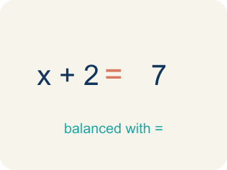
solution (solución) — A value of the variable that makes an equation true.
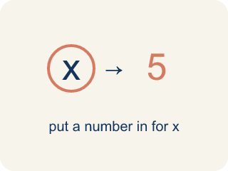
substitute (sustituir) — To replace a variable with a number so you can compute.
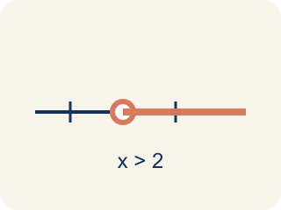
at least (al menos) — That amount or more — the smallest amount that still works.
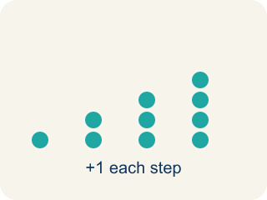
predict (predecir) — To make a reasonable guess about a future amount using information you already have.

justify (justificar) — To explain WHY an answer or recommendation makes sense, using the mathematics.

Practice
Show your work. Use the blank space under each problem.
1. The assembly line produces 2.5 cars per hour. How many cars does it produce in one 8-hour shift?
A. 20 cars
B. 10.5 cars
C. 16 cars
D. 25 cars
______________________________________________________________________
2. Let h = hours of operation and c = cars produced. Which equation represents the assembly line?
A. c = 2.5h
B. c = 2.5 + h
C. h = 2.5c
D. c = h ÷ 2.5
______________________________________________________________________
3. The order requires 1,000 cars. Using 2.5h = 1,000, how many hours will the plant need?
A. 400 hours
B. 2,500 hours
C. 997.5 hours
D. 40 hours
______________________________________________________________________
4. The plant needs 400 hours to fill the order. Running 24 hours a day, about how many days is that?
A. About 17 days
B. 400 days
C. 50 days
D. 4 days
______________________________________________________________________
5. The goal is $500 at $12 per car. Using 12n = 500, at least how many cars must be washed?
A. 42 cars
B. 41 cars
C. 40 cars
D. 50 cars
______________________________________________________________________
6. Can the student council wash 41 cars at $12 each and meet the $500 goal?
A. No — 41 cars raise $492, which is less than $500
B. Yes — 41 cars raise $502
C. Yes — 41 rounds up to 42, so it counts
D. No — 41 cars raise $412
______________________________________________________________________
7. The council predicts 35 cars this year. Using 35p = 500, at least how much must they charge per car to reach $500?
A. About $14.30
B. $12.00
C. $14.00
D. $465.00
______________________________________________________________________
8. How could the council CHECK that charging $14.30 for 35 cars meets the goal?
A. Multiply 35 × 14.30 = 500.50 and confirm it is at least $500
B. Divide 35 by 14.30 and confirm it is at least $500
C. Add 35 + 14.30 and confirm it is at least $500
D. No check is possible after solving
______________________________________________________________________

Answer Key (Teacher)
1. A. 20 cars
Substitute 8 hours: 2.5 × 8 = 20 cars per shift.
Watch for: Adding the rate instead of multiplying — writing 2.5 + 8 = 10.5 cars for an 8-hour shift instead of 2.5 × 8 = 20. The rate applies to EVERY hour, so the total is always rate × amount.
2. A. c = 2.5h
Every hour the plant produces 2.5 cars, so the total is 2.5 times the hours: c = 2.5h. Check with the table: 8 hours gives 20 cars.
Watch for: Adding the rate instead of multiplying — writing 2.5 + 8 = 10.5 cars for an 8-hour shift instead of 2.5 × 8 = 20. The rate applies to EVERY hour, so the total is always rate × amount.
3. A. 400 hours
Divide both sides by 2.5: h = 1,000 ÷ 2.5 = 400 hours.
Watch for: Adding the rate instead of multiplying — writing 2.5 + 8 = 10.5 cars for an 8-hour shift instead of 2.5 × 8 = 20. The rate applies to EVERY hour, so the total is always rate × amount.
4. A. About 17 days
Divide the hours by the hours in a day: 400 ÷ 24 ≈ 16.7, which is about 17 days — about 2.5 weeks.
Watch for: Adding the rate instead of multiplying — writing 2.5 + 8 = 10.5 cars for an 8-hour shift instead of 2.5 × 8 = 20. The rate applies to EVERY hour, so the total is always rate × amount.
5. A. 42 cars
500 ÷ 12 is about 41.7, and you cannot wash a fraction of a car, so round UP: 42 cars raise 42 × 12 = $504, which meets the goal.
Watch for: Adding the rate instead of multiplying — writing 2.5 + 8 = 10.5 cars for an 8-hour shift instead of 2.5 × 8 = 20. The rate applies to EVERY hour, so the total is always rate × amount.
6. A. No — 41 cars raise $492, which is less than $500
41 × 12 = 492, and $492 < $500, so 41 cars fall $8 short.
Watch for: Adding the rate instead of multiplying — writing 2.5 + 8 = 10.5 cars for an 8-hour shift instead of 2.5 × 8 = 20. The rate applies to EVERY hour, so the total is always rate × amount.
7. A. About $14.30
500 ÷ 35 ≈ 14.29, so they must charge at least $14.30 per car: 35 × 14.30 = $500.50, just over the goal.
Watch for: Adding the rate instead of multiplying — writing 2.5 + 8 = 10.5 cars for an 8-hour shift instead of 2.5 × 8 = 20. The rate applies to EVERY hour, so the total is always rate × amount.
8. A. Multiply 35 × 14.30 = 500.50 and confirm it is at least $500
Substitute the price back into the equation: 35 cars at $14.30 raise 35 × 14.30 = $500.50, which is at least $500.
Watch for: Adding the rate instead of multiplying — writing 2.5 + 8 = 10.5 cars for an 8-hour shift instead of 2.5 × 8 = 20. The rate applies to EVERY hour, so the total is always rate × amount.

