Unit 3 Test — Version B
Name: ______________________________ Date: ______________ Period: ______
Questions: 13 Total Points: 19.00
Standards: CCSS.Math.Content.6.RP.A.1 CCSS.Math.Content.6.RP.A.2 CCSS.Math.Content.6.RP.A.3.a CCSS.Math.Content.6.RP.A.3.b CCSS.Math.Content.6.RP.A.3.d

Question 1
Type: Fill-in-the-Blank DOK: 1 Standards: CCSS.Math.Content.6.RP.A.1 Points: 1
Priya is stringing beads to make a bracelet. She will use 1 red bead for every 5 blue beads to have a total of 24 beads on the bracelet. How many of each color bead will Priya use? Enter the answers.
____________ blue beads
____________ red beads

Question 2A (linked: 2B)
Type: Equation Entry DOK: 2 Standards: CCSS.Math.Content.6.RP.A.1 Points: 1
The table shows the number of students in different activities at Marcus’s school.
School Group | Number of Students
Soccer Team | 36
Art Club | 22
Robotics Club | 30
Debate Team | 16

Find the ratio of the number of students in the robotics club to the number of students on the soccer team. Express the answer as a fraction in simplest form. Enter the answer.
____________

Question 2B (linked: 2A)
Type: Short Answer DOK: 2 Standards: CCSS.Math.Content.6.RP.A.1 Points: 1
Explain the meaning of the simplified ratio that you wrote in Part A. Enter the answer.
______________________________________________________________________________________
______________________________________________________________________________________
______________________________________________________________________________________

Question 3
Type: Fill-in-the-Blank DOK: 1 Standards: CCSS.Math.Content.6.RP.A.2 Points: 1
Darnell does 192 jumping jacks in 48 seconds. Write this rate as a unit rate. Enter the answer.
____________ jumping jacks per second

Question 4A (linked: 4B)
Type: Fill-in-the-Blank DOK: 2 Standards: CCSS.Math.Content.6.RP.A.2 Points: 1
Fresh Market sells a 4-pound bag of trail mix for $22.60. Nature’s Pantry sells a 2.5-pound bag of trail mix for $13.50.
What is the unit price at each store? Enter the answers.
Fresh Market: $____________ per pound
Nature’s Pantry: $____________ per pound

Question 4B (linked: 4A)
Type: Multiple Choice DOK: 2 Standards: CCSS.Math.Content.6.RP.A.2 Points: 1
Based on unit prices, the trail mix from which store is a better buy? Choose the correct answer.
○ The Fresh Market trail mix is a better buy because the unit price is lower. | ○ The Nature’s Pantry trail mix is a better buy because the unit price is lower.
○ The Fresh Market trail mix is a better buy because you get a bigger bag. | ○ Buying the trail mix from either store would be equally as good.

Question 5
Type: Cloze DOK: 2 Points: 1
Tasha earns $56 in 4 hours. The double number line shows the amount Devon earns. Choose the correct answers to complete the sentence.
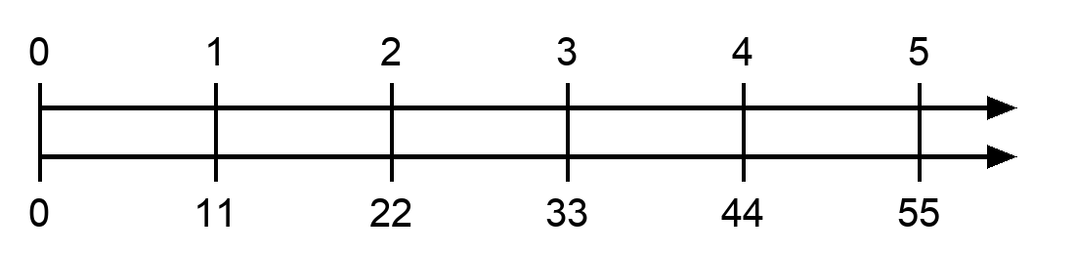
[ Tasha / Devon ] earns $ [ 1 / 2 / 3 / 4 ] more per hour.

Question 6A (linked: 6B)
Type: Fill-in-the-Blank DOK: 2 Standards: CCSS.Math.Content.6.RP.A.3.a Points: 1
A survey found that for every 4 people who preferred chocolate milk, there were 3 people who preferred white milk. Enter the correct answers to complete the table.
Chocolate | 12 | 20 | 32 | 44
White

Question 6B (linked: 6A)
Type: Essay DOK: 2 Standards: CCSS.Math.Content.6.RP.A.3.a Points: 1
Explain how you determined your answer. Enter the answer.
Sentence Frame: "I know this because..."
______________________________________________________________________________________
______________________________________________________________________________________
______________________________________________________________________________________

Question 7
Type: Coordinate Grapher DOK: 2 Standards: CCSS.Math.Content.6.RP.A.3.a Points: 1
Maya puts 3 stickers on each page of her scrapbook. Plot the points on the graph to show the numbers of stickers for 1, 2, 3, 4, and 5 pages.
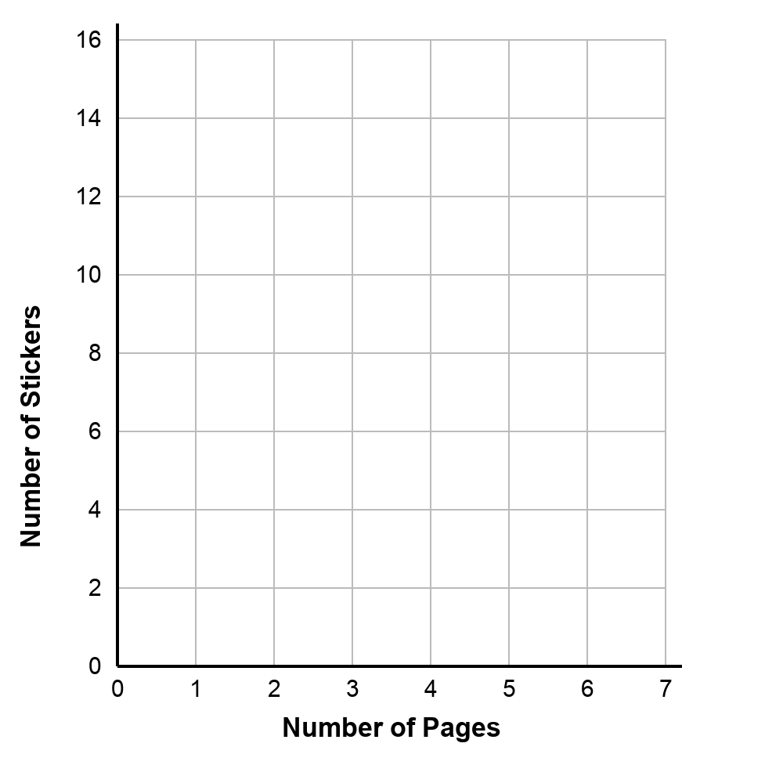

Question 8A (linked: 8B)
Type: Fill-in-the-Blank DOK: 2 Standards: CCSS.Math.Content.6.RP.A.3.a Points: 1
Carlos is comparing the amount of fiber in two different brands of cereal. Brand A advertises 3 grams of fiber per serving. The amount of fiber per serving in Brand B is shown in the table.
Brand B
Number of Servings | 2 | 3 | 4
Fiber (g) | 8 | 12 | 16

Enter the answers to complete the ordered pairs for points on a graph that show the amounts of fiber for 1, 2, 3, and 4 servings of Brand A and Brand B.
Brand A:
(1, ____________)
(2, ____________)
(3, ____________)
(4, ____________)
Brand B:
(1, ____________)
(2, ____________)
(3, ____________)
(4, ____________)

Question 8B (linked: 8A)
Type: Fill-in-the-Blank DOK: 2 Standards: CCSS.Math.Content.6.RP.A.3.a Points: 1
Which brand offers the greater ratio of grams of fiber to servings of cereal? Enter the answer.
Brand ____________

Question 9
Type: Fill-in-the-Blank DOK: 2 Standards: CCSS.Math.Content.6.RP.A.3.b Points: 1
Jordan runs 3 miles in 27 minutes. Enter the answers to complete the sentences.
The unit rate is ____________ minutes per mile.
At this rate, Jordan would run ____________ miles in 45 minutes.

Question 10
Type: Essay DOK: 3 Standards: CCSS.Math.Content.6.RP.A.3.b Points: 1
Marcus burns 270 calories by swimming 30 minutes at the pool. After this, he burns 180 calories by riding a bike for 20 minutes. Are these rates equivalent? Explain your reasoning. Enter the answer.
______________________________________________________________________________________
______________________________________________________________________________________
______________________________________________________________________________________
______________________________________________________________________________________

Question 11
Type: Multiple Choice DOK: 2 Standards: CCSS.Math.Content.6.RP.A.3.d Points: 1
Tanya does squats with 60-kilogram weights. Which is the best approximation for the number of pounds that Tanya uses for her squats? Access the reference sheet for measurement conversions. Choose the correct answer.
○ 27 pounds | ○ 33 pounds
○ 108 pounds | ○ 132 pounds

Question 12A (linked: 12B)
Type: Essay Points: 2
A bakery sells muffins and bagels in a ratio of 7 : 4.
A student created the tape diagram below to represent the ratio.
The student then used the ratio to determine how many bagels there are when the bakery has 42 muffins.
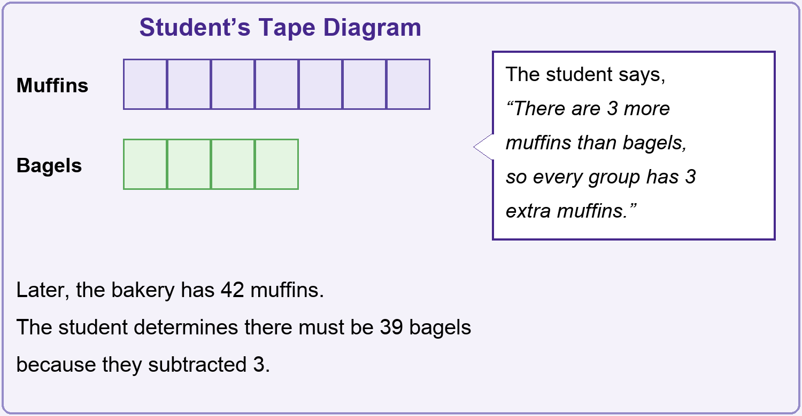
Explain why the student’s reasoning is incorrect. Use the tape diagram below to determine the correct number of bagels when the bakery has 42 muffins. Show your work by labeling the tape diagram.
Sentence Frame: "I know this because..."
______________________________________________________________________________________
______________________________________________________________________________________
______________________________________________________________________________________
______________________________________________________________________________________

Question 12B (linked: 12A)
Type: Drawing Points: 1
Show your work by labeling the tape diagram.
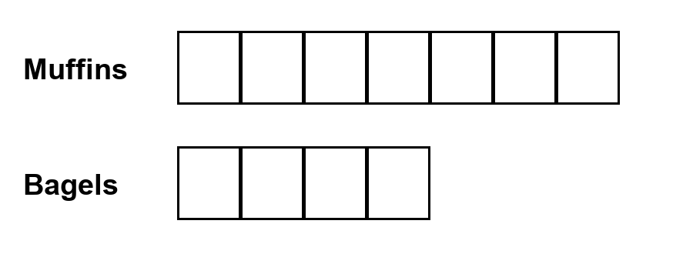

Question 13
Type: Fill-in-the-Blank DOK: 1 Standards: CCSS.Math.Content.6.RP.A.3.d Points: 1
Aaliyah walks to the library. The library is 2,100 feet away. How many yards did Aaliyah walk? Enter the answer.
____________ yards

