EXIT TICKET · LESSON 2-1 · SESSION 1 Name
Statistical Questions

1. Write S (statistical) or N (not statistical).
a. How many hours are in a day? | b. How long is each student’s name?

2. Rewrite “How many students are in Room 12?” as a statistical question.
New question

3. Which question is statistical?
A How many legs does a spider have? | B What is today’s date?
C How many minutes did each student read? | D How tall is our flagpole?

HOW DID IT GO? □ I got it □ Almost □ I need help
cut here
EXIT TICKET · LESSON 2-1 · SESSION 1 Name
Statistical Questions

1. Write S (statistical) or N (not statistical).
a. How many hours are in a day? | b. How long is each student’s name?

2. Rewrite “How many students are in Room 12?” as a statistical question.
New question

3. Which question is statistical?
A How many legs does a spider have? | B What is today’s date?
C How many minutes did each student read? | D How tall is our flagpole?

HOW DID IT GO? □ I got it □ Almost □ I need help
EXIT TICKET · LESSON 2-1 · SESSION 2 Name
Dot Plots and Shape

1. Data: 4, 6, 5, 6, 6, 7.
a. Dots above 6: | b. Most common:

2. Name the shape of this plot.  Shape | 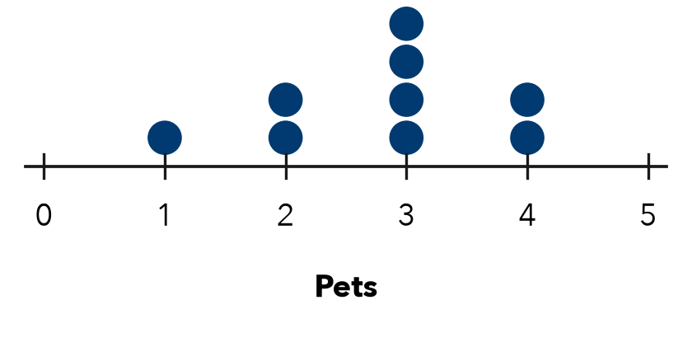

3. A dot plot has stacks of 3, 1, 4 and 2 dots. How many values?
A 4 | B 10 | C 9 | D 3

HOW DID IT GO? □ I got it □ Almost □ I need help
cut here
EXIT TICKET · LESSON 2-1 · SESSION 2 Name
Dot Plots and Shape

1. Data: 4, 6, 5, 6, 6, 7.
a. Dots above 6: | b. Most common:

2. Name the shape of this plot.
Shape

3. A dot plot has stacks of 3, 1, 4 and 2 dots. How many values?
A 4 | B 10 | C 9 | D 3

HOW DID IT GO? □ I got it □ Almost □ I need help

