Name Date Period
Lesson 2-1 · Session 1 · Guided Notes
Statistical Questions
Learning target — I can tell whether a question is statistical by deciding if the answers will vary. · 6.SP.A.1
WORDS TO KNOW fill in the missing words
WORD | WHAT IT MEANS | EXAMPLE
statistical question  pregunta estadística | A question whose answers are expected to . | How many pets does each student have?
variability  variabilidad | How the answers in a data set are. | 0, 2, 5, 1 pets
data  datos | Facts or you collect to answer a question. | 6, 8, 9 hours of sleep
KEY IDEA complete each sentence
• A statistical question expects answers that , so you collect data to answer it.
• A question with one answer is not statistical, even if the answer is a .
WORKED EXAMPLE fill in the blanks as we solve
Is “How many minutes does each student ride the bus?” a statistical question?
Step 1 Who answers? student.
Step 2 Will the answers differ? Yes: 5, 12, 25 minutes, so the answers .
Answer The question is .
YOU TRY use the example as a model

1. Write S (statistical) or N (not statistical).
a. How many days are in May? | b. How tall is each player?

2. “How tall is our classroom door?” is not statistical. Rewrite it so the answers vary.
New question

SUM IT UP in your own words
A question is statistical when because .
Name Date Period
Lesson 2-1 · Session 2 · Guided Notes
Dot Plots and Shape
Learning target — I can build a dot plot and describe the shape of the data it shows. · 6.SP.B.4
WORDS TO KNOW fill in the missing words
WORD | WHAT IT MEANS | EXAMPLE
dot plot  diagrama de puntos | A number line with one for each data value. | 3 dots above 2 = three 2s
peak  pico | The stack; it shows the most common value. | tallest stack above 5
symmetric  simétrico | The left and right sides of the plot . | stacks 1, 3, 5, 3, 1
skewed  sesgado | The data has a long on one side. | tail to the right: skewed right
KEY IDEA complete each sentence
• Repeated values up, so the total number of dots equals the number of .
• A plot is named for its : a tail to the left means skewed left.
WORKED EXAMPLE fill in the blanks as we solve
Six friends ate 4, 5, 5, 6, 5, 7 grapes. Make a dot plot.
Step 1 Draw a line from 3 to 8 and label each whole number.
Step 2 Stack one dot per friend: dots above 5.
Step 3 The peak is at ; there are dots in all.
Answer Most common value: grapes
YOU TRY use the example as a model

1. The plot shows quiz scores. Name the most common value and the shape.  Peak; shape | 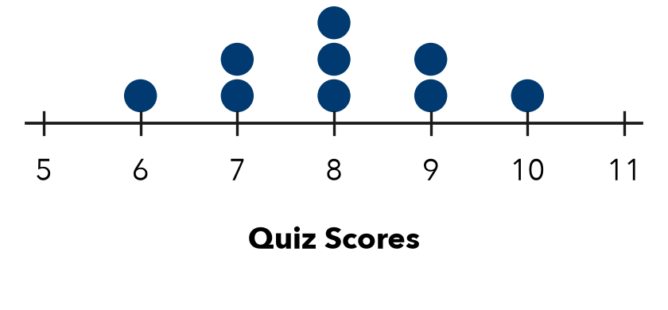

2. A dot plot has stacks of 2, 4, 1 and 3 dots.
a. Number of values: | b. Tallest stack:

SUM IT UP in your own words
A dot plot shows , so I can see .

