Name Date Period
Lesson 2-10 · Session 2 · Practice · Form A
Matching Center and Spread
Learning target — I can match a measure of center and a measure of spread to the shape of a data set. · 6.SP.B.5d

REMEMBER  • Symmetric, no outlier: mean and MAD. Skewed or outlier: median and IQR.  • Never mix the pairs. MAD is built from the mean; IQR is built from the median.  • A long tail to the right means skewed right; to the left means skewed left. | WORKED EXAMPLE  Set C: 20, 22, 24, 26, 28. Set D: 20, 22, 24, 26, 150. Pick a pair for each.  Step 1 C is symmetric: mean 24, MAD 12 ÷ 5 = 2.4.  Step 2 D has an outlier (150): median 24, with the IQR.  Answer C: mean and MAD. D: median and IQR.
WORDS symmetric (simétrico) · skewed (asimétrico) · mean and MAD (media y DMA) · median and IQR (mediana y rango intercuartil)
PRACTICE show your work · label units

1. Write the pair you would report: mean and MAD, or median and IQR.
a. 31, 33, 35, 37, 39 | b. 31, 33, 35, 37, 290
c. 44, 46, 48, 50, 52, 54, 56 | d. 12, 13, 15, 17, 19, 21, 400

2. Donations. The histogram shows the sizes of 20 donations.  a. Shape:  b. Pair to report: | 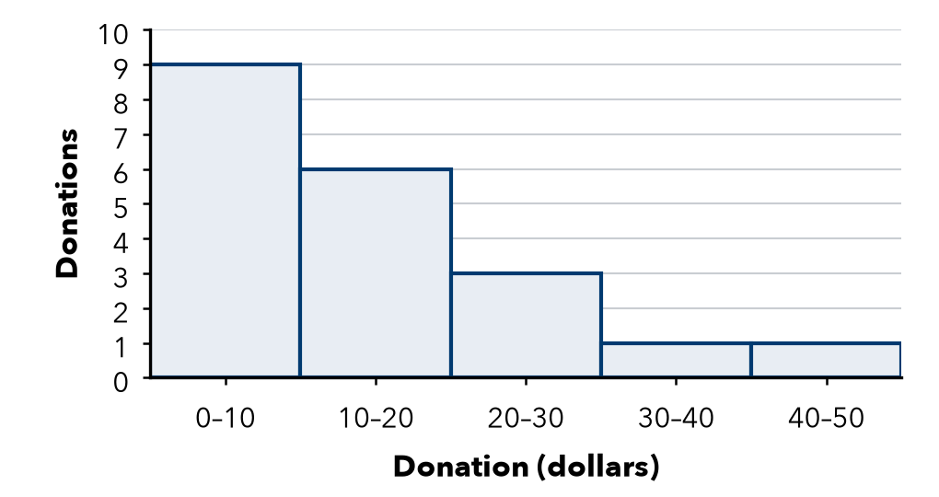

3. Balanced Scores. Set W is 52, 54, 56, 58, 60. It is symmetric.  Hint Find the mean first. MAD = average distance from it.  a. Mean:  b. MAD: | 4. One Big Night. Ticket sales for seven shows were 12, 13, 15, 17, 19, 21 and 400.  Hint Q1 is the middle of the lower half; Q3 of the upper half.  a. Median:  b. IQR:
  Show your work.
  Show your work.

5. Mismatched Pair. Fernanda reports a median of 70 for a skewed set, with the MAD for spread. What spread should she use?  Hint Which center is the MAD built from?  Spread | 6. Heartbeats. Heartbeats per ten seconds: 25, 27, 29, 31, 33, 35, 37. Name the pair to report. Find the center.  Center
  Show your work.
  Show your work.

7. One New Value. The set 80, 82, 84, 86, 88 is symmetric. Then a new value, 500, joins the set.
a. Pair to report before:
b. Pair to report after:
c. New median:

Show your work.

8. Deli Wait Times. The box plot shows wait times, in minutes.
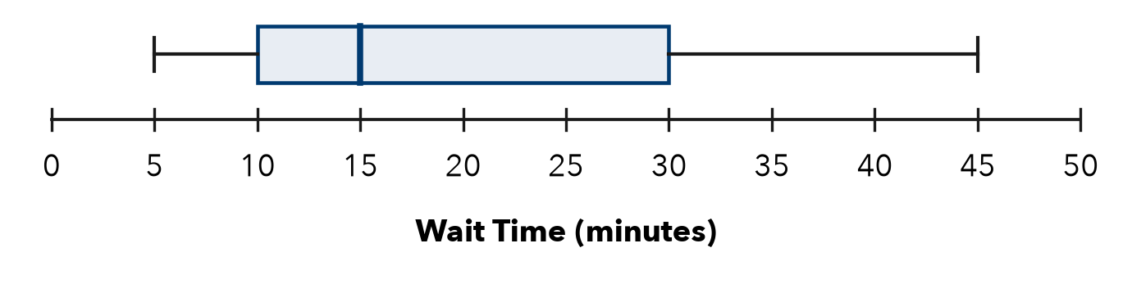
a. Shape:
b. Median: min
c. IQR: min

FIND THE ERROR explain the mistake, then fix it

9. Malik’s Work. Malik saw a set with one huge outlier and chose the mean and MAD, saying “the mean always uses every value.” Explain his mistake.

TEST PRACTICE choose the best answer

10. Symmetric data with no outlier is best summarized by —
A mean and MAD | B median and MAD | C mean and IQR | D range only

11. Which pairing is incorrect?
A mean with MAD | B median with IQR
C mean with IQR | D center with spread

SELF-CHECK CODE find your answer · copy its letter into that problem’s box · spell a math word
20  Y | 84  Z | 15  R | 2.4  Y | 8  M | 85  T | 56  S | 31  E | 12  Q | 17  M

#3a | #3b | #4a | #4b | #6 | #7c | #8b | #8c

CHECK YOURSELF | □ I can do this on my own | □ I need a little help | □ I have a question about #

