Name Date Period
Lesson 2-2 · Session 1 · Practice · Form A
Building a Histogram
Learning target — I can group data into equal intervals and build a histogram from a frequency table. · 6.SP.B.4

REMEMBER  • An interval is a group of numbers, like 10–19. Intervals are equal in width and never overlap.  • Frequency = how many values fall in an interval. It sets the bar height.  • Histogram bars touch. All the bar heights add up to the number of values. | WORKED EXAMPLE  Walk times (min): 4, 15, 9, 22, 11, 18, 27. Use 0–9, 10–19, 20–29.  Step 1 0–9 holds 4 and 9: frequency 2.  Step 2 10–19 holds 15, 11, 18: frequency 3. 20–29 holds 22, 27: frequency 2.  Step 3 Draw touching bars of height 2, 3, 2.  Answer Check: 2 + 3 + 2 = 7 values
WORDS histogram (histograma) · interval (intervalo) · frequency (frecuencia)
PRACTICE show your work · label units

1. Bus Rides. Nine students timed their bus rides (min): 12, 25, 8, 17, 21, 14, 6, 23, 19. Complete the table. Then draw the histogram.  Hint Cross off each value as you tally it.  Most rides | 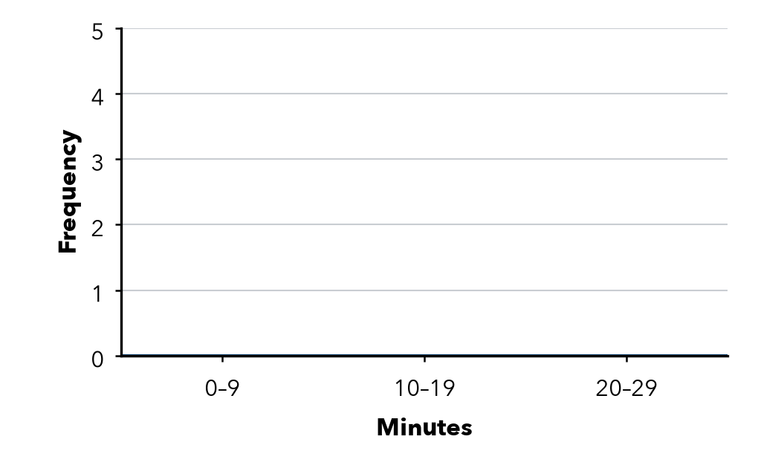
  Interval | Frequency
  0–9
  10–19
  20–29

2. Pushups. 8 students did these pushups: 22, 15, 9, 27, 13, 18, 26, 24. Find each frequency and the total.
a. 0–9: | b. 10–19: | c. 20–29: | d. Total:

3. Read the Table. 40–49: 5, 50–59: 8, 60–69: 4, 70–79: 3.  Hint Add the frequencies; the biggest one is the tallest bar. | 4. Missing Bar. A histogram shows 9 values. Two bars have heights 2 and 4. How tall is the third bar?  Hint All the bar heights add up to the total.  Height
  a. Values in all:
  b. Tallest bar:
  Show your work.

5. Car Wash. Cars washed on 7 Saturdays: 12, 27, 18, 33, 24, 9, 30. Find each frequency.
Hint Put the counts in order first.
a. 0–9: | b. 10–19: | c. 20–29: | d. 30–39:

6. Overlapping Bins. Lena sorts 5, 11, 16, 20, 24 into the intervals 5–10, 10–15, 15–20, 20–25. What is wrong? Write intervals that work.
Hint Look for a number that fits in two intervals.

7. Choose the Intervals. Test scores run from 51 to 98. Write five equal intervals of width 10 that cover every score.
Intervals

8. Field Day. Twelve runners finished in 31, 44, 38, 52, 47, 35, 41, 56, 39, 48, 33, 55 seconds. Complete the table.
a. Which interval holds the most runners?
b. Why does a histogram show the times better than the list?
Interval | Frequency
30–39
40–49
50–59

FIND THE ERROR explain the mistake, then fix it

9. Ibrahim’s Work. For the values 4, 12, 18, 26, Ibrahim drew bars over 0–9, 10–19 and 20–29 with a space between each bar. Explain the mistake and describe the correct histogram.

TEST PRACTICE choose the best answer

10. In a histogram, the height of a bar shows the —
A width of the interval | B frequency of the interval
C greatest value | D number of intervals

11. A frequency table shows 3, 7, 5 and 2. How many values were collected?
A 7 | B 4 | C 17 | D 15

SELF-CHECK CODE find your answer · copy its letter into that problem’s box · spell a math word
8  L | 6  Z | 50–59  I | 10–19  T | 30–39  S | 4  A | 3  E | 20  L | 20–29  X | 9  Q

#1 | #2c | #2d | #3a | #3b | #4 | #8a

CHECK YOURSELF | □ I can do this on my own | □ I need a little help | □ I have a question about #

