Name Date Period
Lesson 2-2 · Session 1 · Practice · Form B
Building a Histogram
Learning target — I can group data into equal intervals and build a histogram from a frequency table. · 6.SP.B.4

REMEMBER  • An interval is a group of numbers, like 10–19. Intervals are equal in width and never overlap.  • Frequency = how many values fall in an interval. It sets the bar height.  • Histogram bars touch. All the bar heights add up to the number of values. | WORKED EXAMPLE  Walk times (min): 4, 15, 9, 22, 11, 18, 27. Use 0–9, 10–19, 20–29.  Step 1 0–9 holds 4 and 9: frequency 2.  Step 2 10–19 holds 15, 11, 18: frequency 3. 20–29 holds 22, 27: frequency 2.  Step 3 Draw touching bars of height 2, 3, 2.  Answer Check: 2 + 3 + 2 = 7 values
WORDS histogram (histograma) · interval (intervalo) · frequency (frecuencia)
PRACTICE show your work · label units

1. Route 4. Nine students timed their bus rides (min): 5, 14, 22, 11, 8, 17, 26, 3, 19. Complete the table. Then draw the histogram.  Hint Cross off each value as you tally it.  Fewest rides | 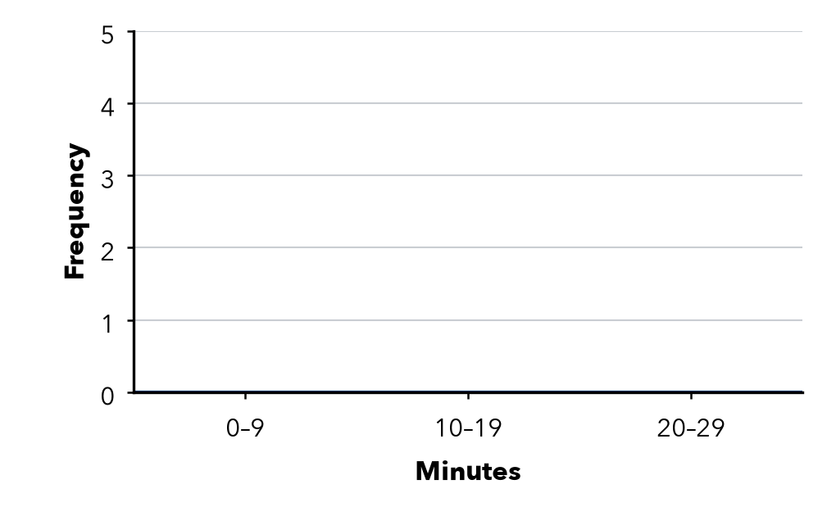
  Interval | Frequency
  0–9
  10–19
  20–29

2. Pushups. 9 students did these pushups: 17, 28, 6, 21, 14, 25, 29, 23, 12. Find each frequency and the total.
a. 0–9: | b. 10–19: | c. 20–29: | d. Total:

3. Read the Table. 30–39: 6, 40–49: 9, 50–59: 5, 60–69: 2.  Hint Add the frequencies; the biggest one is the tallest bar. | 4. Missing Bar. A histogram shows 12 values. Two bars have heights 3 and 5. How tall is the third bar?  Hint All the bar heights add up to the total.  Height
  a. Values in all:
  b. Tallest bar:
  Show your work.

5. Car Wash. Cars washed on 8 Saturdays: 15, 31, 8, 26, 37, 19, 22, 34. Find each frequency.
Hint Put the counts in order first.
a. 0–9: | b. 10–19: | c. 20–29: | d. 30–39:

6. Overlapping Bins. Desmond sorts 3, 8, 12, 15, 19 into the intervals 0–5, 5–10, 10–15, 15–20. What is wrong? Write intervals that work.
Hint Look for a number that fits in two intervals.

7. Choose the Intervals. Plant heights run from 42 to 87 cm. Write five equal intervals of width 10 that cover every height.
Intervals

8. Field Day. Twelve runners finished in 31, 44, 38, 52, 47, 35, 41, 56, 39, 48, 33, 45 seconds. Complete the table.
a. Which interval holds the fewest runners?
b. Why does a histogram show the times better than the list?
Interval | Frequency
30–39
40–49
50–59

FIND THE ERROR explain the mistake, then fix it

9. Nadia’s Work. For the values 4, 12, 18, 26, Nadia drew bars over 0–9, 10–19 and 20–29 with a space between each bar. Explain the mistake and describe the correct histogram.

TEST PRACTICE choose the best answer

10. Which set of intervals is correct for a histogram?
A 0–5, 5–10, 10–15 | B 0–9, 10–14, 15–29
C 0–9, 10–19, 20–29 | D 0–10, 10–20, 20–30

11. Histogram bars touch because the intervals —
A are different widths | B leave no gaps between them
C overlap | D have the same frequency

SELF-CHECK CODE find your answer · copy its letter into that problem’s box · spell a math word
50–59  D | 5  O | 22  N | 30–39  X | 20–29  C | 12  Q | 9  U | 40–49  T | 4  E | 8  Z

#1 | #2c | #2d | #3a | #3b | #4 | #8a

CHECK YOURSELF | □ I can do this on my own | □ I need a little help | □ I have a question about #

