Name Date Period
Lesson 2-2 · Session 2 · Prerequisite Practice B · Skill 1 of 2
Describe Dot Plot Shape
Builds on Lesson 2-1 Session 2 · 6.SP.B.4
TODAY’S LESSON | You will tell if a histogram is symmetric. In problem 6, bars 1, 2, 9, 2, 1 match on both sides.
YOU NEED TO | Find the peak, then check if both sides match. You will use it in Practice Form A, problems 5 and 6.
STEPS TO FOLLOW use these same steps on every problem
1 | Find the peak, the tallest stack.
2 | Compare stacks the same distance out on each side.
3 | All pairs match: symmetric. If not: not symmetric.
WATCH ME the steps in action
Is this dot plot symmetric?  Step 1 The peak is at 4, with 5 dots.  Step 2 Pairs: 3 and 3. 1 and 1.  Step 3 All pairs match. Symmetric.  Answer Yes, symmetric with a peak at 4. | 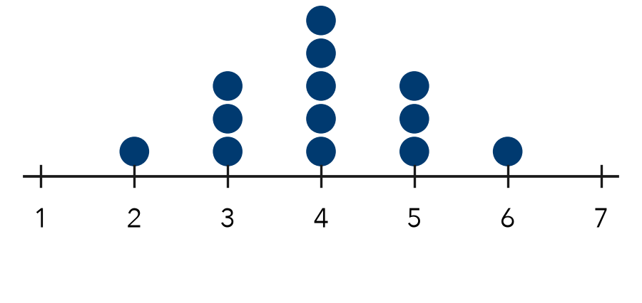

TRY IT WITH HELP fill in each step
1. Stack heights: 1, 2, 4, 2, 1. Is the plot symmetric?
Step 1 The peak is .
Step 2 Pairs: and . and .
Step 3 The plot is .

2. Stack heights: 1, 4, 6, 2, 1. Is the plot symmetric?
Step 1 The peak is .
Step 2 Pairs: and . and .
Step 3 The plot is .

YOUR TURN use the steps on your own

3. Write S for symmetric or N for not symmetric.
a. 2, 5, 2 | b. 1, 1, 2, 5, 7 | c. 3, 4, 4, 3
d. 1, 3, 7, 3, 1 | e. 2, 6, 3, 1 | f. 1, 4, 6, 4, 2

Lesson 2-2 · Session 2 · Prerequisite Practice B · Skill 2 of 2
Build a Frequency Table
Builds on Lesson 2-2 Session 1 · 6.SP.B.4
TODAY’S LESSON | You will sort tomato heights like 14, 22, and 18 into intervals before you name the shape.
YOU NEED TO | Count how many values fall in each interval. You will use it in Practice Form A, problem 1.
STEPS TO FOLLOW use these same steps on every problem
1 | Write each interval in a column.
2 | Make a tally for each value in its interval.
3 | Count the tallies. Check the total.
WATCH ME the steps in action
Make a frequency table for 13, 27, 5, 18, 22, 11, 7, 24, 16. Use 0–9, 10–19, 20–29.
Step 1 Intervals: 0–9, 10–19, 20–29.
Step 2 0–9: 5, 7. 10–19: 13, 18, 11, 16. 20–29: 27, 22, 24.
Step 3 2 + 4 + 3 = 9 values. That matches the list.
Answer 0–9: 2 10–19: 4 20–29: 3
TRY IT WITH HELP fill in each step
4. Make a frequency table for 4, 15, 8, 12, 19, 11.
Step 1 Intervals: and 10–19.
Step 2 0–9 gets tallies. 10–19 gets .
Step 3 Total: values.

5. Make a frequency table for 21, 35, 28, 33, 24, 39, 30.
Step 1 Intervals: and 30–39.
Step 2 20–29 gets tallies. 30–39 gets .
Step 3 Total: values.

YOUR TURN use the steps on your own

6. Data: 12, 27, 18, 33, 24, 9, 30, 15. Find each frequency.
a. 0–9: | b. 10–19: | c. 20–29:
d. 30–39: | e. Total:

READY CHECK a problem like the one in today’s lesson

7. Data: 5, 14, 18, 22, 11, 3. How many values are in 10–19?
A 2 | B 3 | C 4 | D 6

CHECK YOURSELF | □ I can do this on my own | □ I need a little help | □ I have a question about #

