Name |  | Date |  | Period
LESSON 2-2 · SESSION 1 · GUIDED PRACTICE
Building a Histogram
TODAY’S GOAL I can sort data into equal intervals and draw a histogram.

THE IDEA
An interval is a group of numbers, like 10-19. Frequency is how many values are in an interval. Bar height shows the frequency.
Tip: Intervals must be the same width. They must not overlap.
Tip: All bar heights add up to the number of values. Subtract to find a missing bar.

EXAMPLE | Read each step.
Example: Seven students walk to school for these minutes: 4, 15, 9, 22, 11, 18, 27.
1 | Use equal intervals: 0-9, 10-19, 20-29.
2 | Count 0-9: the values 4 and 9 give 2.
3 | Count 10-19: 15, 11, and 18 give 3. Count 20-29: 22 and 27 give 2.
4 | Draw touching bars with heights 2, 3, and 2.
5 | Read it: the tallest bar, 10-19, has the most walks, with 3.
Check: Do the counts 2 + 3 + 2 add up to all 7 values?

WORDS TO KNOW | Read the meaning; find the word in a problem.
histogram  Spanish: histograma | A graph with touching bars; each bar counts the values in an interval. | Bars that touch
interval  Spanish: intervalo | A group of numbers from one number to another, like 10-19. | 10-19 is one interval
frequency  Spanish: frecuencia | How many values are in one interval. | Bar height shows the count
frequency table  Spanish: tabla de frecuencias | A table that lists each interval and how many values it has. | 10-19 . . . 3
distribution  Spanish: distribución | The way the data is spread out across the intervals. | Tallest bar in the middle

TRY IT TOGETHER | Use the example above to complete each part.
1. Minutes on the Bus
Nine students recorded how many minutes their bus ride took: 12, 25, 8, 17, 21, 14, 6, 23, 19.
a. Intervals. Use 0-9, 10-19, 20-29. Are they the same width? ______ Do any overlap? ______
b. Tally. Count the rides in each interval. 0-9: ______ 10-19: ______ 20-29: ______
c. Graph. Draw a histogram in the frame below with three touching bars at those heights.

d. Read. Which interval holds the most rides? ______ How does the graph show it? __________ | 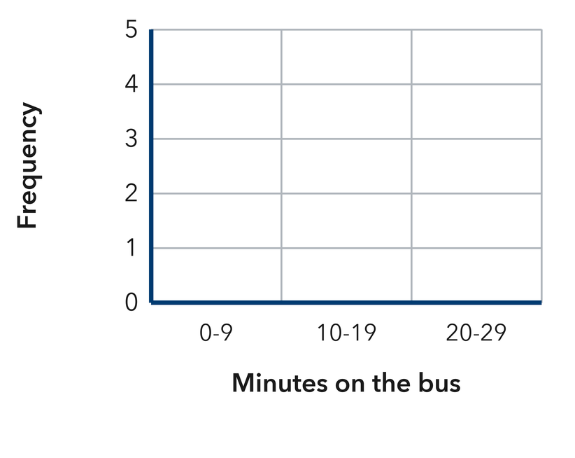​

TURN AND TALK
Why must the intervals be the same width and never overlap?

PRACTICE WITH A PARTNER | Take turns solving and explaining. Check each other’s work.
2. Pushup Challenge. Eight students did these numbers of pushups: 22, 15, 9, 27, 13, 18, 26, 24.  a. Frequencies for 0-9, 10-19, 20-29 __________  b. Add your three counts. What number should they make? __________ | c. Histogram. Draw one touching bar per interval at the height you counted. Use the intervals 0-9, 10-19 and 20-29.​  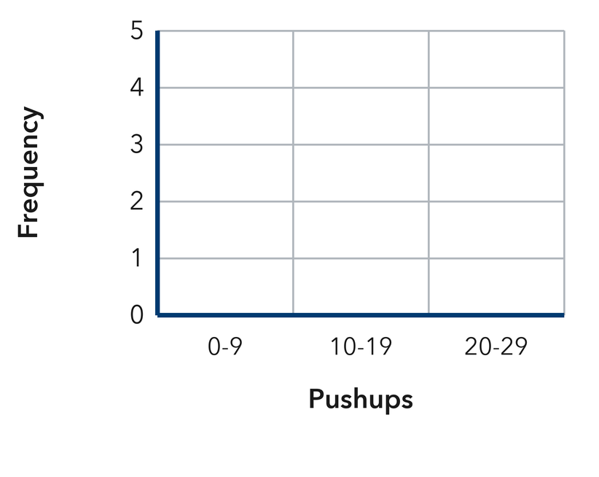
  PARTNER TALK
  How do the bar heights together compare with the number of students surveyed?

3. Song Lengths. Eight songs last these numbers of seconds: 118, 134, 126, 145, 121, 139, 155, 137.  a. Frequencies for 110-129, 130-149, 150-169 __________  b. Draw the histogram. Which bar is tallest? __________ | 4. Craft Club Beads. Eight bracelets used these numbers of beads: 21, 34, 46, 29, 38, 52, 31, 44.  a. Frequencies for 20-29, 30-39, 40-49, 50-59 __________  b. What number should your four counts add to? __________
  PARTNER TALK
  Why do the bars of a histogram touch when the bars of a bar graph do not?
  PARTNER TALK
  Why does every bracelet land in exactly one bar and never in two?

PRACTICE ON YOUR OWN | Show your steps. Label quantities. Use a hint if you need one.
5. Rainfall Totals. Seven weeks brought these rainfall totals in mm: 3, 16, 11, 28, 9, 21, 14.  Find the frequency for each interval 0-9, 10-19, 20-29, then draw the histogram.  Hint Sort the values first so each one drops into exactly one interval as you tally.  Answer frequency for each interval | 6. Overlapping Bins. Lena groups the values 5, 11, 16, 20, 24 using the intervals 5-10, 10-15, 15-20, 20-25.  Explain what is wrong with Lena’s intervals, then write a set that works.  Hint Draw a visual model (like a tape diagram or double number line) to show this relationship.  Answer the flaw; a corrected set of intervals

7. Missing Bar. A histogram of 9 reading logs has a bar of height 2 over 0-19, a bar of height 4 over 20-39, and one more bar over 40-59.  Find the height of the third bar and explain how you know.  Sentence Frame: "I know this because..."  Hint Every reading log lands in exactly one bar, so the bar heights account for all of them.  Answer height of the third bar | 8. Saturday Car Wash. Seven Saturdays brought these car counts: 12, 27, 18, 33, 24, 9, 30.  Find the frequency for each interval 0-9, 10-19, 20-29, 30-39, then draw the histogram.  Hint Sort the counts first so each one drops into exactly one interval as you tally.  Answer frequency for each interval

9. Unequal Bins. Malachi groups the values 8, 13, 19, 26, 40 using the intervals 5-9, 10-19, 20-39, 40-59.
Explain what is wrong with Malachi’s intervals, then write a set that works.
Hint Count how many numbers each interval covers before you tally anything.

Answer the flaw; a corrected set of intervals

10. Plant Heights. Eight plants grew 62, 75, 68, 81, 77, 64, 79, and 85 cm. Use the intervals 60–69, 70–79, and 80–89 and give the frequency of each.  Hint Count how many heights land in each interval.  Answer three frequencies | Histogram. Draw one touching bar per interval at the height you counted.​  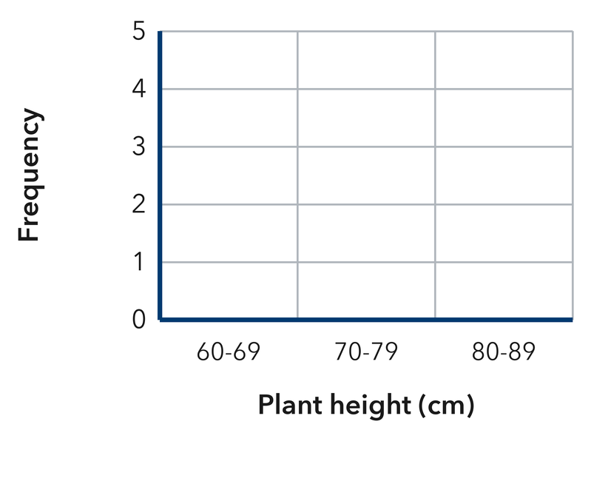
  Show your work.

11. Read the Table. A frequency table shows 40–49: 5, 50–59: 8, 60–69: 4, 70–79: 3.  a. How many values are in the table altogether? __________  b. Which interval has the tallest bar? __________  Hint Add the frequencies; the biggest frequency makes the tallest bar.  Answer: label your responses a and b | 12. Choose the Intervals. Test scores run from 51 to 98. Name five equal intervals of width 10 that cover every score.  Hint Draw a visual model (like a tape diagram or double number line) to show this relationship.  Answer four intervals

FIND AND FIX THE MISTAKE | Explain what went wrong, then solve it correctly.
13. Read the student’s work. Identify the incorrect step, explain why it is incorrect, and show a correct solution.
Sentence Frame: "I know this because..."

IBRAHIM’S WORK
For the values 4, 12, 18, 26, Ibrahim drew bars over 0-9, 10-19 and 20-29 with a space between each bar.
a. Explain the mistake. Look at the spaces between Ibrahim’s bars. What does a histogram require instead? | b. Show correct work  Correct answer (with units, if needed)
  Write the correct steps and label the answer. Check that it fits the problem.

PUT THE IDEAS TOGETHER | Solve each part. Explain how the steps connect.
Sentence Frame: "I know this because..."
14. Field Day Times. Twelve runners finished in 31, 44, 38, 52, 47, 35, 41, 56, 39, 48, 33, and 55 seconds.  a. Build a frequency table using the intervals 30–39, 40–49, and 50–59.  b. Which interval holds the most runners?  c. Explain why a histogram shows the times better than a list of the 12 numbers.  Sentence Frame: "I know this because..."  Answer the table, the busiest interval, and your explanation | d. Histogram. Draw one touching bar per interval at the height you counted. Use equal intervals of width 10.​  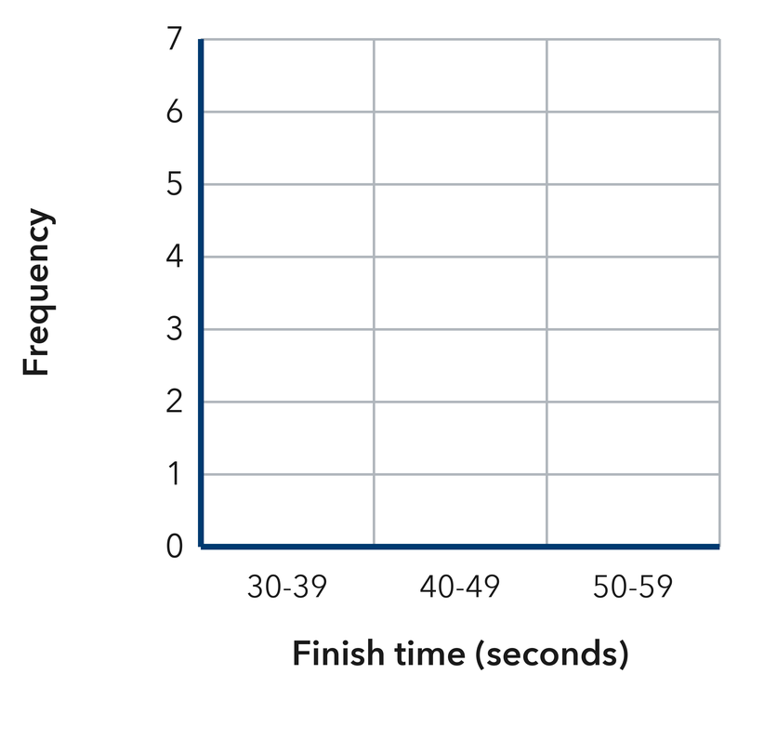
  Show your work.

CHOOSE THE BEST ANSWER | Solve first, then mark one answer for each question.
15. In a histogram, the height of a bar shows the — | 16. Which set of intervals is correct for a histogram?
  □ A. interval width. | □ B. largest value. | □ C. frequency | □ D. median
  □ A. 0–9, 10–25, 26–30 | □ B. 0–9, 5–14, 10–19 | □ C. 0–10, 20–30, 40–50 | □ D. 0–9, 10–19, 20–29

17. A frequency table shows 3, 7, 5, and 2. How many values were collected? | 18. Histogram bars touch each other because the intervals are —
  □ A. 17 | □ B. 7 | □ C. 4 | □ D. 21
  □ A. the same height. | □ B. next to each other. | □ C. always equal. | □ D. in a circle.

REVIEW EARLIER SKILLS | Show the steps you remember; check your result.
19. From Lesson 2-1 Session 2. A dot plot has stacks of 4, 2, and 6 dots. How many values does it show?  Answer (include labels or units) | 20. From Lesson 2-1 Session 1. Is “How tall is our school’s flagpole?” statistical?  Answer (include labels or units)

21. Grade 5. Find 96 ÷ 8.  Answer (include labels or units) | 22. Grade 5. Find 6.5 × 3.  Answer (include labels or units)

SHOW WHAT YOU LEARNED | Solve on your own, then check your answer.
23. Field Day Jumps. Eight students jumped these distances in cm: 106, 122, 115, 131, 119, 127, 110, 118.  a. Frequencies for 100-109, 110-119, 120-129, 130-139 __________  b. Which interval is the most common? __________  Hint Tally one jump at a time and cross it off, so no value gets counted in two intervals.  Answer (include labels or units) | c. Histogram. Draw one touching bar per interval at the height you counted. Use the intervals shown.​  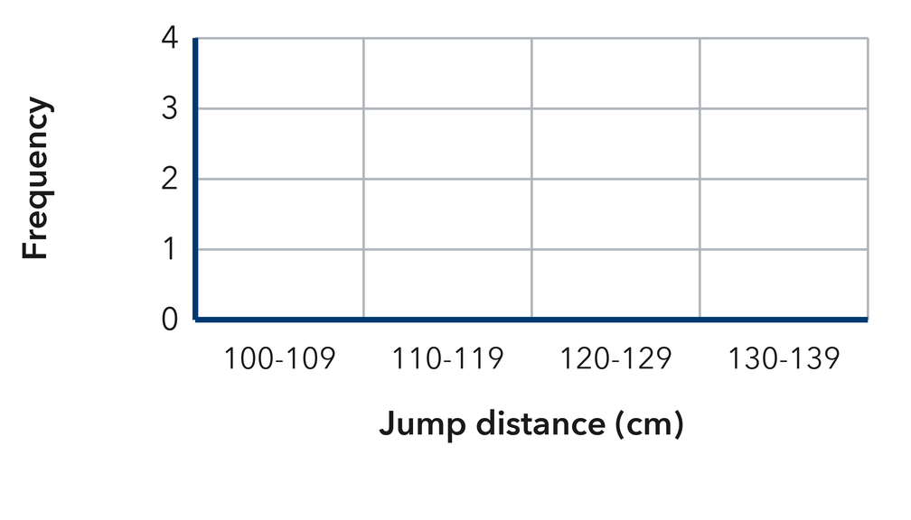
  Show your work.

□ 4 — Can teach it | □ 3 — Got it | □ 2 — Need hint | □ 1 — Need help
Mark one confidence box. Star a problem you can explain. If you need help, write its number: _____.

