Name Date Period
Lesson 2-3 · Session 1 · Prerequisite Practice B · Skill 1 of 2
Find the Middle Position
Builds on Grade 5 · 5.OA.A.2
TODAY’S LESSON | Nine clubs give nine values. The median is the 5th value, with 4 on each side.
YOU NEED TO | Find which place in an ordered list is the middle. You will use it in Practice Form A, problems 1 and 3.
STEPS TO FOLLOW use these same steps on every problem
1 | Count the values.
2 | Subtract 1. Then divide by 2.
3 | Add 1. That place is the middle.
WATCH ME the steps in action
A list has 7 values. Which place is the middle?
Step 1 There are 7 values.
Step 2 7 − 1 = 6. 6 ÷ 2 = 3.
Step 3 3 + 1 = 4. The 4th value is the middle.
Answer 4th
TRY IT WITH HELP fill in each step
1. A list has 5 values. Which place is the middle?
Step 1 There are values.
Step 2 5 − 1 = 4. 4 ÷ 2 = .
Step 3 2 + 1 = . The middle is the value.

2. A list has 11 values. Which place is the middle?
Step 1 There are values.
Step 2 11 − 1 = 10. 10 ÷ 2 = .
Step 3 5 + 1 = . The middle is the value.

YOUR TURN use the steps on your own

3. Find the middle place for each count.
a. 3 values: | b. 13 values: | c. 15 values:
d. 17 values: | e. 21 values: | f. 19 values:

Lesson 2-3 · Session 1 · Prerequisite Practice B · Skill 2 of 2
Read Data From a Dot Plot
Builds on Lesson 2-1 Session 2 · 6.SP.B.4
TODAY’S LESSON | In problem 1 you order nine values. A dot plot shows data in order.
YOU NEED TO | Turn a dot plot into an ordered list: one value for each dot. You will use it in Practice Form A, problem 1.
STEPS TO FOLLOW use these same steps on every problem
1 | Start at the left end of the line.
2 | Write the number once for each dot above it.
3 | Move right. Check: one value per dot.
WATCH ME the steps in action
List the values in this dot plot.  Step 1 Start at 2. It has 1 dot: 2.  Step 2 4 has 3 dots: 4, 4, 4.  Step 3 7 has 1 dot: 7. 5 dots, 5 values.  Answer 2, 4, 4, 4, 7 | 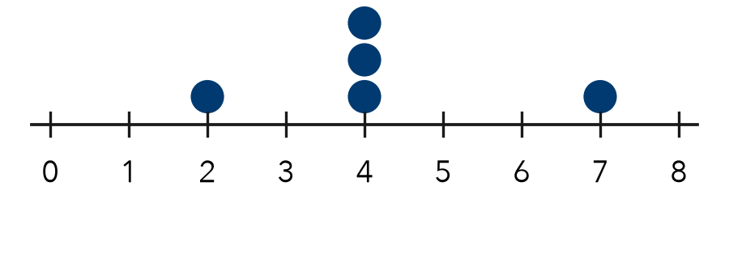

TRY IT WITH HELP fill in each step
4. A dot plot has 1 dot above 3, 2 dots above 5, and 1 dot above 6. List the values.
Step 1 Start at .
Step 2 Write 5 times.
Step 3 List: . Count: values.

5. A dot plot has 2 dots above 0, 1 dot above 2, and 3 dots above 4. List the values.
Step 1 Start at . Write it times.
Step 2 Write 4 times.
Step 3 List: . Count: values.

YOUR TURN use the steps on your own

6. Write the values for each dot plot.
a. 3 dots above 7: | b. 2 dots above 1, 1 above 4:
c. 1 dot above 5, 3 above 6: | d. 2 dots above 0, 2 above 9:

READY CHECK a problem like the one in today’s lesson

7. Dots: 1 above 2, 3 above 4, 1 above 7. What is the middle value?
A 2 | B 3 | C 4 | D 7

CHECK YOURSELF | □ I can do this on my own | □ I need a little help | □ I have a question about #

