Name Date Period
Lesson 2-6 · Homework Packet · Level 1 · Sheet 1 of 2
Median and Outliers
Maryland Standard 6.SP.B.5d · Learning target — I can explain why the median is a better measure of center than the mean when a data set has an outlier.

REMEMBER  • An outlier is a value much greater or much less than the rest of the data.  • An outlier pulls the mean toward it. The median barely moves, so it is resistant to outliers.  • With an outlier, the median usually describes a typical value better. Still report the outlier; it is real data. | WORKED EXAMPLE  Six bike rides lasted 14, 18, 15, 16, 64, and 17 minutes. The mean is 24 minutes. Which measure better describes a typical ride?  Step 1 Order: 14, 15, 16, 17, 18, 64. The outlier is 64.  Step 2 Median: (16 + 17) ÷ 2 = 16.5. The mean, 24, is greater than 5 of the 6 rides.  Answer The median, 16.5 minutes

WORD BANK  outlier — a number far away from the others  median — the middle number | mean — add all, then divide by how many  typical — usual, like most of the data
PRACTICE show your work · label units

1. Find the median of each data set. Circle the outlier in each set.
Step 1 Order each list.
Step 2 Circle the number far from the rest.
Step 3 Find the middle number.
a. 9, 11, 10, 12, 13, 8, 48 | b. 3, 70, 72, 75, 78, 71, 74
c. 25, 28, 30, 31, 33, 95 | d. 40, 41, 43, 44, 46, 47, 150
e. 6, 7, 7, 8, 9, 10, 34 | f. 56, 52, 55, 54, 9, 53, 57, 58

2. Homework Minutes. The dot plot shows minutes 10 students spent on homework one night. The mean is 31 minutes.  Step 1 Find the dot far from the others.  Step 2 Order the 10 values; the median is between the 5th and 6th.  Step 3 Count students below 31.  a. Outlier:  b. Median: min  c. Students below the mean:  d. Better center: | 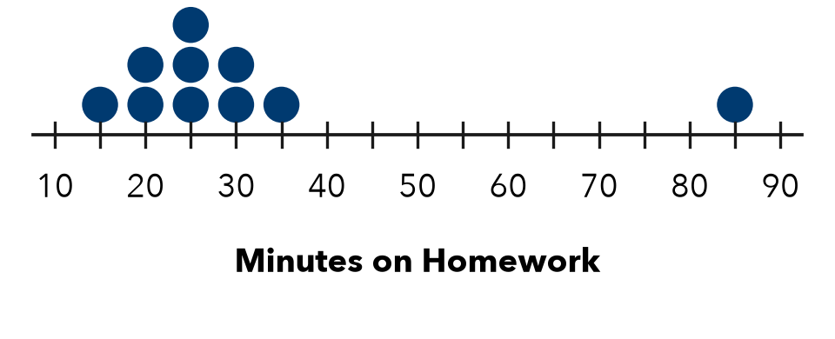

3. Library Visitors. Visitors on 7 days: 64, 58, 61, 66, 59, 63, and 4 (the library closed early for snow).
a. Median of all 7 days: | b. Median without the 4:

4. Car Wash. A club earned $10, $12, $13, $14, $15, $16, and $60 on 7 Saturdays.
Step 1 Mean: add the 7 amounts, then divide by 7.
Step 2 Median: the 4th amount in order.
a. Mean: $ | b. Median: $ | c. Better center:

5. Find the Error. Andre’s data are 31, 33, 34, 36, 37, 39, and 210. He says, “The outlier 210 makes the median much bigger, so the median is not a good measure.” Is he right? Find the median to support your answer.
Frame Andre is . The median is . Without 210 it would be .

CHECK YOURSELF | □ I can do this on my own | □ I need a little help | □ I have a question about #
AT HOME Ask someone at home about a normal trip and their slowest trip. Which trip is an outlier?
Name Date Period
Lesson 2-6 · Homework Packet · Level 1 · Sheet 2 of 2
Comparing Distributions
Maryland Standard 6.SP.B.5d · Learning target — I can compare two distributions using the median and the interquartile range together.

REMEMBER  • Compare centers with the medians. Compare spreads with the IQRs (IQR = Q3 − Q1).  • A smaller IQR means more consistent data. A full comparison names both measures for both groups, with numbers. | WORKED EXAMPLE  Team Red: median 14 points, IQR 6. Team Blue: median 18 points, IQR 15. Compare the teams.  Step 1 Centers: 18 > 14, so Blue usually scores more.  Step 2 Spreads: 6 < 15, so Red is more consistent.  Answer Blue scores more; Red is more consistent.

WORD BANK  median — the typical value  IQR — Q3 − Q1, the spread of the middle half | consistent — close together  predictable — you can guess it well
PRACTICE show your work · label units

1. Reading Minutes. The box plots show minutes read per day by Class A and Class B.  Step 1 Find the line in each box: the medians.  Step 2 IQR = right edge − left edge of each box.  a. Medians: A B  b. IQRs: A B  c. Usually reads more:  d. More consistent: | 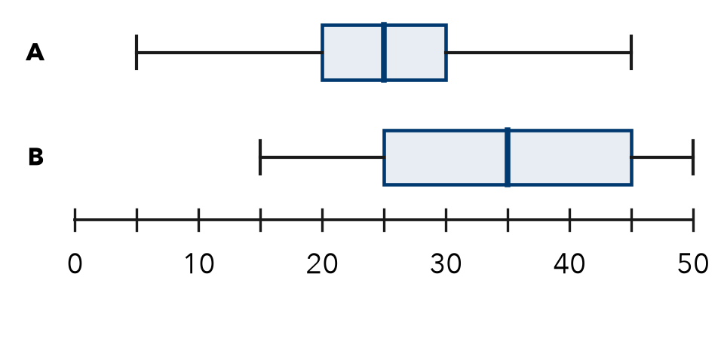

2. Bus Routes. Minutes late on 7 days. Route 3: 2, 3, 5, 6, 8, 9, 11. Route 8: 0, 1, 4, 6, 10, 14, 15.
Step 1 Order is given. The median is the 4th value.
Step 2 Q1 is the 2nd value, Q3 is the 6th value.
a. Route 3: median IQR Route 8: median IQR
b. Which route is more predictable? Why?

3. Plant Heights (cm). Sun: 10, 12, 13, 15, 16, 18, 19, 21. Shade: 6, 7, 8, 8, 9, 10, 10, 12.
a. Sun: median cm IQR cm | b. Shade: median cm IQR cm

4. Delivery. Shop K: median 28 min, IQR 8 min. Shop L: median 36 min, IQR 8 min. What is the same?
□ the same center | □ the same spread | □ both center and spread

5. Find the Error. Set E: median 70, IQR 25. Set F: median 64, IQR 6. Jada says, “Set E is higher and more consistent.” Explain her error.
Frame Set E has the higher . The more consistent set is because its is .

TEST PRACTICE choose the best answer

6. Group 1: median 12 cm, IQR 3 cm. Group 2: median 12 cm, IQR 9 cm. Which is more consistent?
A Group 1 | B Group 2 | C Both the same | D Cannot tell

7. What is the IQR of 3, 5, 6, 8, 10, 12, 13?
A 7 | B 8 | C 10 | D 17

CHECK YOURSELF | □ I can do this on my own | □ I need a little help | □ I have a question about #
AT HOME Tell someone at home why a bus with a small IQR is easier to plan around.

