Name Date Period
Lesson 2-4 · Session 2 · Practice · Form A
Comparing Box Plots
Learning target — I can compare two groups by reading the medians and box widths of their box plots. · 6.SP.B.4

REMEMBER  • Put both box plots on the same scale.  • Compare medians for center: which group is typically higher, and by how much?  • Compare box widths (Q3 − Q1) for spread: the narrower box is more consistent. | WORKED EXAMPLE  Trail X: Q1 18, median 20, Q3 22. Trail Y: Q1 19, median 26, Q3 33 (minutes).  Step 1 Medians: 26 − 20 = 6, so Y is typically 6 min longer.  Step 2 Box widths: X is 22 − 18 = 4; Y is 33 − 19 = 14.  Answer Y is longer; X is more consistent
WORDS center (centro) · spread (dispersión) · consistent (constante)
PRACTICE show your work · label units

1. Two Quizzes. The box plots show scores on two quizzes.  Hint The line inside each box is the median.  a. Higher median:  b. By how many points:  c. Wider box: | 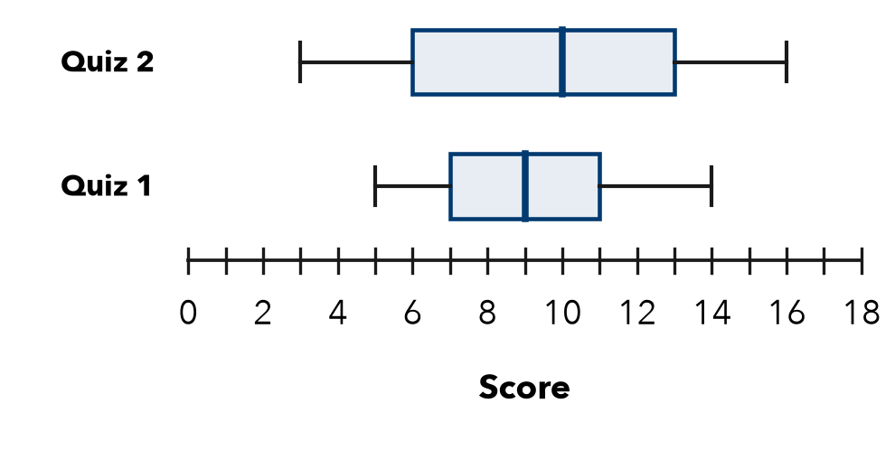

2. Two Teams. Team Red points: 42, 50, 46, 54, 48, 56, 52. Team Blue points: 41, 45, 49, 43, 55, 37, 58. Complete the table. Which team was more consistent?
Hint The narrower box is the more consistent team.
Team | Min | Q1 | Median | Q3 | Max
Red
Blue
More consistent

3. Same Median. Two plots have a median of 30. Box C runs from 27 to 33. Box D runs from 18 to 42. | 4. More Consistent? Plot P has Q1 = 22 and Q3 = 30. Plot Q has Q1 = 18 and Q3 = 36. Which middle half is more consistent?  Hint Find each box width: Q3 − Q1.  Widths
  a. Width of box C:
  b. Width of box D:
  □ P | □ Q

5. Equal Spread? Plot M runs from 20 to 90 with a box from 45 to 65. Plot N runs from 50 to 70 with a box from 55 to 60. Jamal says they are equally spread. Is he right? Compare the spans and the boxes.
□ Yes, equal spread | □ No, M is more spread out | □ No, N is more spread out

6. Two Groups. Which group has the higher median, and by how much?  Group; difference | 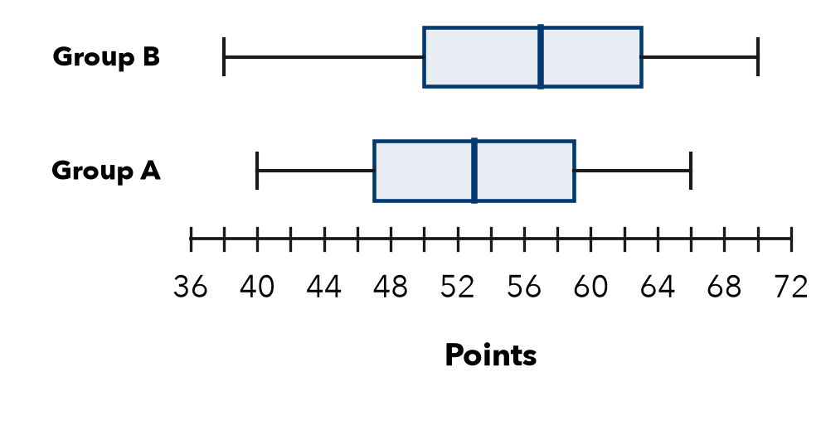

7. Matching Boxes. Plot W runs from 10 to 60. Plot Z runs from 28 to 44. Both boxes run from 30 to 40. Omar says they show the same spread.
a. Whole span of W (max − min):
b. Whole span of Z:
c. Is Omar right? Explain.

8. Two Bus Routes. Travel times (minutes) for two routes.  a. Higher median:  b. More predictable (use box widths):  c. A rider must not be late. Which route? Why? | 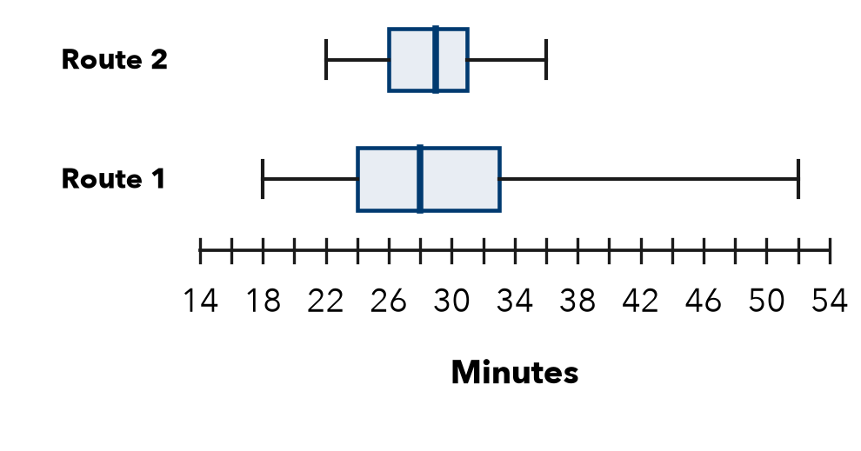

FIND THE ERROR explain the mistake, then fix it

9. Bianca’s Work. Comparing two box plots, Bianca wrote: “Plot E has a longer right whisker, so Plot E has the greater median.” Explain the mistake.

TEST PRACTICE choose the best answer

10. The line inside a box plot’s box shows the —
A mean | B median | C range | D Q1

11. Group A’s median is 50 and Group B’s is 62. Group B’s center is higher by —
A 12 | B 112 | C 62 | D 10

SELF-CHECK CODE find your answer · copy its letter into that problem’s box · spell a math word
24  R | Route 1  X | Route 2  S | 1  S | 60  Q | Red  P | 4  E | Blue  Z | 50  A | 16  D

#1b | #2 | #3b | #6 | #7a | #7b | #8b

CHECK YOURSELF | □ I can do this on my own | □ I need a little help | □ I have a question about #

