Name Date Period
Lesson 2-4 · Session 1 · Prerequisite Practice B · Skill 1 of 2
Find the Median
Builds on Lesson 2-3 · 6.SP.B.5c
TODAY’S LESSON | Each five-number summary needs the median, like 21 for the pumpkin weights.
YOU NEED TO | Find the median of an odd or an even number of values. You will use it in Practice Form A, problems 1 and 7.
STEPS TO FOLLOW use these same steps on every problem
1 | Order the values.
2 | Find the middle: one value or two.
3 | Two middle values? Add them and divide by 2.
WATCH ME the steps in action
Find the median of 3, 5, 8, 10, 12, 14, 18, 20.
Step 1 The values are in order.
Step 2 8 values. The two middle values are 10 and 12.
Step 3 (10 + 12) ÷ 2 = 11.
Answer 11
TRY IT WITH HELP fill in each step
1. Find the median of 9, 4, 12, 7, 15.
Step 1 In order: .
Step 2 One middle value: .
Step 3 The median is .

2. Find the median of 6, 10, 14, 18.
Step 1 In order: .
Step 2 Two middle values: and .
Step 3 (10 + 14) ÷ 2 = .

YOUR TURN use the steps on your own

3. Find the median.
a. 4, 7, 9, 12, 15 | b. 2, 6, 8, 11
c. 18, 7, 12, 25, 9 | d. 33, 21, 40, 28
e. 6, 15, 9, 3, 12, 10 | f. 80, 75, 90, 85, 70

Lesson 2-4 · Session 1 · Prerequisite Practice B · Skill 2 of 2
Plot Points on a Number Line
Builds on Grade 5 · 5.MD.B.2
TODAY’S LESSON | In problem 6 you draw a box plot for 12, 18, 24, 31, and 40 on a line.
YOU NEED TO | Place a value on a number line where not every tick is labeled. You will use it in Practice Form A, problem 6.
STEPS TO FOLLOW use these same steps on every problem
1 | Find what one tick is worth.
2 | Find the label just below the value.
3 | Count ticks from that label to the value.
WATCH ME the steps in action
Plot 26.  Step 1 One tick is 2.  Step 2 20 is the label just below 26.  Step 3 26 − 20 = 6. Count 3 ticks past 20.  Answer 26 is 3 ticks past 20. | 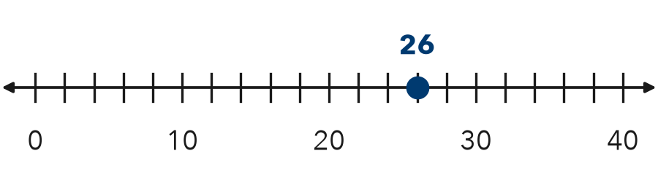

TRY IT WITH HELP fill in each step
4. Ticks are every 2. Labels are 10, 20, 30, 40. Where does 18 go?
Step 1 One tick is .
Step 2 The label just below 18 is .
Step 3 Count ticks past 10.

5. Ticks are every 5. Labels are 0, 20, 40. Where does 35 go?
Step 1 One tick is .
Step 2 The label just below 35 is .
Step 3 Count ticks past 20.

YOUR TURN use the steps on your own

6. Ticks are every 2. Labels are 0, 10, 20, 30, 40. Write how many ticks past which label.
a. 6: | b. 14: | c. 22:
d. 28: | e. 38: | f. 12:

READY CHECK a problem like the one in today’s lesson

7. Ticks are every 4, starting at 0. What value is at the 5th tick after 0?
A 5 | B 9 | C 20 | D 24

CHECK YOURSELF | □ I can do this on my own | □ I need a little help | □ I have a question about #

