Name Date Period
Lesson 2-4 · Session 2 · Prerequisite Practice B · Skill 1 of 2
Find a Five-Number Summary
Builds on Lesson 2-4 Session 1 · 6.SP.B.4
TODAY’S LESSON | In problem 2, each team’s seven scores become five numbers: min, Q1, median, Q3, max.
YOU NEED TO | Find the min, Q1, median, Q3, and max of a data set. You will use it in Practice Form A, problem 2.
STEPS TO FOLLOW use these same steps on every problem
1 | Order the data. The ends are the min and max.
2 | Find the median. It splits the data in half.
3 | Find the middle of each half: Q1 and Q3.
WATCH ME the steps in action
Find the five-number summary of 14, 31, 20, 9, 27, 18, 23.
Step 1 9, 14, 18, 20, 23, 27, 31. Min 9, max 31.
Step 2 The median is 20.
Step 3 Lower half 9, 14, 18: Q1 = 14. Upper half 23, 27, 31: Q3 = 27.
Answer 9, 14, 20, 27, 31
TRY IT WITH HELP fill in each step
1. Find the five-number summary of 1, 3, 5, 7, 9.
Step 1 Min = . Max = .
Step 2 Median = .
Step 3 Q1 = . Q3 = .

2. Find the five-number summary of 11, 25, 16, 19, 22, 14, 27.
Step 1 Min = . Max = .
Step 2 Median = .
Step 3 Q1 = . Q3 = .

YOUR TURN use the steps on your own

3. Each list is in order. Write Q1 and Q3.
a. 10, 20, 30, 40, 50, 60 | b. 4, 6, 7, 8, 10, 12, 13, 15
c. 2, 2, 5, 6, 9, 9 | d. 30, 35, 40, 45, 50, 55, 60, 65, 70

Lesson 2-4 · Session 2 · Prerequisite Practice B · Skill 2 of 2
Read a Box Plot
Builds on Lesson 2-4 Session 1 · 6.SP.B.4
TODAY’S LESSON | In problem 1 you read each quiz’s median and box from two box plots.
YOU NEED TO | Read the five-number summary from a box plot. You will use it in Practice Form A, problems 1 and 8.
STEPS TO FOLLOW use these same steps on every problem
1 | The whisker ends are the min and the max.
2 | The box edges are Q1 and Q3.
3 | The line inside the box is the median.
WATCH ME the steps in action
Read the five-number summary.  Step 1 Ends: min 10, max 50.  Step 2 Edges: Q1 20, Q3 35.  Step 3 Line inside: median 30.  Answer 10, 20, 30, 35, 50 | 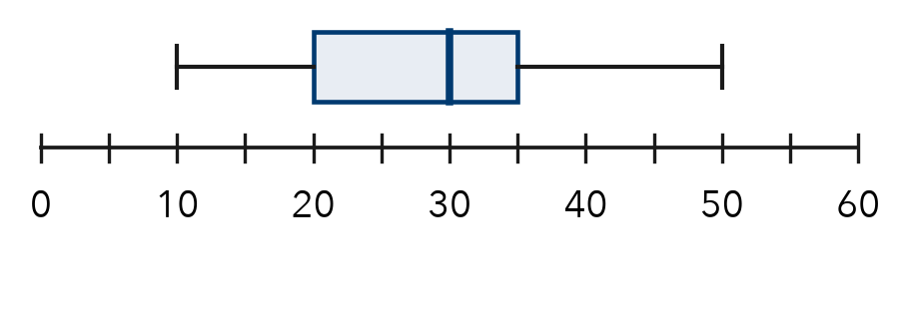

TRY IT WITH HELP fill in each step
4. Whiskers go from 45 to 95. The box goes from 60 to 75. The line is at 70.
Step 1 Min = . Max = .
Step 2 Q1 = . Q3 = .
Step 3 Median = .

5. Whiskers go from 12 to 40. The box goes from 18 to 30. The line is at 22.
Step 1 Min = . Max = .
Step 2 Q1 = . Q3 = .
Step 3 Median = .

YOUR TURN use the steps on your own

6. Read this box plot. | 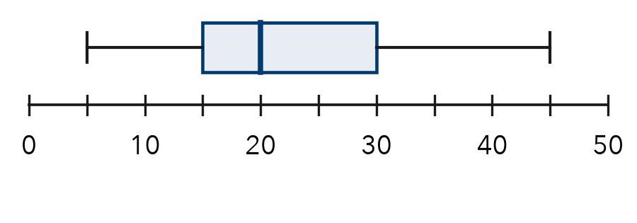
  a. Min and max:
  b. Q1 and Q3:
  c. Median:

READY CHECK a problem like the one in today’s lesson

7. A box goes from 25 to 40 with a line at 32. What is the median?
A 25 | B 32 | C 40 | D 15

CHECK YOURSELF | □ I can do this on my own | □ I need a little help | □ I have a question about #

