Name |  | Date |  | Period
LESSON 2-4 · SESSION 1 · GUIDED PRACTICE
Building a Box Plot
TODAY’S GOAL I can find the five numbers and draw a box plot.

THE IDEA
A box plot uses five numbers: least, Q1, median, Q3, and greatest. Q1 is the middle of the lower half. Q3 is the middle of the upper half.
Tip: With an even count, split the list into two equal halves.
Tip: With 9 values, skip the 5th. Each half has 4 values. Q1 is halfway between the 2nd and 3rd.
Tip: Each section holds one fourth of the values.

EXAMPLE | Read each step.
Example: Seven runners’ times in minutes are 14, 5, 20, 9, 23, 11, 16.
1 | Order the times: 5, 9, 11, 14, 16, 20, 23.
2 | Find the median, the 4th value: 14. Leave it out of both halves.
3 | Find Q1, the middle of 5, 9, 11: it is 9. Find Q3, the middle of 16, 20, 23: it is 20.
4 | Mark 5, 9, 14, 20, and 23 on a number line.
5 | Draw the box from 9 to 20 with a line at 14.
Check: Is each number in order: least, Q1, median, Q3, greatest?

WORDS TO KNOW | Read the meaning; find the word in a problem.
box plot  Spanish: diagrama de caja | A graph that uses five numbers to show how data is spread. | Box with two whiskers
quartile  Spanish: cuartil | A number that splits the ordered data into four equal parts. | Q1, median, Q3
five-number summary  Spanish: resumen de cinco números | The least, Q1, median, Q3, and greatest values of the data. | 6, 8, 14, 19, 22
whisker  Spanish: bigote | A line from the box out to the least or greatest value. | Left whisker reaches the min
middle half  Spanish: mitad central | The half of the values in the middle; the box covers them. | The box holds half the data

TRY IT TOGETHER | Use the example above to complete each part.
1. Pumpkin Weigh-in
Seven pumpkins weigh these numbers of pounds: 12, 26, 18, 30, 15, 24, 21.
a. Order. Write the seven weights from least to greatest: __________
b. Median. Median: ______ How many weights sit on each side of it? ______
c. Quartiles. Quartile 1 (middle of lower half): ______ Quartile 3 (upper half): ______

d. Draw. Draw the box plot on the scale below. Label all five markers.
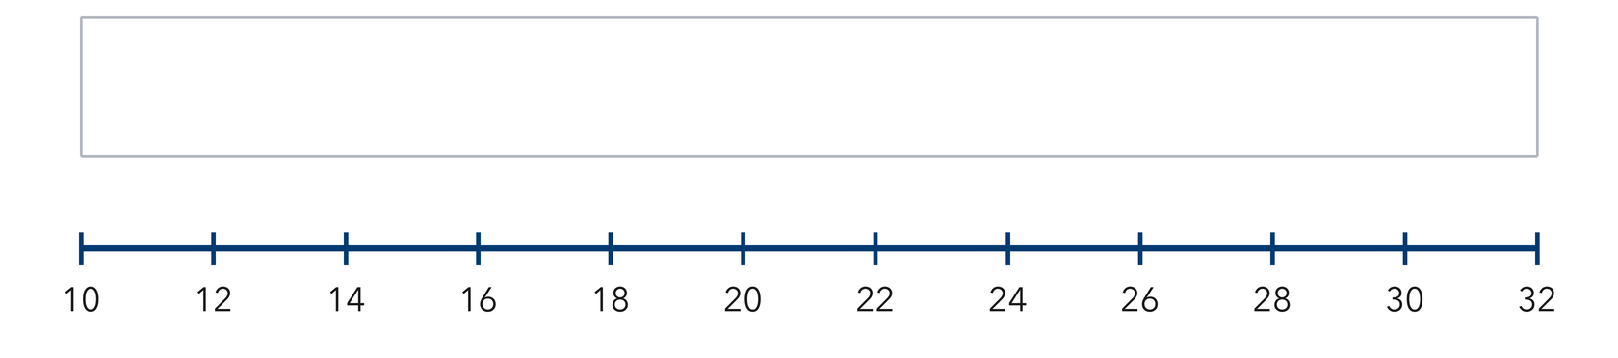​

TURN AND TALK
What part of the data does the box of a box plot cover?

PRACTICE WITH A PARTNER | Take turns solving and explaining. Check each other’s work.
2. Morning Bird Counts. Seven mornings brought these bird counts: 9, 17, 13, 25, 11, 20, 15.
a. Five-number summary __________
b. Draw the box plot. How wide is the box from quartile 1 to quartile 3? __________
c. Box plot. Mark all five values on the scale, then draw the box and both whiskers in the band above it.​
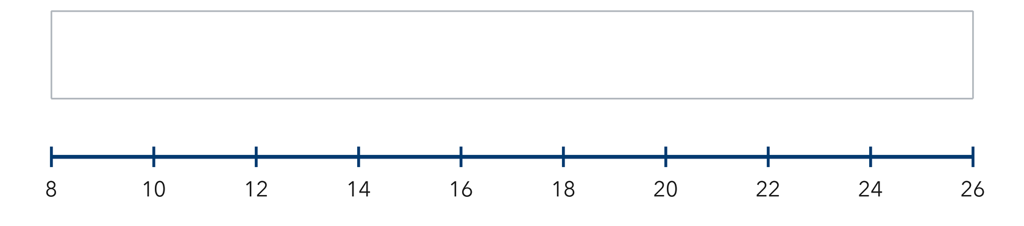

PARTNER TALK
What does a long box tell you about the middle half of the counts?

3. Cone Sales. Seven days of ice cream cone sales: 88, 108, 99, 120, 102, 115, 110.  a. Five-number summary __________  b. Longer whisker: left or right? __________ | 4. Sandwich Orders. Seven days brought these sandwich orders: 32, 45, 38, 56, 41, 50, 47.  a. Five-number summary __________  b. Width of the box from quartile 1 to quartile 3 __________
  PARTNER TALK
  How does the length of a whisker describe the values at that end of the data?
  PARTNER TALK
  What share of the seven days does the box of your plot cover?

PRACTICE ON YOUR OWN | Show your steps. Label quantities. Use a hint if you need one.
5. Rainy Days. Seven months had these numbers of rainy days: 14, 6, 19, 10, 22, 8, 16.  Find the five-number summary, then draw the box plot on a number line.  Hint Mark the median first; it splits the ordered list into the halves the quartiles come from.  Answer five-number summary | 6. Whisker Claim. A box plot shows minimum 20, quartile 1 at 27, median 31, quartile 3 at 35, maximum 46. Kai says half the data sits between 20 and 27.  Justify or correct Kai’s statement.  Hint A box plot cuts the data into four sections that each hold the same share of values.  Answer Is Kai right? Explain

7. Reading the Box. A box plot of ticket prices shows minimum 16, quartile 1 at 23, median 28, quartile 3 at 34, maximum 50.  Determine how wide the box is and explain what share of the prices falls inside it.  Hint Draw a visual model (like a tape diagram or double number line) to show this relationship.  Answer width of the box; share of prices | 8. Guitar Practice. Seven practice sessions lasted these numbers of minutes: 25, 40, 18, 47, 33, 29, 52.  Find the five-number summary, then draw the box plot on a number line.  Hint Mark the median first; it splits the ordered list into the halves the quartiles come from.  Answer five-number summary

9. Long Whisker. A box plot of backpack weights shows minimum 6 lb, quartile 1 at 10 lb, median 13 lb, quartile 3 at 17 lb, maximum 28 lb. Adaeze says most of the weights sit between 17 lb and 28 lb because that stretch is the longest part of the plot.
Justify or correct Adaeze’s statement.
Hint Each of the four sections of a box plot holds the same share of the values.

Answer Is Adaeze right? Explain

10. High Temperatures. Seven highs are 58, 71, 64, 83, 66, 77, and 61 degrees. Find the five-number summary.
Hint Draw a visual model (like a tape diagram or double number line) to show this relationship.
Box plot. Mark all five values on the scale, then draw the box and both whiskers in the band above it.​
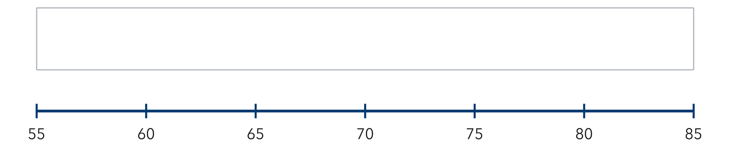
Show your work.
Answer min, Q1, median, Q3, max

11. Build the Box. A data set has min 12, Q1 18, median 24, Q3 31, and max 40.
a. Where does the left edge of the box sit? __________
b. Where does the right whisker end? __________
Hint Draw a visual model (like a tape diagram or double number line) to show this relationship.
c. Box plot. Mark all five values on the scale, then draw the box and both whiskers in the band above it.​
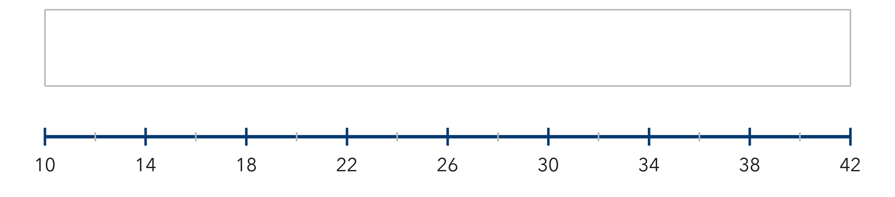

Answer: label your responses a and b

12. Eight Values. Eight scores are 44, 52, 61, 48, 57, 65, 50, and 59. Find the five-number summary.
Hint Draw a visual model (like a tape diagram or double number line) to show this relationship.

Answer min, Q1, median, Q3, max
FIND AND FIX THE MISTAKE | Explain what went wrong, then solve it correctly.
13. Read the student’s work. Identify the incorrect step, explain why it is incorrect, and show a correct solution.
Sentence Frame: "I know this because..."

YUSUF’S WORK
For 5, 9, 12, 16, 20, 24, 30 Yusuf marked quartile 1 at 12 and quartile 3 at 20.
a. Explain the mistake. Yusuf used the values next to the median. Where do the quartiles really come from? | b. Show correct work  Correct answer (with units, if needed)
  Write the correct steps and label the answer. Check that it fits the problem.

PUT THE IDEAS TOGETHER | Solve each part. Explain how the steps connect.
Sentence Frame: "I know this because..."
14. Field Trip Costs. Nine costs in dollars are 18, 25, 12, 30, 22, 27, 15, 33, and 20.
a. Find the five-number summary.
b. Describe where the middle half of the costs falls.
c. Explain what the length of the box tells a reader about the data.

Answer the summary and both explanations
CHOOSE THE BEST ANSWER | Solve first, then mark one answer for each question.
15. The box in a box plot stretches from — | 16. Q1 is the median of the —
  □ A. Q1 to Q3 | □ B. min to max. | □ C. Q1 to median. | □ D. median to max.
  □ A. whole data set. | □ B. lower half. | □ C. upper half. | □ D. two middles.

17. For 4, 8, 12, 16, 20, what is the median? | 18. How many numbers are in a five-number summary?
  □ A. 8 | □ B. 16 | □ C. 12 | □ D. 60
  □ A. 3 | □ B. 4 | □ C. 6 | □ D. 5

REVIEW EARLIER SKILLS | Show the steps you remember; check your result.
19. From Lesson 2-3 Session 2. Find the median of 6, 10, 14, 18.  Answer (include labels or units) | 20. From Lesson 2-3 Session 1. Find the median of 31, 24, 39, 28, 35.  Answer (include labels or units)

21. From Lesson 2-2 Session 1. Name equal intervals of width 10 for values from 22 to 58.  Answer (include labels or units) | 22. Grade 5. Find 7.5 ÷ 5.  Answer (include labels or units)

SHOW WHAT YOU LEARNED | Solve on your own, then check your answer.
23. Cart Loads. Seven carts carried these numbers of boxes: 11, 29, 18, 35, 23, 14, 27.
a. Five-number summary __________
b. Draw the box plot. What does the box cover? __________
Hint Order the loads, mark the median, then take the middle of each half for the quartiles.
c. Box plot. Mark all five values on the scale, then draw the box and both whiskers in the band above it.​
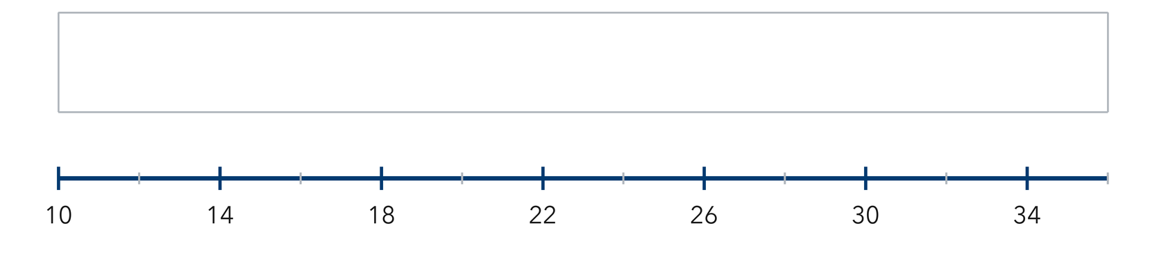
Show your work.
Answer (include labels or units)

□ 4 — Can teach it | □ 3 — Got it | □ 2 — Need hint | □ 1 — Need help
Mark one confidence box. Star a problem you can explain. If you need help, write its number: _____.

