Name Date Period
Lesson 2-5 · Session 1 · Practice · Form A
Range and IQR
Learning target — I can find the range and the interquartile range of a data set. · 6.SP.B.5c

REMEMBER  • Range = greatest − least. It uses only the two extreme values.  • IQR = Q3 − Q1. It is the spread of the middle half of the data.  • Changing only the greatest value changes the range, not the IQR. Missing max = min + range. | WORKED EXAMPLE  Hikes (km): 5, 12, 8, 20, 15, 10, 18.  Step 1 Order: 5, 8, 10, 12, 15, 18, 20.  Step 2 Range = 20 − 5 = 15 km.  Step 3 Q1 = 8, Q3 = 18, so IQR = 18 − 8 = 10 km.  Answer Range 15 km; IQR 10 km
WORDS range (rango) · interquartile range (IQR) (rango intercuartil) · variability (variabilidad)
PRACTICE show your work · label units

1. Camp Hikes. Seven hikes covered 5, 12, 8, 20, 15, 10, 18 km.
Hint Order first. Range uses the ends; IQR uses Q1 and Q3.
a. Range: | b. Q1: | c. Q3: | d. IQR:

2. Bake Sale. Seven sales earned 48, 62, 55, 70, 51, 64, 59 dollars. | 3. Chorus Rehearsals. Seven lasted 55, 72, 61, 88, 66, 79, 70 minutes.  Hint Leave the median out of both halves.
  a. Range:
  b. IQR:
  a. Range:
  b. IQR:

4. Swapped Value. A data set is 12, 14, 18, 22, 24, 29, 33. Someone replaces 33 with 95. Priscilla says both the range and the IQR grow.
Hint Only the greatest value changed.
a. Range before; after:
b. IQR before; after:
c. Is she right? Explain.

5. Missing Maximum. Seven values have min 7, range 38, Q1 = 15 and Q3 = 32.
Hint Add the range to the minimum.
a. Maximum: | b. IQR:

6. Same Range? Set C: 20, 24, 28, 32, 36, 40, 44. Set D: 20, 22, 23, 32, 41, 42, 44.
a. Range of C: | b. IQR of C: | c. Range of D: | d. IQR of D:

7. Which Spread? Hourly wages: min $11, Q1 $14, median $16, Q3 $19, max $62.
a. Range: | b. IQR: | c. Better for typical spread:

8. Two Snack Bars. The box plots show daily sales.  a. Range and IQR of each bar:  b. Which bar has the steadier middle half?  c. Why could the ranges mislead if one day had unusual weather? | 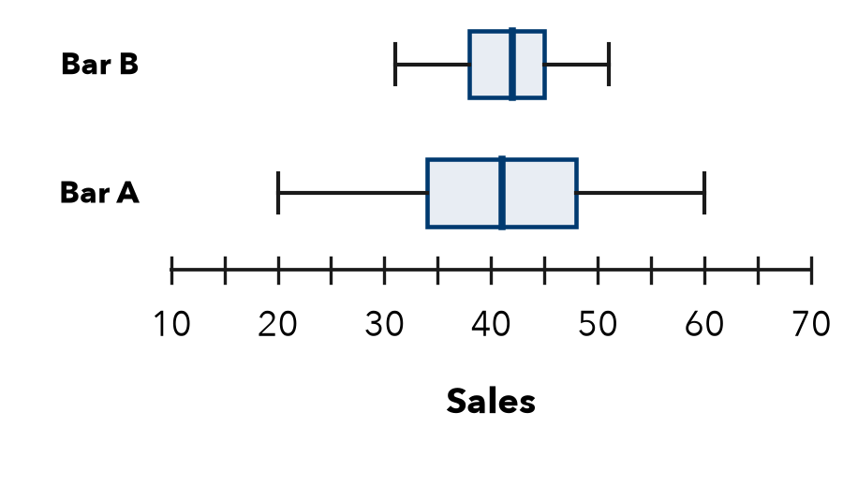

FIND THE ERROR explain the mistake, then fix it

9. Tobias’s Work. For 6, 10, 13, 19, 24, 30, 36, Tobias wrote: “The IQR is 30, the greatest value minus the least.” Explain the mistake and find the IQR.

TEST PRACTICE choose the best answer

10. The range of a data set is found by —
A Q3 − Q1 | B greatest − least
C adding all values | D finding the middle

11. For min 18, Q1 25, median 30, Q3 39, max 52, the IQR is —
A 34 | B 14 | C 9 | D 21

SELF-CHECK CODE find your answer · copy its letter into that problem’s box · spell a math word
17  M | 15  E | 51  E | 27  Z | 45  E | 31  J | 19  Q | 10  X | 18  R | 13  T

#1a | #1d | #2b | #3b | #5a | #5b | #7a

CHECK YOURSELF | □ I can do this on my own | □ I need a little help | □ I have a question about #

